Don’t Forget the Boys!
As the day light hours are getting shorter your does will be coming into season and ready for joining. As the bucks are larger, a little more difficult to handle and smellier than the does they can easily be forgotten but it is important to have them in the best physical condition leading into joining. The bucks contribute a large percentage to the genetics of the next generation of kids.
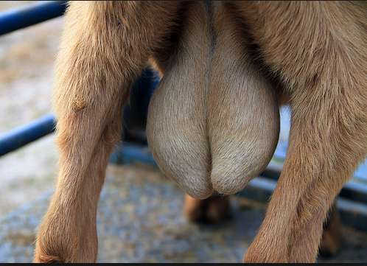
Ideally you want your bucks in a body condition score 3 and good general health with no underlying health concerns. They should have a thorough clinical examination to ensure they have no physical injuries that could hinder their reproductive performance prior to joining.
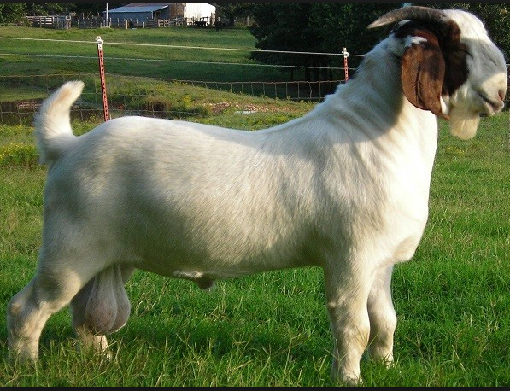
Physical examination:
- Buck should move with no sign of lameness- check for arthritis, weak pasterns and abnormal gait. Feet should be well trimmed.
- No evidence of back pain as this will hinder their ability to thrust.
- Palpate and examine their external reproductive tract: scrotum (scrotal circumference), testicles (size, shape, consistency and symmetry of the testes), epididymis, spermatic cord, prepuce, preputial orifice, presence of urethral process. Cull bucks with abnormalities.
- It is also ideal to check the sperm quality; ideal volume, motility, morphology absence of inflammatory cells and a good live: dead ratio. This will need to be done by a trained professional.
- Ensure the buck does not have any genetic defects that you don’t want passed onto the next generation, i.e. jaw malformations, hernias and extra teats. Likewise you want to breed with the buck with the most ideal body conformation that fits with your reproductive goals.
- Check the bucks libido, did you know that your bucks sexual drive is also hereditable.
- Does your buck have other intercurrent diseases such as internal parasites? Disease can lead to decreased sperm production.
- What is your Buck: Doe ratio for breeding? Could your buck be overused? 1 mature buck: 30-35 does for a healthy buck and optimal reproduction (Based on Australian Boer Goats).
- Is the buck on a good source of nutrition?
- Is your buck under any stress that could decrease his reproductive performance?
- Have you vaccinated your buck against Clostridial diseases?
If you have any further questions with regards to examining your bucks for reproductive soundness please don’t hesitate to call your local District Veterinarian.

