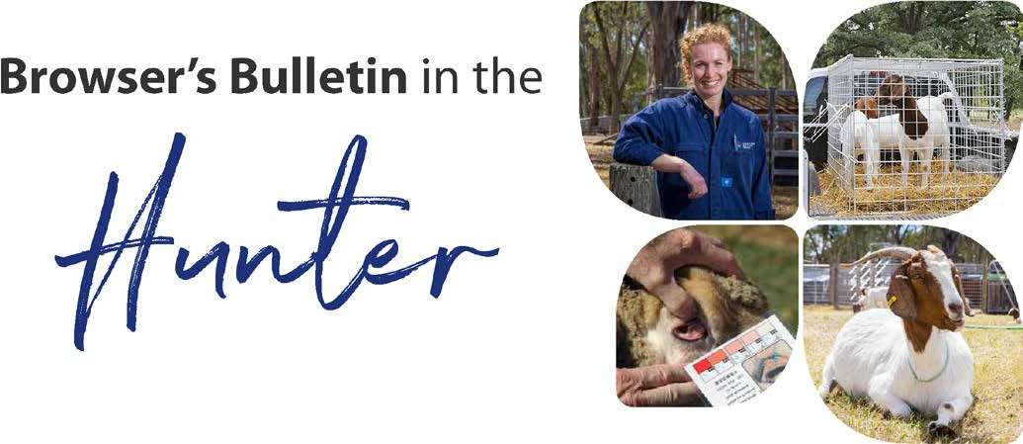
October 2019
Browser’s Bulletin 37: Abomasal Bloat in Kids

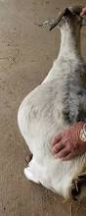
This week I have been contacted about a case of abomasal bloat causing death here in the Hunter. Kids are much more susceptible to abdominal catastrophes than adult goats.

Abomasal bloat in not uncommon in artificially fed kids between 4-12 weeks of age. It is not entirely understood but appears to be linked to ingesting a large quantity of milk and much more common in kids being fed out of a bucket than with bottle fed kids. When the kid ingest too much milk it can leak back into the rumen, leading to excessive fermentation and the buildup of gas. The abdomen becomes distended like a drum and the animal is in a lot of pain. You may see the kid stretching, yawning and screaming in pain. Sometimes they will have diarrhea, go into shock and die suddenly.

All bloating in kids should be treated as serious and they should be checked regularly! Treatment in mild cases would include drenching or giving the kid a tablespoon of vegetable oil or a specific bloat drench. In the more severe cases veterinary attention will be required. The vet may need to administer a needle into the abdomen to release the gas and administer drugs to stop the gut spasms, decrease the pain and restore the gut tone. Some animals that have gone into shock will require antibiotics and fluid therapy in order to recover.

Some kids are more prone to the condition and if you have a kid that appears to keep bloating after each milk feed it is recommended that they are given smaller quantities more frequently at the correct temperature and concentration. If this kid continues to bloat with smaller more frequent feeds then early weaning is recommended in order to prevent sever bloating and death.

It also appears more common in kids fed on a milk replacer than those fed goat or cow’s milk. However, if feeding goat’s milk you need to be sure the milk is Caprine Arthritis Encephalitis (CAE) free otherwise this disease will spread into your kids leading to much bigger issues!

When feeding milk from bowls or buckets the kid will tend to drink more and instead of the milk going directly into the 4th stomach (abomasum) it also goes into the undeveloped rumen and fermentation will occur. The sucking process from the doe or bottle ensures the milk goes directly into the abomasum.

Other conditions that could cause abdominal distension, extreme pain and sudden death in kids include mesenteric torsion (immune system connective tissue in the abdomen twists), intussusception (intestine folds into the section of intestine directly ahead), caecal torsion (twisting of the large intestine) and ruminal bloat.
If you have any other question about abomasal bloat in kids please contact Kylie Greentree at email kylie.greentree@lls.nsw.gov.au

© State of New South Wales through Local Land Services 2019. The information contained in this publication is based on knowledge and understanding at the time of writing November 2019. However, because of advances in knowledge, users are reminded of the need to ensure that the information upon which they rely is up to date and to check the currency of the information with the appropriate officer of Local Land Services or the user’s independent adviser.
For updates go to www.lls.nsw.gov.au

