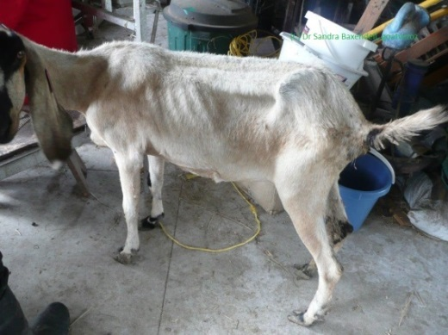
Johne’s Disease in Goats
There has been a lot of talk about Johne’s Disease in cattle over the last couple of months due to a new ‘risk based’ approach to the disease, so I thought it would be a great idea to discuss the importance of this disease in goats. Australia is in a fortunate position to have very limited Johne’s disease compared to many countries; however, it is much more prevalent in intensive industries such as dairy cattle and dairy goats. Johne’s disease causes an incurable wasting disease in goats but generally does not cause scouring as it does in cattle. There are 2 strains of the disease (cattle and sheep strain) and unfortunately goats are susceptible to both, with the cattle strain causing the most pathological issues. It is always important to enquire about the Johne’s disease status of any sheep and cattle that you plan to introduce onto your property.
Johne’s disease is caused by a bacterium called Mycobacterium avium subspecies paratuberculosis that lives mainly in the intestine of infected animals. The bacteria causes thickening of the intestine and reduces the absorption of nutrients. Initially the goats appear hungry but they continue to lose condition, resulting in wasting and finally death. The organism is shed in the faeces of infected animals and can survive in the environment for 12 months. There is no treatment for this disease and the animal will gradually starve to death.
Most cattle become infected with Johne’s disease when they are a calf and develop resistance to picking up Johne’s disease as they get older (>2 years of age) but this is not the case with goats as they have very poor age resistance to Johne’s disease and consequently can become infected at any age. The bacteria are not shed in the infected goat’s faeces until they are greater than 12 months of age (while cattle don’t shed the bacteria until they are greater than 2 years of age).
If you are purchasing goats, you want to minimise bringing the disease onto your property and you can do this by purchasing goats from properties that are enrolled in the Market Assurance Program (MAP) for Johne’s disease. https://edis.animalhealthaustralia.com.au/public.php?page=mapsearch&aha_program=3 these animals have been tested for Johne’s disease and are negative on the test. The more testing they have done the greater the guarantee that they are free of Johne’s disease. When purchasing stock it is important to ask the producer for a “National Goat Health Declaration” form which will give you an overall risk rating for Johne’s disease and other diseases.http://www.farmbiosecurity.com.au/wp-content/uploads/2012/10/National-Goat-Health-Declaration.pdf
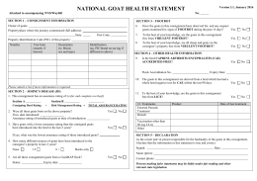

The ‘National Kid Rearing Plan’ can be found on the Animal Health Australia website and promotes hygienic management of kids to avoid contamination by Johne’s disease bacteria from birth until maturity. This plan discusses limiting exposure to Johne’s disease by snatching kids at birth, prevention of faecal contamination in feed and water troughs, spelling paddocks, grazing low risk paddocks, maintain stock proof boundary fences and ideal to have a closed herd. http://www.animalhealthaustralia.com.au/national/kid/
From 1st October 2017 sheep, goats and cattle producers will need to complete a Farm Biosecurity Plan to maintain or obtain accreditation under the Livestock Production Assurance program. LPA is the Australian livestock industry on-farm assurance program covering food safety, animal welfare and biosecurity. A Farm Biosecurity Plan is a set of measures designed to protect a property from entry and spread of pests and disease. On the Animal Health Australia web page you will find an On-Farm Biosecurity Template. http://www.farmbiosecurity.com.au/wp-content/uploads/On-Farm-Biosecurity-Plan-Template_All-Species.pdf. You can fill out this template and keep this Plan with your records.
Under the new Biosecurity Act 2015, producers have the responsibility (General Biosecurity Duty) to manage biosecurity risks and prevent the spread of any disease to other herds/properties. Consequently if you have a disease such as JD or CAE diagnosed on your property you have the legal obligation to prevent the spread of disease.
If you have any further question with regards to Johne’s disease or are concerned that your goat may have the disease please contact your local District Veterinarian or private practitioner as Johne’s disease is a Notifiable disease. We are able to do a number of tests in order to diagnose the causal agent.
FAMACHA TRAINING:
I have an opportunity to get Sandra Baxendell to Maitland to do FAMACHA training. Sandra runs “Goat Veterinary Consltancies, Goat Vet Oz” and is a vet who is extremely knowledgeable about goats with a PhD on goats and has also done her Membership with the Australian and New Zealand College of Veterinary Scientists. Sandra is passionate about sharing her knowledge and her aim is to leave her legacy of healthier goats and a stronger goat industry.
FAMACHA is a diagnostic test that will help sheep and goat producers identify animals that require anthelmintic treatment and those that do not. The tool is a card that measures the degree of anaemia which is often caused by Barber’s Pole worm. Producers must receive training in order to receive a card which consists of a theory component and a practical session. I have very limited places and the course would cost $30/person. I have no date at this point in time as I wanted to put it out to the group to see if the interest is there before I book Sandra. I will conduct these courses in future so if you miss out this time don’t worry I will run them again soon. Please email me ASAP your interest.
