September 2019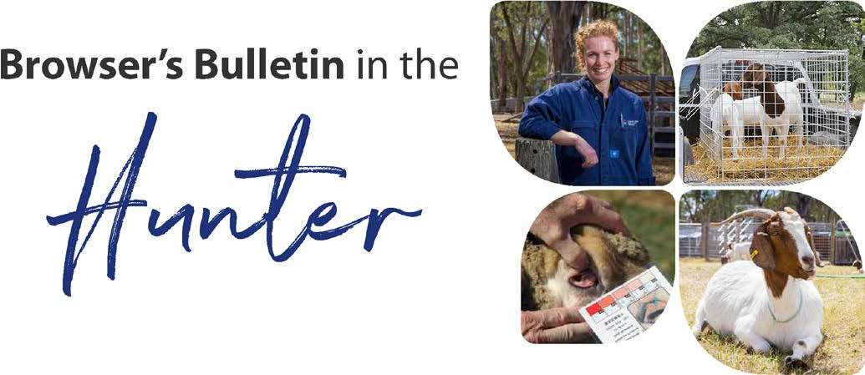
Browser’s Bulletin 36: Joint ill (Infectious Polyarthritis) in Kids

Bacterial Polyarthritis predominantly occurs in kids less than 3 months of age. Kids will develop pain and swelling in more than one joint and they will develop varying degrees of lameness. Some kids with polyarthritis may have a minor limp but others may become non-weight bearing. Kids with polyarthritis may develop a temperature, become lethargic, unwell, anorexic and even death. The carpal (front leg knee joint), stifle (back knee joint) and hock joints are the most commonly affected but not exclusively. Any number of joints can be involved including joints in the vertebral canal which can lead to recumbancy and paralysis. Polyarthritis may coincide with concurrent or previous episodes of diarrhoea, pneumonia or naval abscess.

Infection usually occurs due to bacterial environmental contaminants entering through the umbilical cord (most commonly), cuts in the skin (abrasions and castrations), through the lining of the gut, respiratory tract or tonsil region. There are a large number of bacteria that can be involved and they produce a destructive inflammatory response.

Unfortunately response to treatment is usually unsuccessful. Treatment would involve culture and sensitivity of the joint fluid from the infected joint, appropriate antibiotics, anti-inflammatories and potentially flushing joints under a sterile surgical environment by a private practitioner. Therefore prevention of polyarthritis is paramount!

Preventative measures:

- Ensure that the kidding area is clean. Bacteria can survive in the environment for a long time, so if you have kidding pens ensure that the area is cleaned out thoroughly between kiddings.
- Treat the umbilical cord with Lugol’s iodine or an antibacterial spray as soon after birth as possible and check regularly for signs of inflammation or infection. If there is any noticeable reddening or swelling then antibiotics may need to be used to prevent the infection spreading to the joints.
- It is also very important that kids have adequate colostrum within 6 hours of birth to provide them with an immune system that can fight off infections before they develop. If you have to provide the colostrum due to the kid not feeding from the doe (or snatched kids), then the kid will require 50ml/kg of colostrum within the first 6 hours (50ml/kg three times within the first 24 hours). Consuming colostrum is the single most important event in any kid’s life and failure to absorb adequate colostrum leads to high mortality rates in young kids. Colostrum has many functions including; laxative, nutritional and protective function.

If you have any further questions on polyarthritis in kids please send me an email on kylie.greentree@lls.nsw.gov.au

Failure of Colostrum Transfer to Newborn Kids

Maternal Factors:
- Short dry period
- Abortion/premature birth of kid
- Number of pregnancy doe has had
- Litter size (colostrum was all drunk by dominant kid)
- Shape of the Udder
- Poor mothering ability
Management Factors
- Milked before kidding
- Leakage of colostrum
- Overcrowding and inability of kid to get to doe
- Lack of supervision especially of first time does
- Failure to stomach tube when colostrum is not consumed by the kid within first 6 hours and intervention is required
Kid Factor
- Weak kid, can’t get to doe
- Anoxia, lack of oxygen during the birth process and potential damage to the brain
- Prematurity (possibly nutritional deficiency in the doe, bacterial, viral, protozoal infection)
- Too much competition for the teats

Colostrum
- Can be milked and stored for 12 months in freezer
- Allow frozen colostrum to thaw naturally
- Once colostrum has thawed naturally use straight away
- Can use cows colostrum
- Colostrum fed at 50ml/kg or until stomach feels full
- Stomach tubing may be necessary. The stomach tube must be able to reach the last rib.

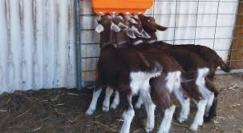
Goat Spam: Thought I would share this lovely Anglo Nubian with you, not related to the topics but just a pretty face I got to meet this week!!
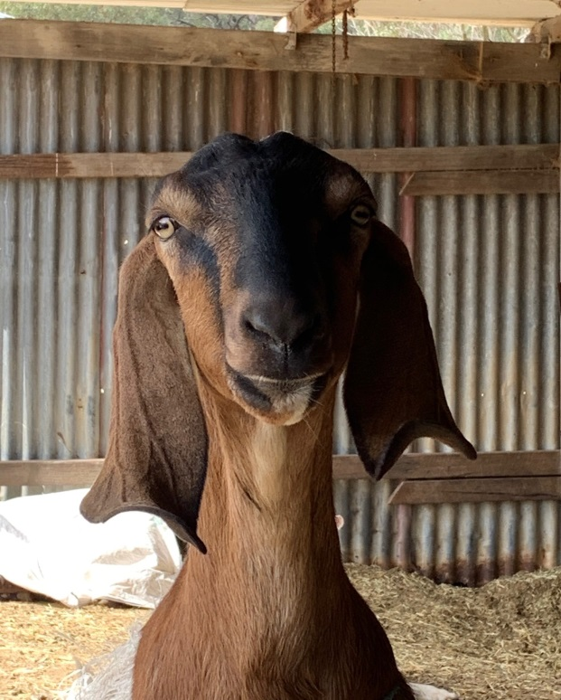

Reminder: FAMACHA Training Course at Tocal
l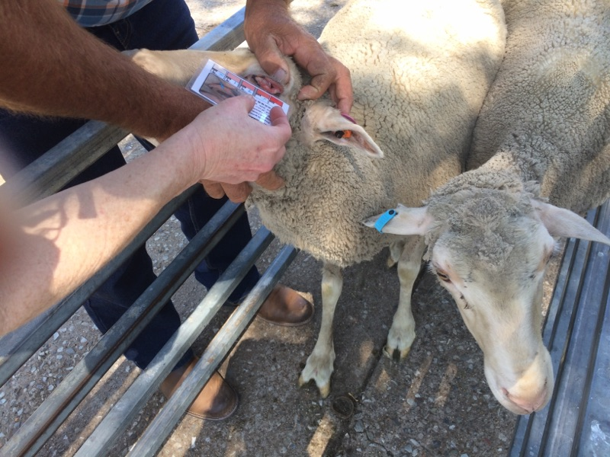
Date: 30/10/19
Time: 9am-12:30pm
Location: Tocal
RSVP: 49384900 or email kylie.greentree@lls.nsw.gov.au

PLACES ARE LIMITED!!

References:
Matthews, J. 2009. Diseases of the Goat (3rd edition)
Smith, M.& Sherman, D.A. 2009 Goat Medicine Second edition:

© State of New South Wales through Local Land Services 2019. The information contained in this publication is based on knowledge and understanding at the time of writing September 2019. However, because of advances in knowledge, users are reminded of the need to ensure that the information upon which they rely is up to date and to check the currency of the information with the appropriate officer of Local Land Services or the user’s independent adviser.
For updates go to www.lls.nsw.gov.au

