August 2019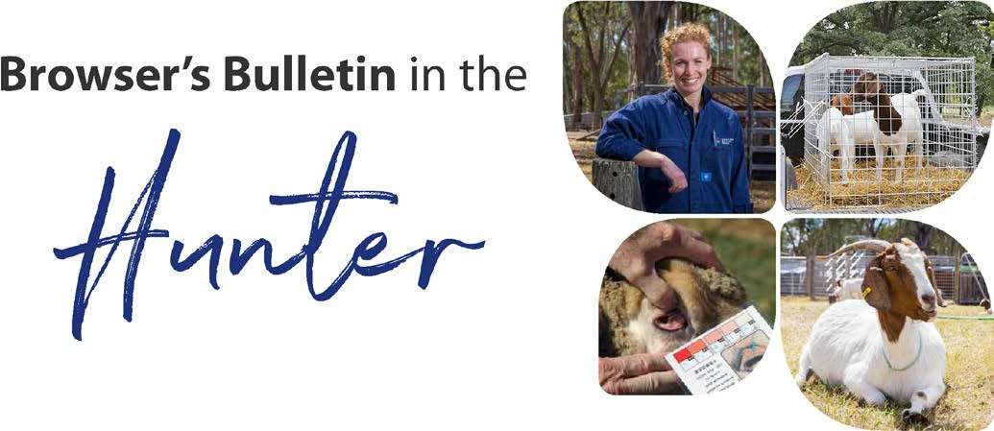
Browser’s Bulletin 35: Pestivirus in Small Ruminants; A rare occurrence but worth thinking about!

Pestivirus in cattle is one of the most economically important cattle pathogens worldwide, but did you know that it can also infect your sheep and goats? In cattle, Pestivirus causes reproductive issues such as conception failure, embryonic mortality, abortion and the birth of persistently infected animals that have a markedly reduced life expectancy.
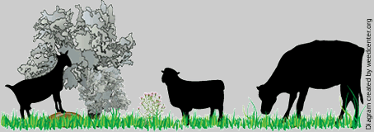

Pestivirus is also known as Bovine Viral Diarrhoea Virus (BVDV). Cattle are considered to be the natural host of BVDV, but this virus is capable of infecting other species. When a pregnant cow is infected with Pestivirus for the first time during the first 3-4 months of pregnancy and fetus survives, then the calf is likely to become what is known as a ‘persistently infected’ (PI) animal and will become a carrier of the virus for life. The calf in this early stage of gestation has not established its immune system enough to recognize the virus as something foreign and consequently the fetus accepts the virus as a normal part of itself and doesn’t produce antibodies against the virus.
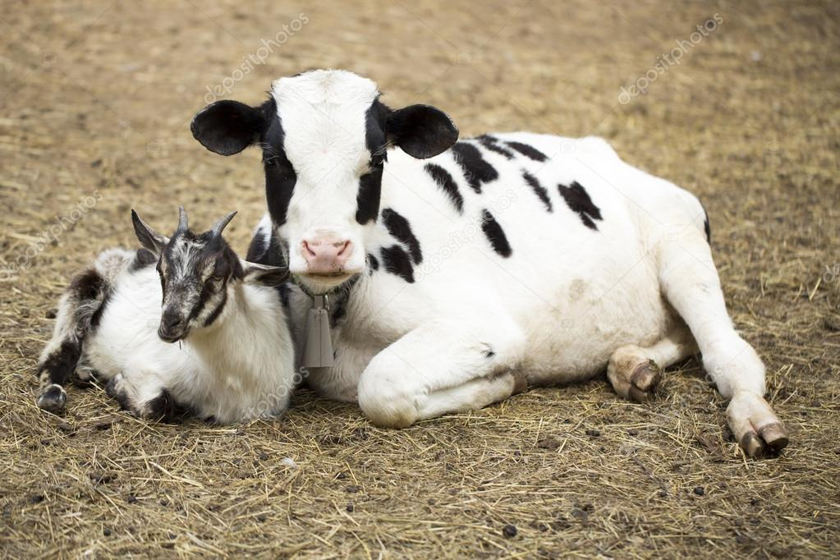
BVDV can also infect pigs, alpacas, sheep, goats and deer. Studies have been done where pregnant ewes were inoculated with BVDV at different stages of gestation resulting in abortions and PI lambs. BVDV infections in pregnant goats usually results in abortion but several PI kids have also been detected over the years including a probable case in Australia in 1978. Just like the case of a PI calf, the PI kid will constantly shed the BVD Virus and potentially cause reproductive issues within your herd.

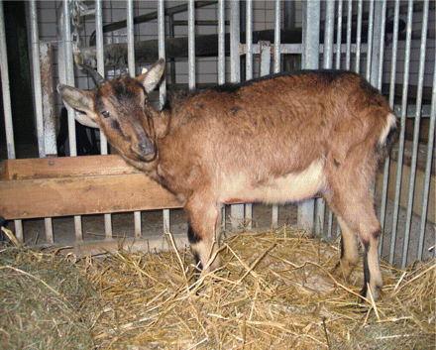
Transmission of BVDV is via direct contact with a carrier animal (usually cattle). Pestivirus is shed in all body secretions of a carrier animal: saliva, tears, nasal discharges, milk, urine, semen and dung. So as you could imagine, if you have your pregnant goat co-grazing with a PI calf, you could have reproductive issues on your hands.

The goat in the picture originated from a mixed flock of goats and cows in Austria. A few years prior to detecting this PI goat they had culled 4 BVDV calves. This goat was reasonably healthy except for poor weight gain but at around 12 months of age it started to lose condition despite having a good appetite, became anaemic, laboured breathing, dull coat and susceptible to infection and parasites. Despite veterinary treatment it died after a short period of illthrift.

Obviously Pestivirus is incredibly rare in Australian goats but it is not rare in cattle. I think it is certainly a differential that needs to be considered as a possible diagnosis when you have goats with reproductive issues such as early term abortion and return to service and kids with poor viability that are co-grazing with cattle.

If you have any further questions about pestivirus in goats please send me an email at kylie.greentree@lls.nsw.gov.au.

References:
- Bovine Pestivirus infection DPI Primefact https://www.dpi.nsw.gov.au/__data/assets/pdf_file/0015/226041/Bovine-pestivirus-infection.pdf
- Ruminant Pestivirus Infections PD Kirkland and SG MacKintosh Elizabeth Macarthur Agricultural Institute PMB 8 Camden, NSW 2570 Australia peter.kirkland@dpi.nsw.gov.au
http://www.agriculture.gov.au/SiteCollectionDocuments/animal/ahl/ANZSDP-Pestiviruses.pdf
- Descriptive study of a pestivirus infection in an Austrian goat. https://veterinaryrecord.bmj.com/content/163/6/192
- Transmission of Bovine Viral Diarrhea Virus to Adult Goats from Persistently Infected Cattle, 2007.
Journal of Veterinary Diagnostic Investigations
https://journals.sagepub.com/doi/full/10.1177/104063870701900514
- Fraser, G.C, Littlejohn, I.R, Moyle, A. THE ISOLATION OF A PROBABLE PESTIVIRUS FROM A GOAT, AVJ

© State of New South Wales through Local Land Services 2019. The information contained in this publication is based on knowledge and understanding at the time of writing September 2019. However, because of advances in knowledge, users are reminded of the need to ensure that the information upon which they rely is up to date and to check the currency of the information with the appropriate officer of Local Land Services or the user’s independent adviser.
For updates go to www.lls.nsw.gov.au

