Browser’s Bulletin 34: Opening a Can of Worms
Are Tapeworms in goats a problem or not?

Have you ever noticed creamy white rice grain-like segments in the dung of your young sheep and goats? This is most likely Tapeworms (Moniezia) (Photo below). There is a lot of controversy around the clinical effects and economic impacts of tapeworms on small ruminants and it is important to understand how they can lead to ill-thrift in your livestock.
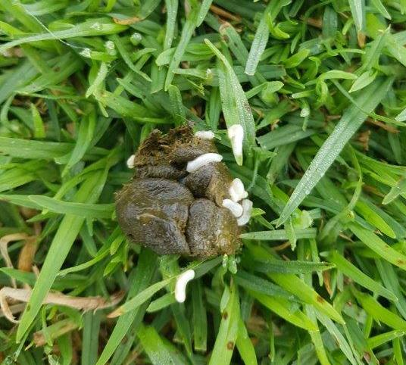
Figure 1: Tapeworm proglottids segments in faeces
These rice looking segments (Proglottids) that you see occasionally in goat’s faeces are small sections of the tapeworm that are released by the adult worm and are packed full of eggs. Once the proglottids are released in the faeces, the outer casing disintegrates and an intermediate host (Oribatid mite) ingests the eggs. These mites live in soil and on herbage; hundreds of thousands of these mites can live on one square meter of soil. The tapeworm larval stage develops within the mite over a four month period until they are consumed by ruminants while they feed. Once the mite is ingested, the tapeworm larvae are released into the small intestine of the ruminant and here they develop into an adult tapeworm. Once ingested by the ruminant it takes 6-7 weeks to become an adult tapeworm.

Adult tapeworms do not feed destructively with active mouth parts on the lining of the small intestine but rather absorb nutrients from the intestine through their outer skin (integument), competing significantly for nutrients that the growing kid requires. The mouth parts of the adult tapeworm have spiny hooks or suckers which allow them to attach to the wall of the intestine and the rest of the tapeworm is made up of a chain of flat segments. A decrease in available nutrient will not only affect the kid’s growth rate but also their immune system. Growing kids may appear lethargic, signs of colic, pot-bellied due do distended intestinal loops and a slow transit time of the ingesta travelling through the gut which make them more susceptible to conditions such as Pulpy Kidney (Enterotoxaemia). A Massive tapeworm infestation can even cause a partial or complete blockage in the gut and these goats can appear constipated and die.

As the animals age they build a natural resistance to the tapeworms and consequently the tapeworm burdens are less severe in the adult small ruminant. Clinical disease is usually seen in the kids less than six months of age.

Diagnosis is usually on detection of proglottids segments in the faeces and clinical signs. Also a faecal floatation can be done to demonstrate the tapeworm eggs. If the animal has died a post mortem will demonstrate strikingly large adult worms in the small intestine or free in the abdominal cavity when rupture of the intestine has occurred. These worms can be several meters in length.
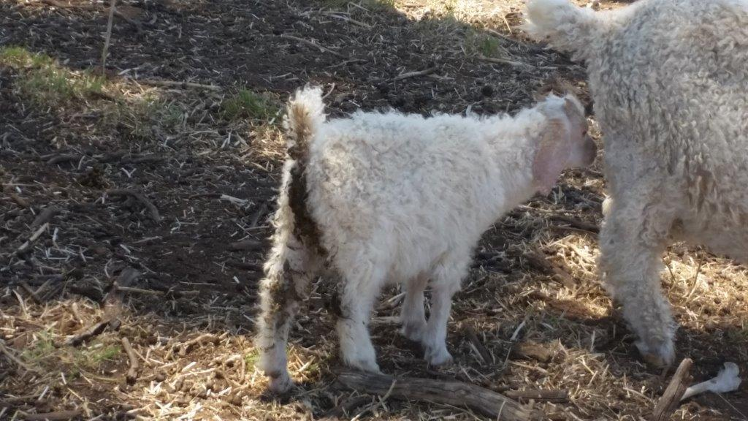
Figure 2: Scouring, ill thrifty kid from tapeworms

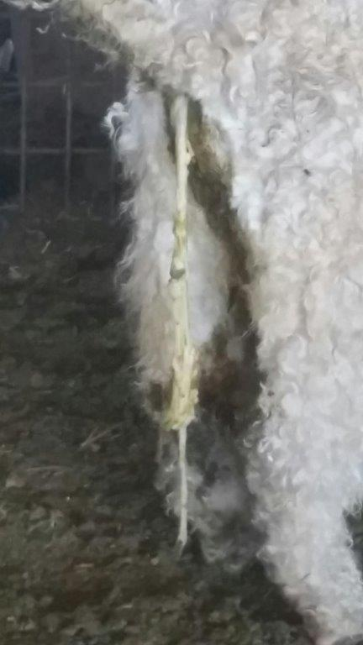
There are many studies out there that claim that there are no production benefits in treating for tapeworm. If treating sheep or goats for tapeworm infestations, the drug of choice is Praziquantel. Benzimidazole anthelmintics (Albendazole) also aids in removal of tapeworm segments but will not kill the head of the worm. If you are using Albendazole (BZ White drench which is registered in goats) then you also need to be aware of worm resistance to this chemical on your property. Praziquantel is not a registered chemical in goats in Australia, so to use the chemical it is important to get a prescription from your veterinarian which will show the recommended dose rates and withholding period. Praziquantel comes in a combined drench with other broad spectrum drench families, so once again ensure this other drench family (usually a Mectin drench) is effective against intestinal worms on your property otherwise you are going to develop further resistance in intestinal worms.
Figure 3: Meters of Tapeworm

If you have a read of the following wormboss link it has the opinion from a number of veterinary parasitologists about the lack of evidence and benefits of treating for tapeworms in lambs with the overall concern about producers forgetting the effects of the other gastrointestinal worms which can be more lethal in your herd/flock (barber’s pole worm).
http://www.wormboss.com.au/news/articles/worms-and-other-parasites/what-about-tapeworms-in-sheep.php

I have been fortunate enough to work alongside an experience Angora goat producer in the Hunter who has noticed significant improvement in his kids when treating for tapeworm (photos supplied by local producer). Prior to treatment for tapeworm he has noticed poor growth rates, weight loss, pot bellies, colic signs, constipation, ill-thrift and deaths. On treatment he has seen massive amount of flat, ribbon-shaped worms expelled in the kid’s faeces (see photo 3).Our plan within the next kid growing season is to do a comparative tapeworm drench response trial, looking at weight gains, effect on mohair production and mohair quality. Watch this space!
If you have any further questions about tapeworms in goats please send me an email at kylie.greentree@lls.nsw.gov.au.

References:
http://www.wormboss.com.au/worms/tapeworms/intestinal-tapeworm.php
https://www.dpi.nsw.gov.au/__data/assets/pdf_file/0017/721700/Managing-worms-in-goats-in-NSW.pdf
https://www.wormx.info/tapeworms
Goat Medicine Second edition: Smith, M.& Sherman, D.A. 2009
Sheep and Goat Medicine Second Edition, Pugh D.G & Baird, A.N, 2012

© State of New South Wales through Local Land Services 2019. The information contained in this publication is based on knowledge and understanding at the time of writing July 2019. However, because of advances in knowledge, users are reminded of the need to ensure that the information upon which they rely is up to date and to check the currency of the information with the appropriate officer of Local Land Services or the user’s independent adviser.
For updates go to www.lls.nsw.gov.au

