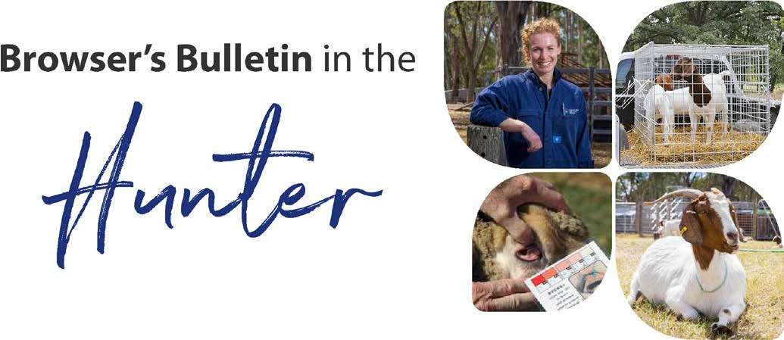
February 2020

Browser’s Bulletin 41:

Female Infertility

The breeding season of goats is largely in response to a decreasing day length. This can also depend on temperature, the nutritional environment and the presence of males. Decreasing day length will also stimulate reproductive activity in the buck. Some breeds have a longer breeding season, including the miniature breeds and Anglo-Nubians.
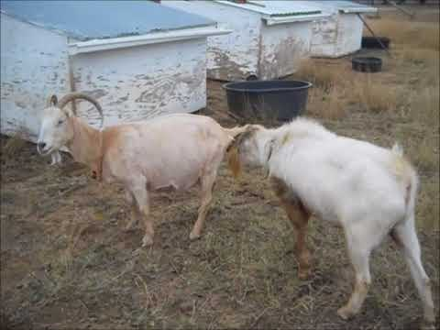

I have recently been asked a great question of when you can start breeding goats, at what age and weight? Male kids will start to become reproductively active at around 4-6 months, so it is important to remember to separate males and females from 4 months of age. The females start to come into season from 7-18 month of age. First mating can occur when the doe is 60-70% of the predicted adult weight if there is enough nutrition to support the continued growth of the goat and the developing pregnancy.

Female goats are seasonally polyoestrus. This means that as the day length gets shorter (February-June) they start to cycle roughly every 21 days. The duration of oestrus lasts 24-96 hours and ovulation usually occurs approximately 24 hours after the start of the oestrus cycle. For the remainder of the year goats will not cycle but some of the miniature breeds can cycle all year round.

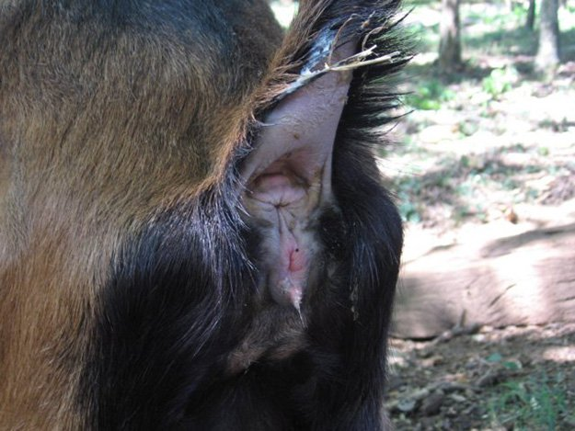
Oestrus detection can be difficult with some breeds of goat as they will only show minor behavioural changes. Typical behavior of oestrus does include tail wagging, frequent bleating, urination near the buck, swelling of the vulva and a mucus vaginal discharge.

Sometimes you are presented with female infertility and an investigation is required.

Investigation:
- Is it a herd or an individual issue?
- The overall health and body condition of the doe/s/herd? Are there any other intercurrent diseases such as high worm burden?
- Nutritional status; What are they being fed including mineral supplements, energy and protein deficiency, mineral deficiency
- Is the buck running with the does? AI, mating technique, male infertility
- Stress and overcrowding, recent grouping of goats can cause major stress in goats
- Poor heat detection
- Service at the incorrect time (Have you been trying to mate goats out of season?)

Assessment of an Individual Doe with Infertility

The individual doe is clinically examined, looking at body conformation checking for any abnormality that could hinder mating, dentition, body condition and any other obvious issues. One of the major causes of infertility is being overfed and overweight which we see a lot in our pet goats.

An individual doe infertility should fit into one of the below 4 categories

- Doe is failing to stand at mating; doe may not be in season, scared (common with maiden does), vaginal constriction which causes discomfort or a persistent hymen. The doe may have had a difficult kidding last time, and this has caused constrictions and adhesions.

- Doe is not Cycling (Anoestrus); out of season, she is pregnant (this happens more than you think!), poor heat detection, malnutrition, has recently kidded, lactation anoestrus (usually seen in high producing dairy does), surgical adhesions, hydrometra (false pregnancy), intersex (pseudo hermaphrodite), Freemartin and ovarian inactivity.

- Doe is cycling regularly; male infertility, service at the wrong time, delayed ovulation, large milk producers, a reproductive tract infection (uterus or vagina) or sometimes they have oestrus during their pregnancy

- Irregular oestrus

- Long oestrus cycle; embryonic death, silent oestrus, persistent corpus luteum which supplies a hormone that makes the body think it is pregnant
- Short Oestrus Cycle; The start and the end of the season, normal in kids that just start to cycle, prostaglandins (hormonal medications), stress, ovarian cysts, metritis and mummified kids.

So as you can see, female infertility is a very complex issue and as the joining season is upon us now I thought I would give you a list of potential problems that you may come across, giving you some tools to assist with your infertility investigation.

Prior to any breeding season, I would recommend a routine examination of the breeding herd to ensure there isn’t any issue before you begin. Any animals that are not sound should be either treated or culled from the breeding herd to decrease the chance of infertility issues.

We have had drought condition over the last few years which have certainly affected the reproductive performance in livestock across NSW. There are a number of areas in the Hunter region that have had recent rains and we have had some lovely green growth but this brings about a change in diet that can cause an imbalance of the gut bacteria and increase the chance of Pulpy kidney or Enterotoxaemia.

I would highly recommend that you vaccinate your stock with a multivalent Clostridial vaccination that protects against the bacteria Clostridium perfringens type D (Pulpy Kidney) and Tetanus (5-in-1 , 2-in-1, 3-in-1) and other clostridial diseases. The persistence of the response to vaccination is shorter in duration in goats than sheep, so it is necessary to shorten the interval between the booster vaccinations to every 3-6 months, or even more frequently with any change in their diet.

If you have other questions and concerns about infertility in your herd please send me an email on kylie.greentree@lls.nsw.gov.au

References:
- Matthews, J; 2009. Diseases of the Goat

© State of New South Wales through Local Land Services 2019. The information contained in this publication is based on knowledge and understanding at the time of writing November 2019. However, because of advances in knowledge, users are reminded of the need to ensure that the information upon which they rely is up to date and to check the currency of the information with the appropriate officer of Local Land Services or the user’s independent adviser. For updates go to www.lls.nsw.gov.au

