Hunter Local Land Services
June 2019
Browser’s Bulletin 33
BioWorma Trial in the Hunter
Kylie Greentree (District Veterinarian, Hunter LLS) and Anne Jones (CSU Final Year Student)
Resistance to chemical anthelmintics is a significant and growing concern for livestock producers in Australia, with massive implications for livestock growth, fertility and welfare. The major gastrointestinal nematodes that infect sheep are also seen in goats, namely barber’s pole worm (Haemonchus contortus), black scour worm (Trichostrongylus spp.) and small brown stomach worm (Teladorsagia spp.). These worms are abundant in temperate coastal areas such as the Hunter, where warm winter temperature minima and high average annual rainfalls promote the pasture stages of the nematode life cycle.
Goat producers are already at a disadvantage as there are few chemical anthelmintics registered for goats, and they are often used at sheep label rates when goats need higher doses for effective treatment. Goat owners in the Hunter are usually small scale farmers and this poses additional challenges to worm control, which may include:
- High stocking densities
- Lack of opportunity to rotate and rest paddocks
- Lack of access to fresh pasture or browse
- Unwillingness to cull ill-thrifty animals due to their emotional value
- Mixture of animals with unknown health and/or NLIS status
Current best drenching practice recommends combining multiple active ingredients from different classes of drugs. This is difficult for hobby farmers who do not operate on a scale that justifies the purchase of multiple large drums of drench.

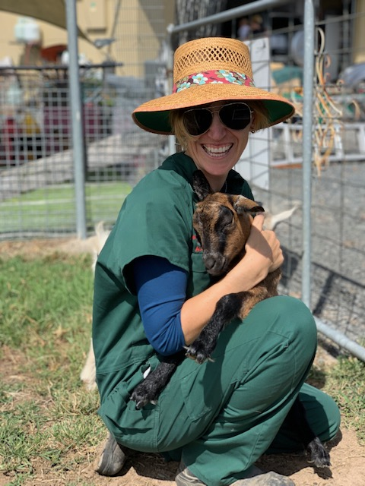
Miniature goats are charming and increasing in popularity with small scale producers. However, all goat breeds in the Hunter carry lots of resistant worms and GIT parasite control can be very challenging.
A new product called BioWorma has a promising new mode of action in the ever-evolving fight against worms. BioWorma is made by International Animal Health Products and is available on its own, or in combination with the vitamin and mineral supplement Livamol. It contains spores of the fungus Duddingtonia flagrans IAH1297 , which pass unchanged through the gut when given in a supplementary feed, hatch in the faeces and predate infective L3 nematode larvae. The fungus has reduced pasture larval counts, faecal egg counts (FECs), parasitosis rates and chemical anthelminthic use in many studies on cattle, sheep^{1,2}, goats and horses³ in Australia, North and South America, and Europe. However, it is expensive, requires daily supplementary feeding and most studies have used animals which are drenched and then placed into clean paddocks at the start of the trial^{1,2,3,4}. It is therefore difficult to determine whether the reported effect of D. flagrans is additional to, or simply because of, the concurrent implementation of other parasite controls.
We are interested in seeing whether daily feeding of BioWorma has any effect on FECs in an environment that more accurately represents Hunter goat farms. For example, pasture availability is very limited in the current drought and very few producers have uncontaminated paddocks or access to browse. In most cases goats are being supplementary fed in small paddocks close to the house or sheds, which also increases worm burdens in these high activity areas.
Aim
To determine whether there is a significant difference in the worm burden of miniature goats (n=5) given a daily supplement of Livamol + BioWorma compared to miniature goats (n=5) given a daily supplement of Livamol alone.
Methods
The trial site is a private farm located near Dungog, NSW. There are 40 miniature goats on the property. The goats have a fairly even BCS at 3-3.5/5. All are supplementary fed with lucerne chaff plus a sunflower seed, dairy mix and 16% protein pellet once a day, with ad lib access to lucerne and millet hay. A molasses-based multivitamin mineral supplement (TNN mineral pulse) is given monthly. This feeding regime will continue unchanged throughout the trial. The owners rotate their paddocks with a 3 month spell phase in winter. Welfare and preventative health care are of a high standard with no known disease outbreaks or prior problems. The goats were last vaccinated with Glanvac 6 in October 2018. Chemical drenching is sporadic – the owners use FAMACHA scoring to evaluate their herd (fig. 1) and have not drenched for at least 2yrs.
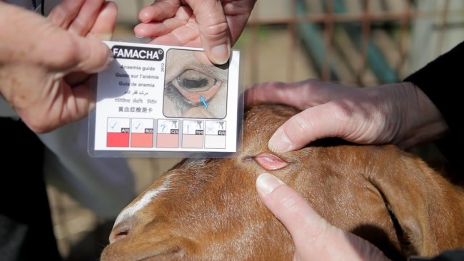
Fig. 1: FAMACHA colour chart using inner eyelid colouring to check for parasitic anaemia.
The control and treatment group have been assigned to an 840m² and 1,400m² paddock, respectively. They have similar topography, approximately 1200kg dry matter/Ha ground cover, and 10% shade cover. There is no free groundwater in either paddock. The only pasture species present is Kikuyu grass. There is clean water and similar feeding systems in each paddock. At least 30cm² trough size per goat are available in each paddock to minimise competition at feeding. There are wooden cubby houses and inverted fiberglass pools in each paddock to provide strata and environmental enrichment for the goats.
The paddocks have been rested for 3 months and the goats added two weeks before starting the supplement, to create an equivalent level of pasture contamination. Each goat is female and between 6-24mo. FECs and FAMACHA scores were taken two weeks before starting the supplement. Any goat with both a FEC ≥ 0epg and a FAMACHA ≥ 3 were drenched with Q drench before starting the trial except Moana who was early pregnant and they used Panacur 25 (Dose rate). Q drench contains levamisole hydrochloride 40g/L, Closantel 37.5g/L, Albendazole 25g/L and Abamectin 1g/L and Panacur 25 contains 25g/L Fenbendazole. Blossom in the treatment group became pregnant during the trial via their AI program.
The recommended dose rate of 30,000 spores/kg BW will be fed, which equals 1g/kg/day, added to their normal feed. BW, FEC and FAMACHA were supposed to be taken each month. Daily temperature and rainfall was recorded. The trial was supposed to run for 6 months or until it becomes too cold for H. contortus egg hatching.
Results: Table 1
Paddock 1 – Control (Livamol) | March
Goat ID |  |  |  |  | 10/3/2019
 | FAMACHA | FEC | BW (Kg) | Drenched | Add Livamol
1 Gracie (white) | 2 | 200 | 12.7
2 Glitter girl (black and white stripes) | 3 | 1120 | 14.6
3 Jess (brown frosted ears) | 4 | 0 | 9.9
4 Moana (pregnant) | 3 | 200 | 26.5
5 Muffin (pygmy, no star) | 3 | 640 | 14.7
Average Paddock weight= 15.68 100g Livamol/paddock |  | Average FEC= 432epg
Paddock 2 – Treatment (Livamol+BioWorma) | FAMACHA | FEC | BW (Kg) | Drenched
Goat ID |  |  |  |  | Add Livamol + BioWorma
6 Blossom (brown, 2yo) | 2 | 680 | 22
7 Miley | 3 | 0 | 15.7
8 Popcorn | 4 | 360 | 13.2
9 Gertie (spots) | 2 | 0 | 12.3
10 Maisie | 4 | 40 | 11.9
Average Weight 15.02 100g BioWorma + Livamol/paddock |  | Average FEC= 216 epg

Table 2
Paddock 1 – Control (Livamol) | May
Goat ID |  |  | 6/05/2019
 | FAMACHA | FEC | BW (Kg) | Drenched
1 Gracie (white) | 4 | 1720 | 14.4
2 Glitter girl (black and white stripes) | 2 | 760 | 16.4
3 Jess (brown frosted ears) | 3 | 1000 | 13
4 Moana (pregnant) | 3 | 4320 | 31.6
5 Muffin (pygmy, no star) | 2 | 320 | 20.2
Average Paddock weight= 19.12kg  100g Livamol/paddock |  | Average FEC=1624epg
Paddock 2 - Treatment (Livamol+BioWorma)
Goat ID
6 Blossom (brown, 2yo) | 1 | 1400 | 23.9
7 Miley | 3 | 0 | 16.4
8 Popcorn | 2 | 440 | 16.1
9 Gertie (spots) | 2 | 520 | 15.2
10 Maisie | 5 | 2640 | 13.5
Average Weight= 16.98  100g BioWorma + Livamol/paddock |  | Average FEC= 1000epg

Table 3: Daily temperature and Rainfall Chart for the Dungog Area
 | March Temp  (degrees C) | March Rainfall (mm) | April Temp  (degrees C) | April Rainfall  (mm) | May Temp  (degrees C) | May Rainfall  (mm)
1 | 31 |  | 23 |  | 25
2 | 30 |  | 24 |  | 26
3 | 32 |  | 24 |  | 26
4 | 34 |  | 23 |  | 26 | 21
5 | 21 |  | 23 |  | 21 | 8
6 | 30 |  | 29 | 12 | 20 | 2
7 | 33 | 9 | 31 |  | Trial Stopped
8 | 34 | 11 | 34
9 | 30 |  | 28
10 | 35 |  | 21
11 | 26 |  | 21
12 | 30 |  | 23
13 | 26 |  | 25
14 | 30 |  | 24 | 14
15 | 26 | 13 | 27
16 | 25 | 20 | 25
17 | 25 | 13 | 24
18 | 25 | 4 | 27
19 | 27 |  | 25
20 | 27 |  | 25
21 | 28 |  | 27
22 | 30 |  | 26
23 | 31 | 5 | 26
24 | 37 | 8 | 27
25 | 32 |  | 26
26 | 28 |  | 25
27 | 27 |  | 26
28 | 28 |  | 27
29 | 30 |  | 27
30 | 27 |  | 27
31 | 23 |  | 24
Total | Average= 29C | 83mm | Average= 26C | 26mm | Average= 24C | 31mm

The larval differentiation on May 6th 2019 across both groups
29 % Haemonchus contortus= barber's pole worm
49% Trichostrongylus= black scour worm
20% Ostertagia= brown stomach worm
4% Oesophagostomum= Large intestinal worm

Discussion
The BioWorma Feeding Trial on goats in the Hunter was stopped after 2 months due to rising Faecal Egg Counts and FAMACHA Scores. This property rarely had internal parasite issues prior to this trial and has a very good integrated worm management program in place which means they rarely require anthelmintics on the property.
We set up two very similar paddocks with similar ground cover, shade, grass species and similar age and weight of goats. A ‘Control’ group and a ‘Treatment’ group were set up.
There were a few areas that could have contributed to the result not going as well as we had hoped or as well as previous studies have shown:
- The paddocks had been spelled for 3 months prior to the trial but the groups were put into the paddocks before the trial started enabling paddock contamination. The average FEC of the goats prior to drenching was (432epg Control, 216epg Treatment). We thought that the level of contamination was reasonably low, and in general much better than the average contamination on small Hunter land holdings with small ruminants. Our opinion at the time was that this was a more accurate level of contamination of what producers in the Hunter would be starting with if they incorporated BioWorma into their property worm management program.
- Goats were drenched but a follow up FEC was not done to check the effectiveness of the drenches used.
- April FEC and FAMACHA were missed due to life getting in the way, shows and Easter holidays so we have missed a set of results there.
- BioWorma seemed to settle out on the bottom of the feeders and some got left behind. How much are they getting? The BioWorma was mixed well in to the feed daily.
- Did we have a large enough sample size? A small clinical trial is useful with conditions that have little variability but as we know, internal parasites in small ruminants are a complex disease syndrome with highly variable outcomes.
- Variation in goats resilience and resistance to internal parasites
- Natural season change in eggs in manure in the region
- Only one goat had soft faeces, otherwise the goats were not showing clinical signs except deterioration in the FAMACHA Scores.

Ideal Environmental Conditions for Internal Parasites

- Barber’s pole worm eggs live for 5 days, need a minimum temperature of >10C overnight and >16-18 during the day with the ideal temperature range 25-30 and >10-15mm/week of moisture

- Black scour worm eggs live for 16 days, require a minimum overnight temperature of >5C (T. colubriformis) (>2C in T. vitrines) and >15C in the day, with the ideal temperature range 25-28 and >10mm of moisture/week

- Small brown stomach worm eggs can survive over the winter, need a minimum overnight temperature of >4C with the ideal temperature range 13-21C and the moisture is often enough in the faeces alone.
Given the temperature and rainfall recorded on the property (Table 3) we can see that conditions were certainly ideal for the development of Trichostrongylus sp and Haemonchus contortus.

Both the Control and Treatment group’s average FECs had increased by approximately 400% to a level that is considered dangerous to the health and wellbeing of these animals over a 2 month period and consequently the Trial was stopped.
Conclusion

After 2 months of feeding BioWorma+ Livamol to miniature goats in a clinical trial and comparing the FECs of miniature goats being fed Livamol only, we had to stop the trial due to high FECs in both groups that could be detrimental to the health of the goats.
As discussed earlier, there are a number of limitations in doing a small clinical trial with a complex disease so how do we interpret these set of results?
Our results show a very poor response to the BioWorma in goat feed and I would be very cautious in recommending BioWorma on its own for integrated worm management on a small holding. The results certainly have limitations as previously discussed but we have not shown any positive benefits in this small scale trial.

References
Waller, P. J., Ljungström, B. L., Schwan, O., Martin, L. R., Morrison, D. A., & Rydzik, A. (2006). Biological control of sheep parasites using Duddingtonia flagrans: trials on commercial farms in Sweden. Acta veterinaria Scandinavica, 47(1), 23-32.
Pena, Maria & Miller, J.E. & E Fontenot, M & Gillespie, A & Larsen, Maiya. (2002). Evaluation of Duddingtonia flagrans in reducing infective larvae of Haemonchus contortus in feces of sheep. Veterinary parasitology. 103. 259-65. 10.1016/S0304-4017(01)00593-3.
Buzatti, A., de Paula Santos, C., Fernandes, M. A. M., Yoshitani, U. Y., Sprenger, L. K., dos Santos, C. D., & Molento, M. B. (2015). Duddingtonia flagrans in the control of gastrointestinal nematodes of horses. Experimental parasitology, 159, 1-4.
Kahn, L., Norman, T. M., Walkden-Brown, S., Crampton, A., & O'Conner, L. (2007). Trapping efficacy of Duddingtonia flagrans against Haemonchus contortus at temperatures existing at lambing in Australia. Veterinary Parasitology, 146(1-2), 83-89. https://doi.org/10.1016/j.vetpar.2007.02.004
https://www.farmhealthonline.com/disease-management/cattle-diseases/parasitic-gastroenteritis-in-ruminants/

© State of New South Wales through Local Land Services 2019. The information contained in this publication is based on knowledge and understanding at the time of writing June 2019. However, because of advances in knowledge, users are reminded of the need to ensure that the information upon which they rely is up to date and to check the currency of the information with the appropriate officer of Local Land Services or the user’s independent adviser.
For updates go to www.lls.nsw.gov.au

