Factors that affect parasite infection in Livestock
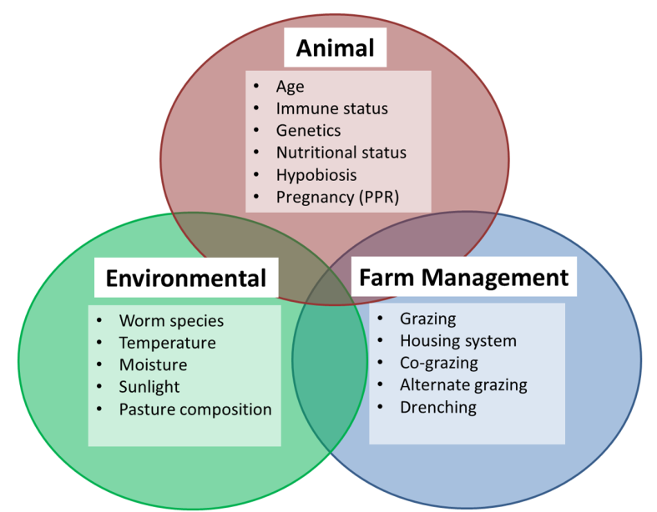
Development of parasites (worm) within the host and through the life-cycle stages depends on a number of factors that are listed in the diagram on the right. This Browser’s Bulletin will discuss the environmental factors that influence the lifecycle of the worm, enabling you to be aware of high risk periods and/or develop strategies to assist with minimal exposure to the parasites.

Worm Lifecycle and Environmental Factors that affect Worm Survival
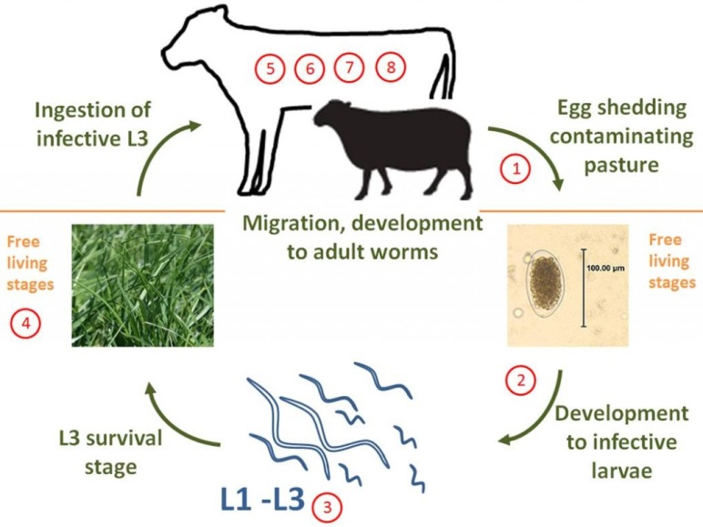
- Egg passed in the animals faeces
- Egg develops into the first larval stage (L1)
- L1 moults to L2 then again to L3. The L3 stage migrates out of the faeces and onto the pasture
- L3 stage is the infective larval stage. It migrates up and down the pasture depending on the temperature and the moisture in the environment
- L3 is consumed by the ruminant and develop into L4-L5 before emerging as a mature adult. The male and female worms reproduce and the female starts producing eggs which are once again passed in the faeces. Amazingly, the barber’s pole worm and the small brown stomach worm can go into the lining of the abomasum (4th stomach) into a state of arrested development if the environmental conditions are not ideal outside for the survival and development of their eggs and larval stages. For example when the temperatures are too cold, too hot or too dry.
Our seasonal patterns are continuously changing which makes predicting the time of year where we will have worm issues in our goats a little tricky and variable.
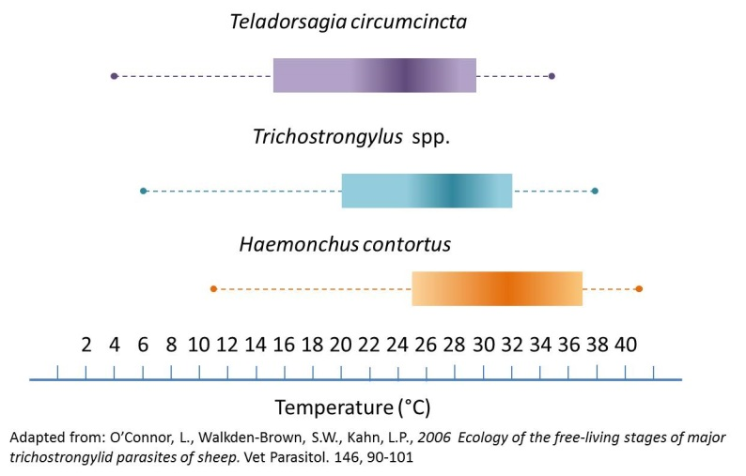
Climate influences development and survival of larvae on the pasture. The most important factors include daily temperatures, moisture and humidity. The below diagram demonstrates the ideal temperatures for the development of Teladorsagia circumcinta (small brown stomach worm), Trichostrongylus sp (black scour worm) and Haemonchus contortus (barber’s pole worm).
Extreme heat and cold temperatures are detrimental to the eggs and larval survival. Eggs of the barber’s pole worm will not develop into the L1 stage until the temperatures reach 8C and the egg can only survive for 5 days. That means that if the temperature is not within the ideal range during the 5 days then the egg will not develop into the L1. As the temperatures increase, the larval development accelerates and also increases the mortality rate of the L3 stage.
Moisture is also essential for the development from egg-L3 stage. Moisture can come in the form of humidity, rainfall, soil and dung moisture. This is why in arid climates they have less internal parasite issues in their stock.
Larvae generally survive much longer than worm eggs! The survivability of the Strongyle (round worm) worm eggs is variable depending on the species. For example the barber’s pole worm egg will not survive winter and will only survive 5 days while the small brown stomach worm egg can survive over the winter.
- Barber’s pole worm eggs live for 5 days, need a minimum temperature of >10C overnight and >16-18 during the day with the ideal temperature range 25-30 and >10-15mm/week of moisture

- Black scour worm eggs live for 16 days, require a minimum overnight temperature of >5C (T. colubriformis) (>2C in T. vitrines) and >15C in the day, with the ideal temperature range 25-28 and >10mm of moisture/week

- Small brown stomach worm eggs can survive over the winter, need a minimum overnight temperature of >4C with the ideal temperature range 13-21C and the moisture is often enough in the faeces alone.
It is important to understand what drives the parasites biology in order for you to put together a control strategy that does not rely totally on anthelmintic usage.
If you have any further questions with regards to the environmental factors that affect the lifecycle of internal parasites of goats please contact me at kylie.greentree@lls.nsw.gov.au
Reference:1) Parasitic Gastroenteritis in Ruminants;https://www.farmhealthonline.com/disease-management/cattle-diseases/parasitic-gastroenteritis-in-ruminants/
2) Managing Internal Parasites in Sheep and Goats. Hepworth, K. https://www.extension.purdue.edu/extmedia/as/as-573-w.pdf

