Hunter Local Land Services
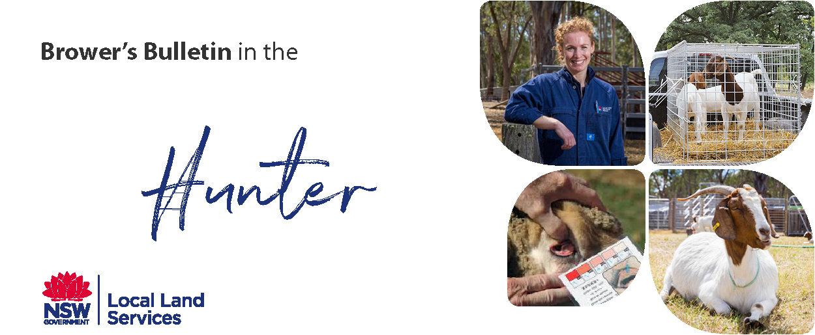
February 2019
Browser’s Bulletin 29: A Case of Pustular Dermatitis
I have had a recent case of Pustular Dermatitis caused by Staphylococcus aureus. Staph aureus is a common bacterium of the skin that can cause pustules of various sizes that most commonly break out on the udder, teats, groin and ventral abdomen. Pustules break open and spread, healing as a scabby hairless lesion that is generally non-painful or itchy to the goat. The bacterium can be spread between goats so separation of infected animals is advisable.
Often a Staphylococcal infection will occur secondarily to some other condition. These include lice, mites, fly worry or another underlying disease.
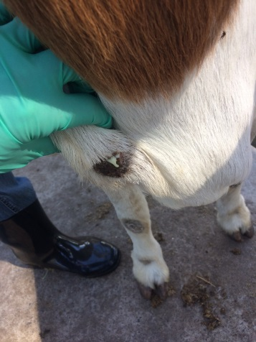
If lesions are small they can be treated with topical antiseptics, such as chlorhexidine or betadine but if the lesion become more extensive systemic antibiotics may be required based on a culture and sensitivity where ever possible. This will ensure that you are using the correct antibiotic that the bacterium is sensitive to.
Skin lesions may require further investigation if they are not improving with basic first aid.

Before contacting your veterinarian it is helpful to take note of a number clinical signs;
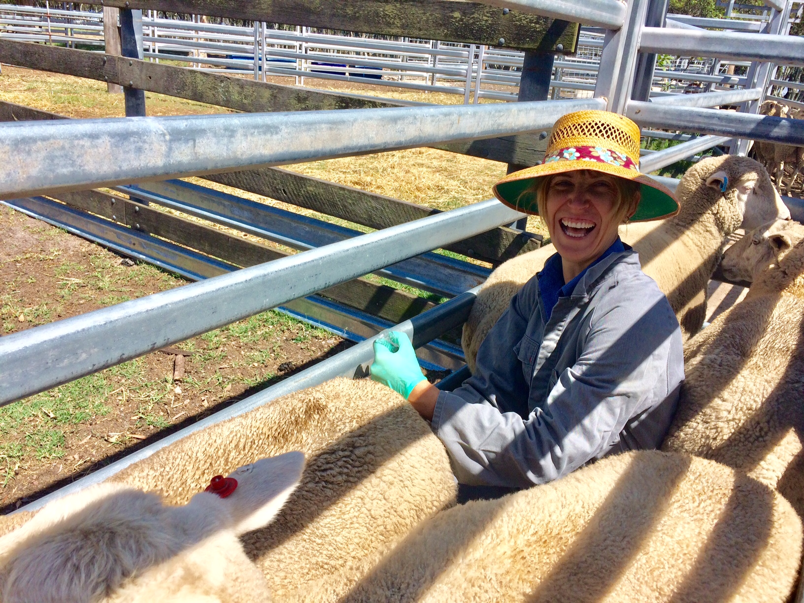Anne Jones (aka AJ) our CSU student got to experience all the wonderful goat breeds we have in the Hunter! We visited everything from Dairy goats, Boer goats, Angora goats and Miniature goats.

- How long have the lesions been present?
- Is it one animal or several in the herd?
- Where on the body are the lesions? Distribution?
- Is the goat itchy/ rubbing?
- What is the animal’s response to palpation of the lesion (with gloves)?
- What is the overall health of the goat/herd? Any other diseases in the herd, including worms?
- Is there hair loss on the lesion? Is the hair broken off mid shaft or falling out at the base (hair follicle bulb)?
- Have there been any new introductions to the herd?
- Can you describe what the lesion looks like? Pus, scaly, scabs, colour, smell, secretions, size and temperature.
If you have any further questions on this topic p[lease send me an email at kylie.greentree@lls.nsw.gov.au

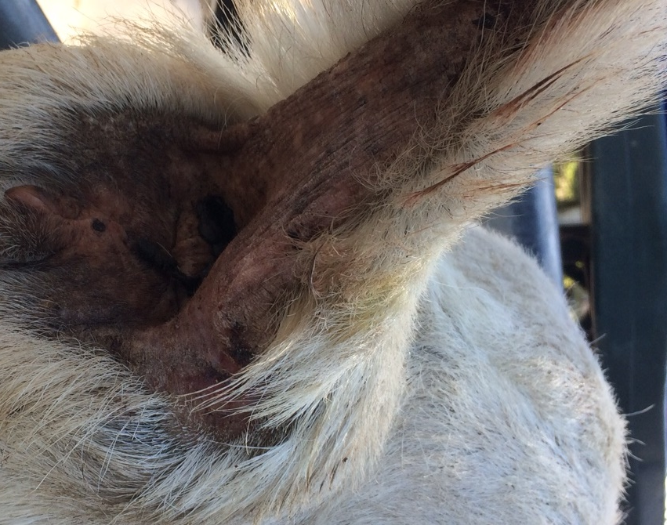
© State of New South Wales through Local Land Services 2019. The information contained in this publication is based on knowledge and understanding at the time of writing February 2019. However, because of advances in knowledge, users are reminded of the need to ensure that the information upon which they rely is up to date and to check the currency of the informationwith the appropriate officer of Local Land Services or the user’s independent adviser. For updates go to www.lls.nsw.gov.au

