Hunter Local Land Services
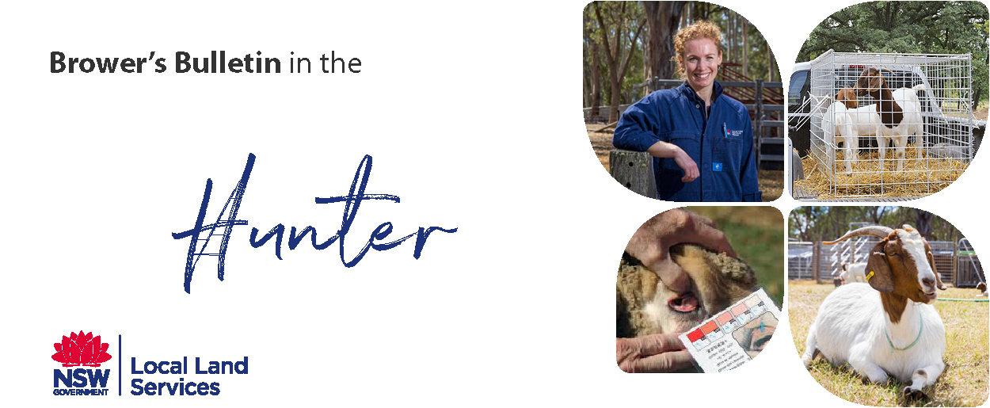
May 2019
Browser’s Bulletin 32: Footrot in the Hunter

A few weeks ago, I was on a property doing a piggery inspection and noticed several limping sheep and goats. After examination of the sheep’s feet, I was pretty convinced that we had footrot on this property.
Footrot is a contagious bacterial disease of both sheep and goats and is caused by a combination of two bacterium; Dichelobacter nodosus (introduced by carrier animals) and Fusobacterium necrophorum (common bacteria in the soil). The two bacteria work together to destroy the hoof and sole and cause extreme lameness. There are different strains of Dichelobacter nodosus, some strains causing mild lesions in the hoof (benign footrot) and other strains leading to much more severe damage (virulent footrot).
Diagnosis is usually based on a combination of clinical signs, herd history (introduced animals), environmental conditions and laboratory tests.
Footrot is a whole herd problem
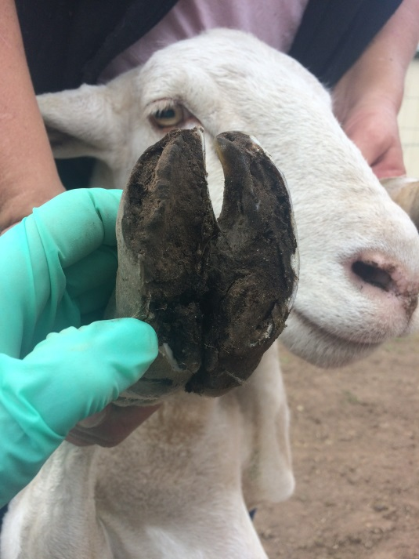
The lesions start in the interdigital space between the toes, where you would see reddening, hair loss and moisture. The soft inner horn of the hoof then becomes under-run, and the infection moves across the sole from the heel, extending to the outside hoof wall and progressing up to the toe. In severe footrot cases there will be extensive inflammation and under-running of the hard horn of the hoof. Footrot will usually affect more than one foot and often has a putrid smell.
Footrot can remain in the foot unnoticed for years, until the environmental conditions are ideal for expression of the disease. The ideal conditions are:
- Average daily temperature of 10C or higher for 4-5 days
- Adequate moisture in the environment
- Adequate pasture length
Footrot will not spread during hot dry weather condition

Virulent Footrot is a notifiable disease which requires a person to notify an authorised officer (e.g. District Vet LLS) under the Biosecurity Act 2015 after they suspect or become aware of footrot in sheep and goats. Regulatory action may result if virulent footrot is not promptly notified. Once footrot is diagnosed or suspected on a property, a District Veterinarian will develop an eradication program in order to clean up the property.
Footrot in goats behaves differently than in sheep. It is impossible to distinguish between the benign and virulent form of the disease. Goats are treated the same as sheep with footrot.

It is very important to ensure that any introduced sheep /goats come from a clean property and that the owners of the sheep/goats are willing to provide a signed National Sheep/Goat Health Statement before you take delivery of the animals.
. 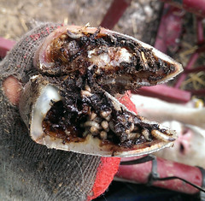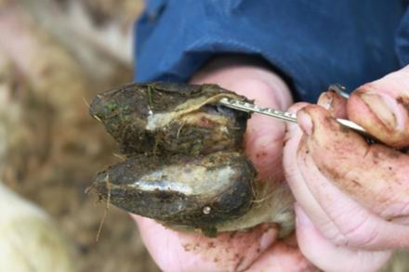
Ideally, go to the vendor’s property and have a look at their flock/herd to ensure there is no sign of illness/lameness and recheck on arrival. Quarantine any new animals, checking for any signs of illness. Maintain strict farm biosecurity, with well-maintained fences in order to prevent straying stock.

Under the Biosecurity Act 2015, everyone involved in the livestock industries must be aware of biosecurity risks for their industry and take all reasonable and practical measures to prevent and manage biosecurity risks. For example in the context of footrot, if someone is aware that their sheep may have footrot it is their biosecurity duty to notify an authorised officer of this notifiable disease and ensure that their high risk sheep cannot infect neighbouring sheep with well-maintained secure boundary fences.
All properties that are known to have virulent footrot are place under an Undertaking or Biosecurity Direction which prevents the movement of those animals off the property without a permit from an authorised officer.
I am telling you this story because many people are purchasing sheep and goats in the Hunter from a variety of sources such as; gumtree, word of mouth, buy swap sell and facebook. Often these sources are not selling animals in the correct way and you are putting your property and other animals at risk. All animals should be transported with a National Vendor Declaration or a Travelling Stock Statement, NLIS tag in their ear which should be transferred on the NLIS Database, everyone with livestock needs a Property Identification Code on their land which can be obtained from your Local Land Service Office and always ask for a National Health Declaration Certificate.
The last thing you want to do is purchase a few sheep or goats to eat your grass and weeds and end up with your property under quarantine.
If you have any further questions on this topic please contact me at kylie.greentree@lls.nsw.gov

References: https://www.dpi.nsw.gov.au/__data/assets/pdf_file/0015/102381/Primefact-1533-Footrot-in-Sheep-and-Goats.pdf
http://www.farmbiosecurity.com.au/wp-content/uploads/National-Sheep-Health-Declaration_fillable.pdf
http://www.farmbiosecurity.com.au/toolkit/declarations-and-statements/
© State of New South Wales through Local Land Services 2019. The information contained in this publication is based on knowledge and understanding at the time of writing May 2019. However, because of advances in knowledge, users are reminded of the need to ensure that the information upon which they rely is up to date and to check the currency of the information with the appropriate officer of Local Land Services or the user’s independent adviser.
For updates go to www.lls.nsw.gov.au

