Hunter Local Land Services
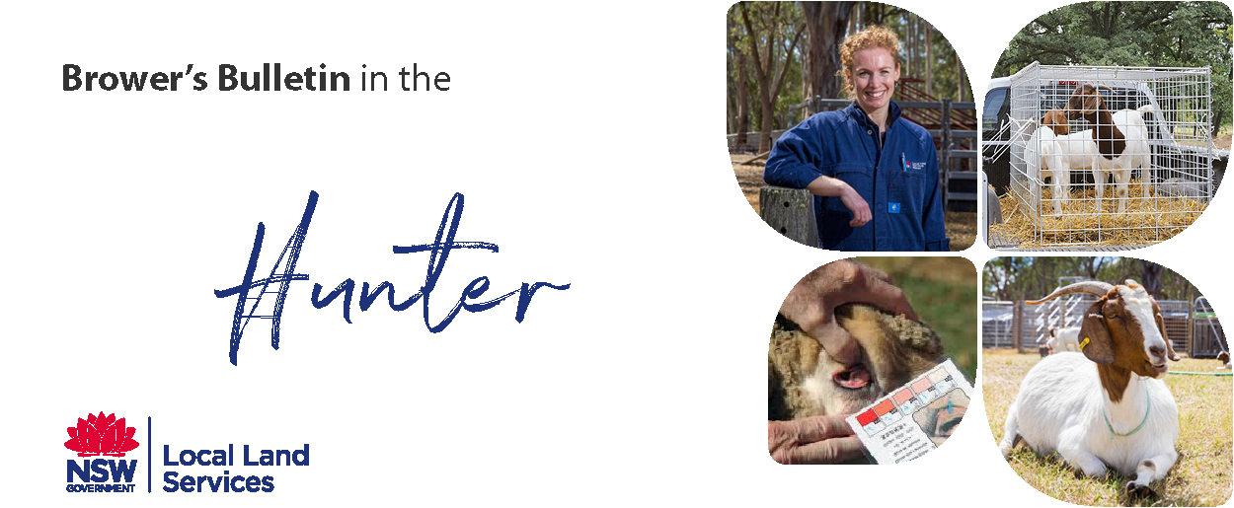
January 2019
Browser’s Bulletin 28: Disbudding Kids

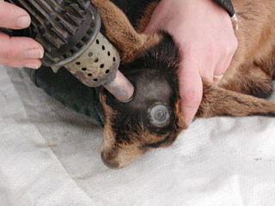
Disbudding in kids is only done when necessary and in a manner that minimises the risk to the welfare of the goats, particularly pain and distress 1. The current breed standard for all dairy breeds in Australia requires dairy goats to be polled or neatly disbudded to match the breed’s ideal.
Often within the dairy goat industry, kids are disbudded (removal of the horn buds before they grow into horns) to improve herd management and to reduce work health and safety risk to people and damage to other goats. Some breeders simply select for polled dairy goats but the poll condition is a dominant genetic trait that is linked to an intersex condition that leads to reproductive disorders. Moveable skin over the area where horns usually protrude indicates a natural hornless or polled condition 2.
It is important to ensure that the doe is vaccinated e.g. with Glanvac 3 (3-in-1)1 month prior to kidding to enable good passive transfer of antibodies to prevent such conditions as tetanus that could result after disbudding if the kid is not protected.
Kids need to be disbudded as soon as you can feel the horn buds. This can be anywhere between 3 -7 days. The buck kids have larger horn buds than the doe kids and therefore disbudding is usually required at day 3-5 where in doe kids it can be anywhere from day 3-7. Those kids that are very small at birth such as Nubians, pygmy and miniature goats can be delayed until 2 weeks with care 3.
It is recommended that you use you private practitioner to do the disbudding, as they are able to give a pain relief and a safe short acting anaesthetic to aid in a speedy recovery for the kid. A hot iron is used to burn the horn bud and the surrounding 1cm circle of skin in order to prevent regrowth and scurs. It is important to clip the hair from the bud area to aid in visibility of the area, decrease the burning time and limit the smoke inhalation.
There are a variety of hot irons used in disbudding. Electric dehorners (usually 2.5cm (doe) - 2.8cm (bucks) diameter tip) are convenient but you must ensure the iron is hot enough (cherry red) to destroy the skin rapidly. It is also important to check the wattage on the dehorner. The cheaper dehorners may have lower wattage and therefore are required to be held on for a longer time. Also a long extension cord could decrease the heat in the tip of the dehorner 3. The British Goat Veterinary Society recommends the use of a wide disbudding iron that is heated externally (blow torch/butane heated) until cherry red and not an electric disbudding iron so the time is minimised. It is heat, not pressure that is used to destroy the horn bud 2.
There is no exact fixed time that the iron is applied to the area; you need to ensure the full thickness of the skin has been destroyed (anything from 5-20 seconds to give a rough idea). This is the case when the skin has turned a copper colour and the colour cannot be scraped off with a finger nail and the entire horn bud must be within the final copper ring. If your initial burn is not adequate, allow that side of the head to cool down and the iron to reheat before reapplying the iron.
If the disbudding procedure is to be done under an anaesthetic, it is important to withhold milk for 2 hours prior to the procedure 2.
If you are performing disbudding at home it is important to appropriately restrain the kid in a cradle or box, and kids should be separated from their mothers for the shortest possible time 1.

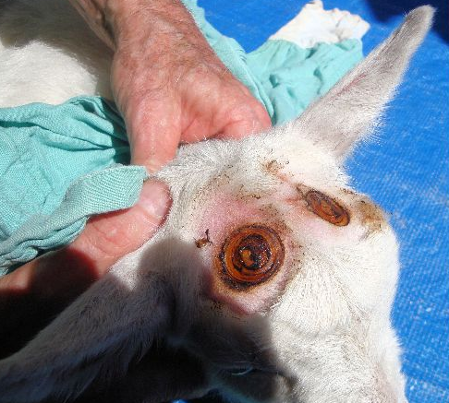
Common Mistakes:
- Iron not hot enough
- Leave kids until the horn buds are too big
- Not burning skin to a copper colour may lead to regrowth and scurs (a horn like stub)
- Leaving the iron on too long can lead to brain damage.
- Too much pressure! It is the heat that kills the skin and horn bud.

If you have any further questions on this topic please send me an email at kylie.greentree@lls.nsw.gov.au

References:
- Animal Health Australia: Australian Industry Welfare Standards and Guidelines for Goats http://www.animalwelfarestandards.net.au/files/2016/08/Standards-Guidelines-Goats_FA.pdf
- DPI Dairy Goats AgGuide page 29-37 Laffan, J. and Baxendell, S. Tocal 2018.
- Goat Medicine Second edition: Smith, M.& Sherman, D.A. 2009
- Sandra Baxendell: https://goatvetoz.com.au/services

© State of New South Wales through Local Land Services 2019. The information contained in this publication is based on knowledge and understanding at the time of writing January 2019. However, because of advances in knowledge, users are reminded of the need to ensure that the information upon which they rely is up to date and to check the currency of the information with the appropriate officer of Local Land Services or the user’s independent adviser.
For updates go to www.lls.nsw.gov.au

