Hunter Local Land Services
December 2018
Browser’s Bulletin 27: Toxoplasmosis in Goats
Toxoplasmosis is caused by the protozoal parasite, Toxoplasma gondii.
Cats are the definitive host of Toxoplasma parasite where the organisms multiplies and then eggs are passed in the faeces of the cat. Other animals, such as goats, sheep, cattle, birds and rodents act as an intermediate host where the organism undergoes an asexual stage of development. The intermediate species pick up the eggs in contaminated foodstuffs.
When a pregnant goat becomes infected with the Toxoplasma organism, the organism will travel to the placenta and cause a placentitis which can lead to resorption of the foetus, foetal death, mummified foetuses if infected in the early stage of pregnancy and abortions, stillbirths, weak kids if infected in the later part of pregnancy. If the doe becomes infected prior to mating then she will not abort. In general the doe will appear clinically normal at the time of abortion but very occasionally fatalities can occur in adult goats.
In the case of abortion from Toxoplasma organisms the cotyledons (areas of placental attachment) will show 1-3mm white-yellow spotted lesions which can be seen in the photo and sometimes there will be the presence of mummified foetuses.
Diagnosis is based on the clinical picture, placental and foetal pathology, presence of mummified foetuses and detection of antibodies in the foetus and maternal bloods.
The best way to prevent Toxoplasmosis creating havoc in your herd is to stop cats having access to feed stores. This includes grain, hay sheds and feed troughs. Also it is important to prevent cats breeding on your property. Cats will acquire immunity to reinfection and do not subsequently present a threat to livestock unless they become immunosuppressed which is why the young cats pose the greatest threat of spreading toxoplasma organisms around your property. Rodent and bird control will reduce the reservoir of infection which exists for susceptible cats. The Toxoplasma eggs can persist in the environment for over 12 months and are very resistant to most disinfectants. It is very important to destroy the products of abortion ASAP and it is essential that you always use personal protective equipment.
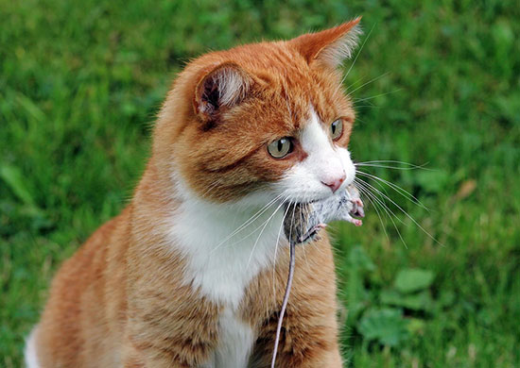
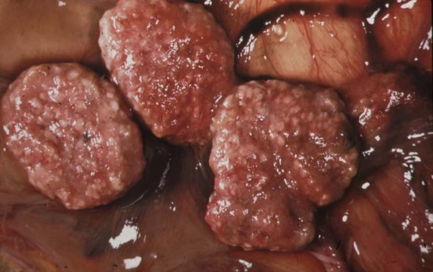
Toxoplasma organisms are passed in the milk of infected does and pose a risk to children and pregnant women who drink infected milk. The materials from abortion should never be handled with bare hands and never be handled by pregnant women and children. If you have any further questions on this topic please send me an email on kylie.greentree@lls.nsw.gov.au
© State of New South Wales through Local Land Services 2018. The information contained in this publication is based on knowledge and understanding at the time of writing December 2018. However, because of advances in knowledge, users are reminded of the need to ensure that the information upon which they rely is up to date and to check the currency of the information with the appropriate officer of Local Land Services or the user’s independent adviser. For updates go to www.lls.nsw.gov.au

