Hunter Local Land Services
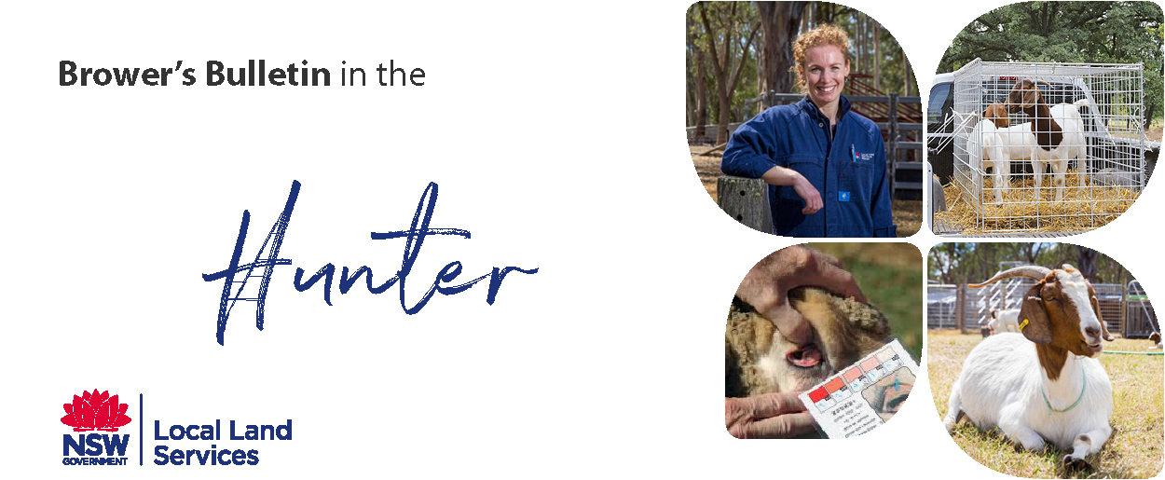
November 2018

A New Development in Worm Control in Goats and Other Livestock
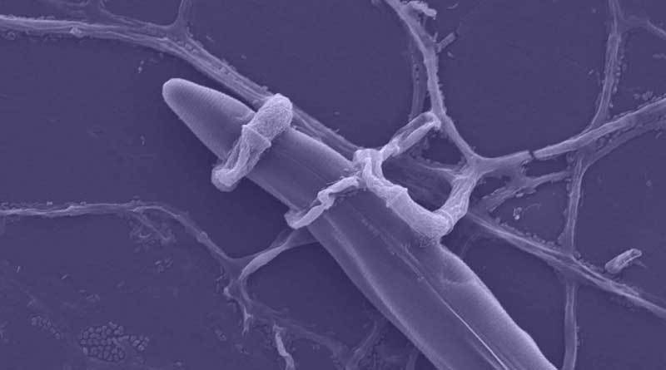
BioWorma is a newish product in Australia that contains the natural fungus Duddington flagrans (IAH 1297). This fungus has been isolated naturally from pasture and it is highly host specific for parasites of grazing animals. When you feed these fungal spores to livestock, they pass through their digestive system unchanged, not affecting the animal and passed out in the manure where the fungus colonises. When the worm larvae become active in the manure the fungus sporulates forming a fungal web that captures, paralyses and consumes the infective larvae (including resistant larvae). It is a non-chemical biological control that interrupts the worm lifecycle reducing the amount of reinfection. This fungus has no effect on other non-target organisms such as insects, earth worms or dung beetles.
As we are all aware, anthelmintic (drench) resistance is becoming more of an issue. A study done in 2014 (Playford et al) found widespread resistance in the common sheep internal parasites to broad spectrum anthelmintics (96% in Benzimidazoles and levamisole, 87% Ivermectin, 77% Abamectin and 54% Moxidectin). Safety studies have concluded that there are no safety concerns from exposure to Duddington flagrans for treated animals, farmers or consumers.
This biological feed supplement was approved to treat parasitic gastrointestinal nematodes of grazing livestock in Australian in July 2018. BioWorma is recommended for strategic use during periods when weather conditions are conducive to larval development.
There are two products on the market.
1) ‘BioWorma’ which is for manufacturing (premix companies, feed mills and veterinarians) to be further mixed with feeds, feed supplements, premixes or concentrates and administered to livestock via the finished products in accordance with the manufacturer’s instruction.
2) ‘Livamol with BioWorma’ is for the end user( for mixing and adding to feed) and is supplied for your personal use as the end consumer to be further mixed with feed and administered to your livestock in accordance with the manufacturer’s instructions.
Dosage and Direction
- Daily feeding rates are weight dependant
- For best results, treat animals with a suitable chemical drench before starting the BioWorma
- Move the treated animals onto a low worm pasture
- Commence daily feeding of ‘Livamol with BioWorma’ (or ‘BioWorma’) to minimise pasture infectivity and maintain the animal’s low worm status
- This product will not reduce pre-existing larval pasture contamination.
- Thoroughly mix ‘Livamol with BioWorma’ with feed or feed supplements
- ‘Livamol with BioWorma’ will begin to work immediately within the manure of treated animals.
- ‘Livamol with BioWorma’ is recommended for strategic use during periods when the weather conditions are conducive to larval development
- Use is conjunction with your property ‘Integrated Worm Management Plan’ for your property and recommendations for your area.
- Do regular Faecal Egg Counts to monitor the effectiveness of your worm management strategy.
- Visit Wormboss http://www.wormboss.com.au/programs/goats.php for more information.
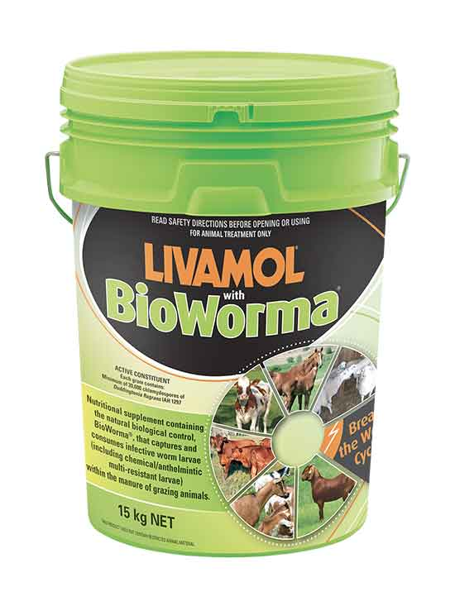
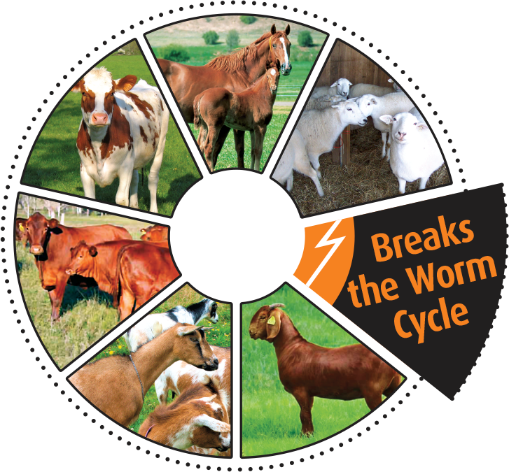
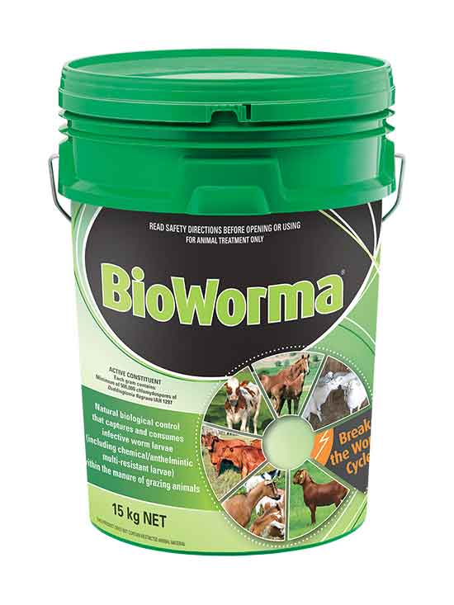

I understand that many trials have been done around the world and in Australia with BioWorma, but I was interested in doing our own local trial. I am looking for one or two willing participants to demonstrate the effectiveness of the BioWorma product. We would be happy to provide the BioWorma and do Faecal Egg Counts each month for 4 months. The trial properties would need to have 2 paddocks that are basically the same, same grass species, drench history, size, shade, water etc and have equal number of goats in each paddock. I am thinking 5 goats in each paddock. If you are interested in being involved in this study, please send me an email at kylie.greentree@lls.nsw.gov.au

© State of New South Wales through Local Land Services 2018. The information contained in this publication is based on knowledge and understanding at the time of writing November 2018. However, because of advances in knowledge, users are reminded of the need to ensure that the information upon which they rely is up to date and to check the currency of the information with the appropriate officer of Local Land Services or the user’s independent adviser.
For updates go to www.lls.nsw.gov.au

