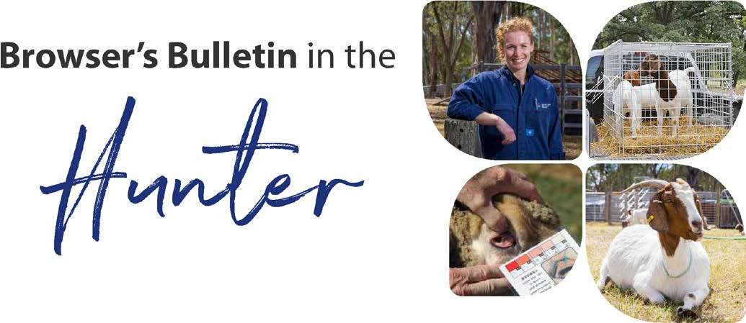
August 2020

Browser’s Bulletin 47:

Metabolic Disorders Commonly seen in Goats in Late Pregnancy and Early Lactation

Over the last month we have been seeing cases of pregnancy toxaemia in sheep and goats in the Hunter Region. Pregnancy Toxaemia threatens the life of the unborn kids and the doe, leading to devastating losses in your herd! Browser’s Bulletin 21 covers Pregnancy Toxaemia in more detail, but this Browser’s Bulletin will touch on a few other metabolic diseases that are linked to poor nutrition.
The feeding requirements of your goats depends on the breed, stage of growth, gestation, disease status, body condition score, feed available and the quality (paddock/supplementary feed) and environmental factors (weather conditions, topography of the property/exercise, shelter) and number of foetuses in utero.

Pregnancy Toxaemia (Ketosis)
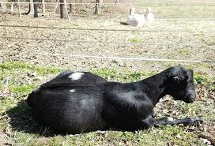
Browser’s Bulletin 21 (https://hunter.lls.nsw.gov.au/_old/resource-hub/newsletters) is about Pregnancy Toxaemia, so a detailed description of the disease can be found there. I cannot express enough the importance of increasing the energy of the diet during the last 6 weeks of gestation. 70-80% of the kid’s growth will occur during the last trimester and if they have multiple kids in utero then there is very little room in their abdomen to take in much feed. Their feed needs to be of good quality, high energy and high protein (>18%) and fed small amounts very regularly. If the doe is not consuming enough energy to meet the demands of the pregnancy, then she will start to break down her own fat and muscle which leads to the production of ketones. These circulating ketones make the doe feel sick, lethargic, unable to stand, abort the pregnancy, coma and death. Once the doe is unable to stand, the chance of recovery is very slim. Most does are pregnant during Winter, when the pasture quality is lower and the cold, wet and windy weather conditions will also increase the energy demand of the goats.
A postpartum toxaemia and lactational ketosis can also occur in early lactation, when the energy demands of lactation are not being met by the diet. A doe will often go off her food just after kidding which will lead to a mild ketosis. Normally this will go unnoticed, but it is important to be mindful of the increased energy demands of lactation and try to encourage the goat to eat anything. Stimulating the appetite with B vitamins (B3 niacin) and twin-lamb remedies such as propylene glycol or glycerol.

Grass Tetany (Hypomagnesaemia)
This is an issue we see in high milk producing goats in early lactation, grazing lush green fertilised feed in early Spring, with a diet that is deficient in magnesium. Hypomagnesaemia can also occur in late pregnancy on goats on poor early spring pastures. Sheep and cattle are more susceptible to Grass Tetany than goats. Clinical signs with grass tetany include staggering gait, tremors, facial twitching, falling over, frothing at the mouth, convulsions and death. A subclinical hypomagnesaemia will result in inappetence, decreased milk yield, irregular gait, overreacts to noise but can spontaneously recover. Magnesium is critical for nerve signaling and muscle contractions. Potassium interferes with magnesium absorption from the goat's digestive tract. Those rapidly growing grasses, such as ryegrass, tend to be high in potassium and so it is important to have other feed on offer such as good quality hay at this stage of high production when magnesium levels have been drained from the goat.

Hypocalcaemia (Milk Fever)
Hypocalcaemia is not overly common in goats but does occur in young, high yielding first kidders in the first few weeks after parturition or some older goats tend to suffer from hypocalcaemia around parturition. Calcium is critical for muscle and nerve activity, so without enough calcium in the blood the doe will become lethargic, tremors, difficulty walking, recumbent, coma and death. It is important to have some 4-in-1 (calcium, phosphorus, magnesium and glucose) in your supplies in late gestation and early lactation time in your herd. Treatment is 80-100ml of 4-in-1 under the skin which is absorbed rapidly in the goat.

Acidosis
Acidosis results from feeding ruminants an excessive amount of high energy feed (normally grain or concentrate feed introduced too quickly), that rapidly ferments leading to an excessive production of lactic acid. This lactic acid will decrease the pH of the rumen which will kill the good bacteria, allowing the bad bacteria to take over, producing toxins that are absorbed into the blood stream. A mild acidosis will result in the goat going off its food briefly and becomes lethargic, but a more severe acidosis will lead to complete anorexia, abdominal pain, teeth grinding, diarrhoea, laminitis, difficulty standing or walking and death.
It is important to remember that fibre is an important part of the goat’s diet. Long fibre stimulates chewing, saliva production and eructation. The fibre contains bicarbonate and phosphate ions which buffer the rumen and help maintain the pH of the rumen. When feeding grains and concentrates, it is best to feed small amounts on a regular basis and gradually introduce over 7-10 days in order to give the rumen bacteria a chance to adapt to the new diet. If you think your goat has acidosis then remove access to grain/concentrate immediately, increase fibre, in the diet and vet veterinary advice. Browser’s Bulletin 2 (https://hunter.lls.nsw.gov.au/_old/resource-hub/newsletters) has more information about drenching the goat with Epsom salts and the dose rates.

Enterotoxaemia
Enterotoxaemia is also called ‘Pulpy Kidney’ or ‘Overeating Disease’. Enterotaemia is caused by the bacterium Clostridial perfringens type C&D that is a normal organism in the gut. If they have a sudden change in their diet, then the Clostridial bacteria rapidly reproduce and excrete a toxin that is absorbed into the blood stream leading to diarrhoea and death. Goats are more susceptable to Enterotoxaemia than sheep and require more regular Clostriadial vaccination such as a 2-in-1 or a 5-in-1. The recommendation is to vaccinate at 2 months of age and a booster 1 month after, then regular 6 monthly vaccinations. Also give a doe a vaccination 1 month prior to kidding. This is not only for passive transfer of immunity to the kid but the doe is much more susceptible to Enterotoxaemia in that month after kidding with dietary changes due to a higher nutritional demand during lactation. Also remember to increase concentrates gradually.

Polioencephalomalacia (Cerebrocortical necrosis)
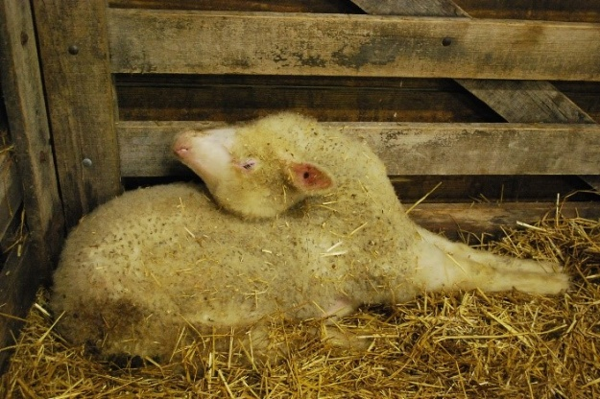
Polioencephalomalacia is caused by a deficiency of vitamin B1 (thiamine). Vitamin B1 is produced in the rumen, but under certain circumstance the production can be blocked. These circumstances include acidosis, feeding of mouldy hay, prolonged diarrhoea, drug therapy or ingestion of plants such as bracken fern. A vitamin B1 deficiency can lead to brain damage. Clinical signs include, stargazing, staggering gait, eyes flicking back and forward, blindness, laying down on side with head thrown back and legs stiff and extended. If the condition is caught early, then vitamin B1 injections can be effective for recovery but often brain damage is already done and recovery is unlikely.

Metabolic disorders are all linked to incorrect nutrition and lead to devastating losses. Ensure an increase in energy and protein is provided in the last 6 weeks of gestation and have appetite stimulants and bags of 4-in-1 in your supplies around kidding time. If you need any further advice on metabolic disease, then please send me an email on kylie.greentree@lls.nsw.gov.au.

References:
Fernandez D. Ahrens C. Nutrition of Meat Goats. University of Arkansas (USA Department of Agriculture)
Matthews, J. 2009. Diseases of the Goat (3rd edition)

© State of New South Wales through Local Land Services 2019. The information contained in this publication is based on knowledge and understanding at the time of writing November 2019. However, because of advances in knowledge, users are reminded of the need to ensure that the information upon which they rely is up to date and to check the currency of the information with the appropriate officer of Local Land Services or the user’s independent adviser. For updates go to www.lls.nsw.gov.au

