Pregnancy Toxaemia in Goats
Pregnancy Toxaemia occurs in response to an insufficient intake of energy to meet the demands of pregnancy.
This condition is most commonly seen in the last 6 weeks of pregnancy when the energy demands are not met adequately by the diet. Kidding will normally coincide with lush spring pasture growth but given the seasons that we have been having across the country it is important to ensure there is adequate energy and protein in the feed available during this stage of pregnancy. The foetus will undergo 70% of its development during the third trimester.
Predisposing factors of Pregnancy Toxaemia
- Multiple foetuses which require an increase in energy, also compressing the rumen as they develop and consequently decreases voluntary food intake
- Goats overfed as a goatling leading to increased intra-abdominal fat
- Goats overfed during the dry period leading to increase abdominal fat which reduces rumen capacity. The excessive abdominal fat is mobilised and becomes deposited in the liver resulting in liver dysfunction
- Lack of exercise
- Undernutrition
- Stress factors can play a role in initiating the disease in goats

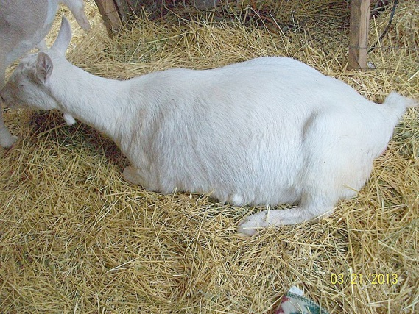
Clinical Signs with Pregnancy Toxaemia
- Initially inappetance (often go off concentrate feeds but remain eating browse but as the condition progresses complete anorexia occurs)
- Teeth grinding
- Lethargic, walks with difficulty, swelling of legs
- Weight loss
- Occasionally nervous signs- tremors of the head and ears, reduced vision, star gazing or blindness, eventual recumbancy, coma, abortion and death
Laboratory testing to diagnose Pregnancy Toxaemia
Pregnancy Toxaemia is diagnosed on history and appearance of clinical signs. A urine or milk sample can be tested to look for an increase in Ketones (Ketostix). Ketones are produced when the body is breaking down its own fat reserves. A blood test can also be taken to look at an energy profile, this test can support a diagnosis. If the doe has died, an autopsy will reveal characteristic lesions including an enlarged fatty orange-yellow liver, fatty flakes in the abdomen and well developed kid or kids.
Prevention is better than cure!
Early detection of the condition and prompt treatment may lead to recovery but late treatment is often unsuccessful with termination of the pregnancy giving the doe the best chance of survival. Other treatments include fluid therapy, appetite stimulants and energy correction (propylene glycol 100-200ml 2-3/day).
Providing sensible nutrition throughout the pregnancy with good quality roughage and concentrate feeding increasing during the last trimester will aid in prevention of pregnancy toxaemia. If the foetal numbers have been determined by ultrasound scanning then ideally break the does up into groups of single foetuses or multiple foetuses and feed them accordingly. Avoid over fat or underweight does and try to maintain their groups so they don’t become stressed during the pregnancy. Encourage exercise during the pregnancy and it is recommended to feed vitamin B3 (niacin) during the last 60 days of pregnancy to stimulate their appetite. Ensure good internal parasite control otherwise worms could be decreasing the ability of nutritional absorption.
Transporting Goats
A large part of NSW is in drought conditions and consequently there will be livestock being transported around the state. There is a “Code of Practice for Livestock Transport” to prevent welfare issues. I have listed a few important points to consider before moving stock.
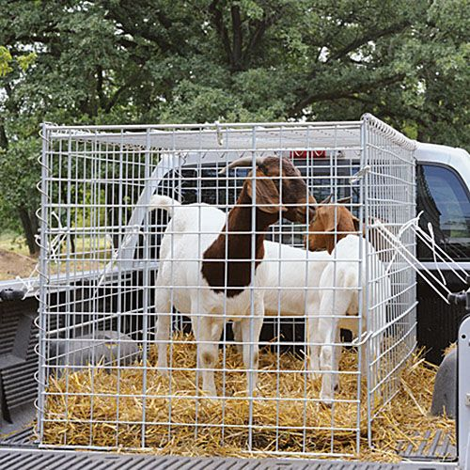
- Only healthy stock are to be transported “Fit for Transport”
- Vehicle must be safe for transporting
- Partitions in the truck if you are transporting large numbers of goats otherwise they may crush each other
- Ensure journey is well planned, prompt delivery, arrival time, minimise stress, minimise transport time, minimise time off food and water
- There is a maximum time off food and water depending on age and stage of development, ensure you are aware of these if the goats are being transported a long distance
- Transporting pregnant does will require extra space on vehicle
- Segregate different classes of goats to avoid trampling of small stock
- There are loading density standards
- Appropriate NLIS ear tags attached and National Vendor Declaration (NLIS Database Transfer is done within 7 days of arrival on new property)
- Avoid extreme weather conditions as goats are highly susceptible to stress
- Don’t carry out highly stressful activities just prior to loading on the truck (ie castration, dehorning, crutching etc.)
- Any animal that is emaciated, weak, severely lame, heavily pregnant and can’t keep up with the herd should not be transported
- Recommend the use of a Goat Health Statement
Any further questions with regards to either of these topics please don’t hesitate to email Kylie Greentree on kylie.greentree@lls.nsw.gov.au or phone the office on 49328866.

