Caprine Encephalitis Arthritis (CAE) in Goats
CAE is a virus that we see more often in dairy goats but can certainly occur in any breed. The clinical signs you see with CAE are varied and they include swollen joints, encephalitis (inflammation of the brain), pneumonia, mastitis (hard udder) and chronic weight loss. Most CAE infected goats will show no clinical signs but they could be carriers of the virus.
Normally the virus is transmitted through the colostrum and milk but is can be transmitted by any bodily secretion (saliva, urine, oral etc). Certain behaviours such as teat biting and leakage of milk can increase the chance of transmission. Normally the virus is picked up in kids in the first few months where it remains latent in the body until the body is placed under stress such as parturition.
There is a blood test available to check if goats are positive to CAE virus. Any goat that is positive on this test is positive to the disease and will remain positive for life but sometimes the goats are not producing enough antibodies to register a positive result (“False negative”). It is important to not do testing 1 month either side of kidding or around time of vaccination as the results may not be accurate.
Having CAE in your herd will not only lead to a number of health issues that are listed above but can also lead to a decrease in milk yield and an increase in their Somatic Cell Count and consequently the production of poor quality milk.
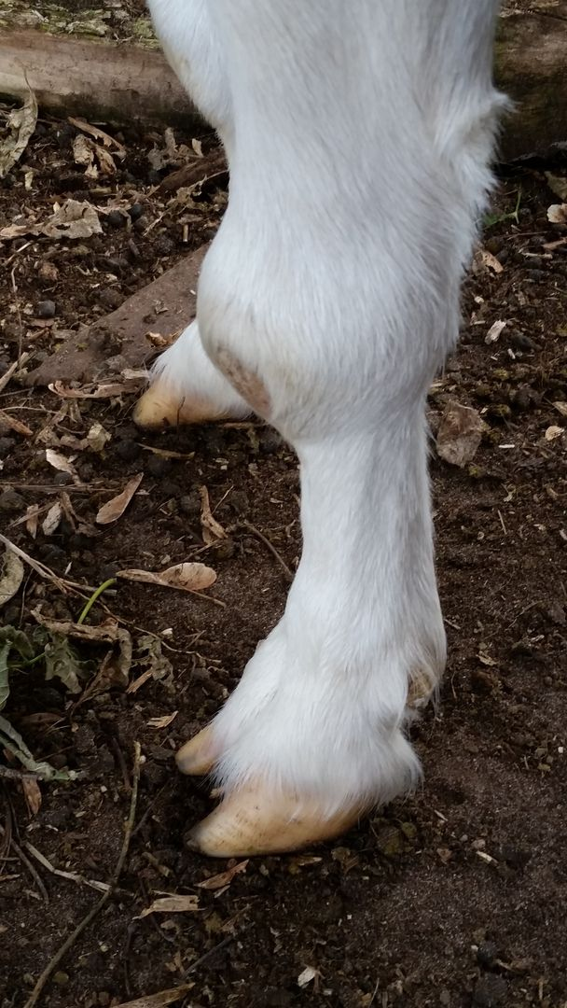
There are certain preventative measures you can put in place in order to try and prevent the spread of disease. These preventative measures also aid in the control of Johne’s Disease, Caseous Lymphadentitis (CLA) and Mycoplasma infections to name just a few.
- Maintain a closed herd or only purchase goats from CAE accredited herds. If you are purchasing stock always ask for a “National Goat Health Declaration” form to confirm the goat is coming from a CAE free herd or a CAE Accredited herd.
- Be careful is you are agisting stock or lending stock for breeding purposes and ensure they are a CAE accredited herd.
- Identify the disease in the herd.
- Snatch kids at birth so they do not have access to their mother’s colostrum and milk. Teat tape may be necessary to avoid kids suckling from dam. Follow the National Kid Rearing Plan. Address listed below.
- After snatching kids wash them clean of all maternal fluids which could potentially contain the CAE Virus.
- Keep kids in small similar size groups, away from adults (Maintain a physical separation from the adults).
- Feed kids pasteurised milk from CAE free goats or cow’s colostrum /cow’s milk or artificial milk replacer.
- Don’t feed pooled goats milk!
- Strict hygiene is essential! Clean milking machine, bottles and feeders thoroughly. Clean shoes and hands and change clothing as the disease can be transferred on people.
- Blood test goats greater than 6 monthd to detect carriers of the virus in your herd and keep these animals separate from those that test negative. Testing every 6 months.
- Culling positive animals is recommended as they are positive for life but producers may want to keep the does in order to snatch the kids at birth before suckling occurs. These positive animals should be kept separate from the negative herd by at least 1.8m. Cull does after parturition.
- The virus is very labile in the environment so you can milk the clean herd in the morning and the positive herd in the afternoon.
- You can become involved in a CAE Accreditation Scheme through your private veterinarian. This will involve several herd tests and setting up a Biosecurity plan to aid in the prevention of entry of this disease and many other.
- Sheep are able to become infected with the CAE Virus and should be considered in an eradication plan if they have been in contact with the goats.
People that drink raw milk from an infected herd can develop antibodies to the CAE Virus. There is no proof that they develop a persistent viral infection like the goats but there is a strong cross reactivity between the surface proteins on the CAE Virus and HIV Virus, and it has been postulated that people could have a false positive reaction to a HIV test. If you are selling your goats and you have goats that are positive to CAE Virus in our herd you have an obligation under the new Biosecurity Act to disclose their status to the new owner.
If you are interested in finding out if your herd has CAE, then please give me a call. You will improve the animal welfare of your goats and improve production. The blood test costs $12.25 each through EMAI at Menangle. Norway and Switzerland have managed to completely eradicate CAE from their country. Australia currently has no CAE Eradication Program in place but I would love to rid the Hunter of CAE! Please call me on Ph 02 49328866 if you are interested in testing your herd.

https://www.animalhealthaustralia.com.au/what-we-do/endemic-disease/goat-health/cae-in-goats/
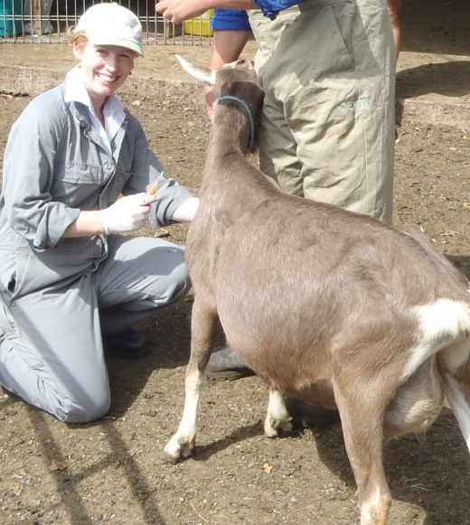
https://www.animalhealthaustralia.com.au/what-we-do/endemic-disease/goat-health/goat-national-kid-rearing-plan/

