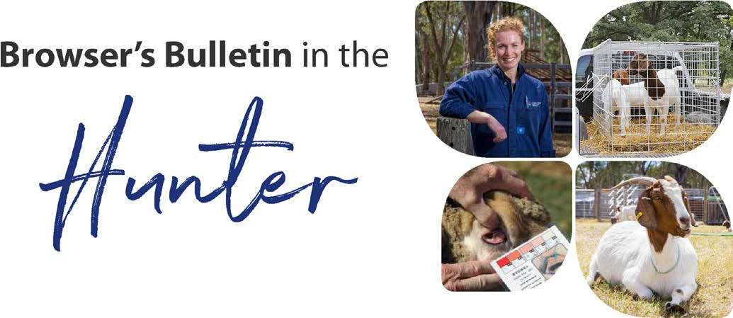
February 2021

Browser’s Bulletin 53:

Yersiniosis in Goats

Over the last 4 months we have seen serious issues with internal parasites across the State with barber’s pole creating the most severe losses. We have noticed within the last month a slight change in the percentage of worm species, with an increase in the scour worms (trichostrogylus and ostertagia). Given that the conditions are still ideal for barber’s pole, it has surprised us to see a rise in the scour worm species. This could be to do with drench resistance in the scour worms, highlighting the importance of checking the effectiveness of your drenches.

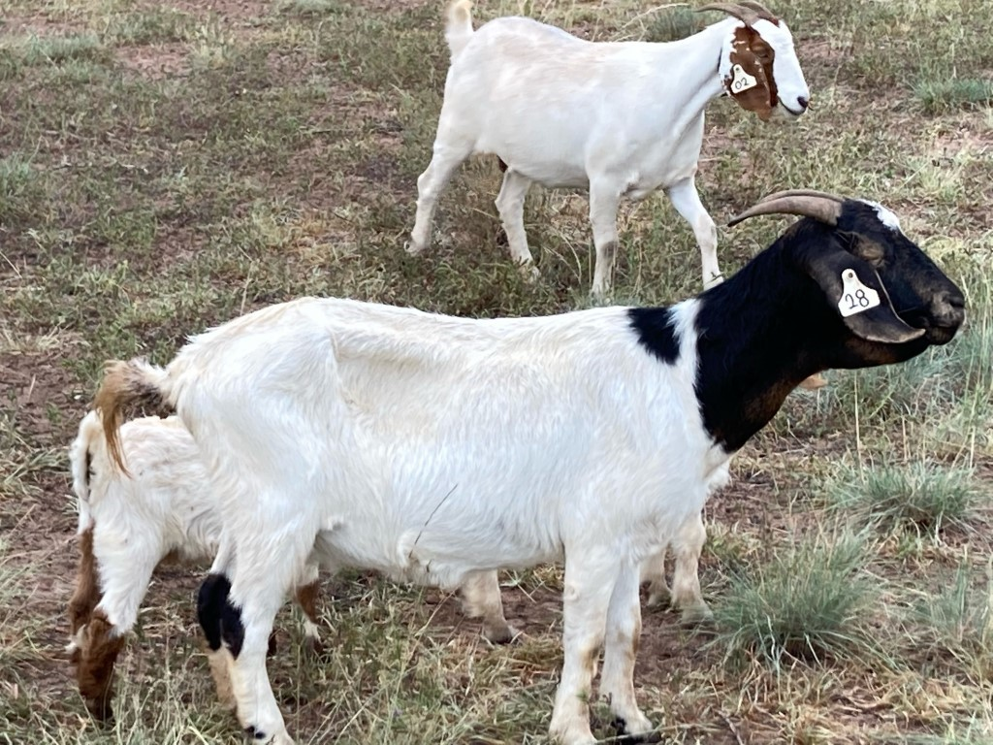
I have been fortunate enough to chat with a fellow District Veterinarian from the North West LLS about an interesting case of scours in a mob of 270 boer goats (14 affected and 8 deaths). The issues began for this producer in December 2020 with scours and deaths occurring in a few goats and barber’s pole worm noticed on postmortem examination. Drenching was undertaken, with many of the goat's scours clearing up. A few goats continued to have a watery brown diarrhoea (+/- mucous), dehydration, bottle jaw (submandibular oedema), rough coats and over 10-14 days they would lose condition, stop eating, lay down and die. Some individuals improved on supplementary feed, but bottle jaw and scours returned when supplement was removed.

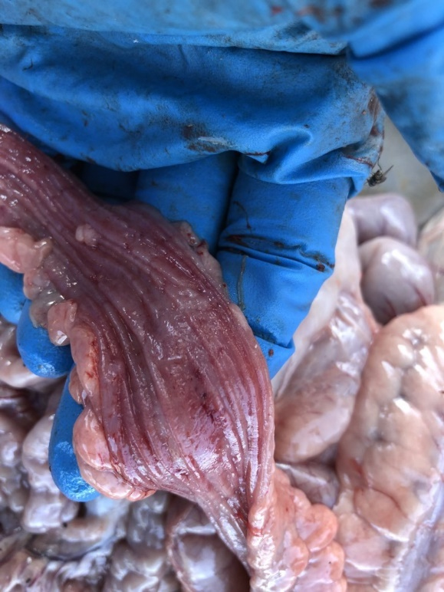
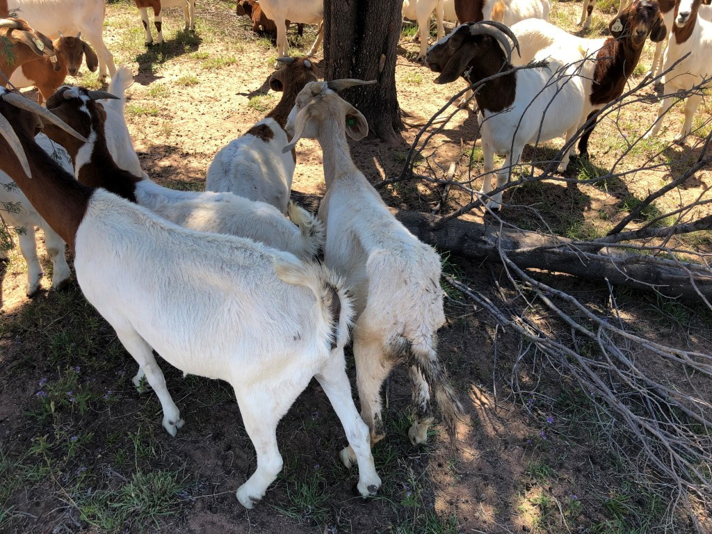
Postmortem examination revealed minimal fat in the carcass and obvious red thickening of the large intestine. Samples were sent to EMAI, and a diagnosis of Yersinia enterocolitica was confirmed on culture and histopathology. The remaining clinical cases were treated with oxytetracycline antibiotics and have responded well with no further deaths. Yersinia bacteria (Yersinia enterocolitica and Yersinia pseudotuberculosis) can lead to enteritis, abortion, mastitis, internal abscesses, septicaemia and death in animals throughout the world and is a zoonotic disease. Predisposing factors to disease include stress, overcrowding, sudden weather changes and concurrent disease (e.g. internal parasites). Birds, pigs, and rodents are considered a reservoir of infection and may introduce a virulent strain into your susceptible herd by contaminating feedstuff. Given that the NSW mouse population has grown to plague proportions, spreading of diseases such as Yersinia are a potential concern for all producers. ” Common things happen commonly’ and worms are generally on the top of the list when it comes to sheep/goats with ill thrift, weight loss, scours and anaemia, but it is important to keep an open mind about other potential concurrent diseases, especially with a mouse plague tearing through regional NSW. Enterotoxaemia (pulpy kidney) is another common disease in goats, so don’t forget to vaccinate your stock every 6 months with a clostridial vaccine.

If you have other questions and concerns about Yersiniosis in small ruminants, please send me an email on kylie.greentree@lls.nsw.gov.au

Reminder of the Small Ruminant Low Stress Stock Handling Course

A reminder that sheep and goat producers are invited to attend a 'Low Stress Stock Handling Course' with trainer Grahame Rees, at Tocal on Thursday and Friday 27th-28th May 2021. This is a great opportunity as the course is heavily subsidised. The course normally costs $600-$800 per person. But it is free to fire affected producers. All other producers are asked to pay a small fee of $50. Please email Jacky O'Neill on jack.oneill@lls.nsw.gov.au to reserve a spot, don't delay as there are approximately 10 spots left.

References:
- Matthews, J; 2009. Diseases of the Goat
- Smith, M.C, Sherman,D.M; 2009.Goat medicine 2nd edition

© State of New South Wales through Local Land Services 2019. The information contained in this publication is based on knowledge and understanding at the time of writing November 2019. However, because of advances in knowledge, users are reminded of the need to ensure that the information upon which they rely is up to date and to check the currency of the information with the appropriate officer of Local Land Services or the user’s independent adviser. For updates go to www.lls.nsw.gov.au

