Akabane Virus in Goats and Other Ruminants
There has been some concern about the number of mosquitos in the Hunter Region and the potential of an Akabane Virus outbreak in livestock. Akabane Virus causes arthrogryposis (permanently flexed joints, contracted tendons and failure of normal muscle development in the limbs and neck) and hydrancephaly (resulting in loss of mentation, blindness and incoordination) in kids, lambs and calves throughout parts of Australia and other countries. Akabane virus is insect transmitted with the only certain vector in Australia being the biting midge, Culicoides brevitarsis. However the virus has been isolated in other arthropods such as the mosquito. The midges are widespread in Northern Australia and down the coast of NSW. The spread time of the virus is late summer and early winter, when the midge activity is greatest.
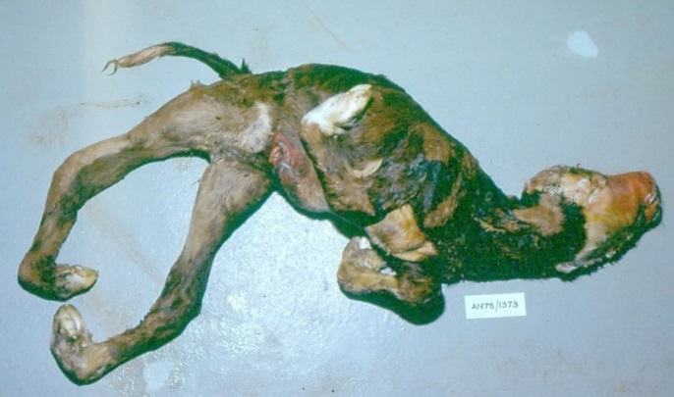
New infections of Akabane Virus will depend on ideal weather conditions for Culicoides reproduction and wind pushing the midges beyond their normal distribution and hence exposing naïve herds to the disease. If the exposed animals are not pregnant then no disease is observed and the animal will develop immunity against the virus, but if they are exposed to the disease while they are pregnant it can result in abortions, stillbirths and congenital defects. Malformations in goat kids are common when infection occurs between 30-50 days of gestation and the kids are normal when infection occurs during the last 100 days of gestation.

Figure 1: Calf with Akabane http://veepro.nl/animal-health/akabane-virus-infection-ruminants/
We seem to have 4-6 yearly intervals between problems with Akabane Virus which is believed to occur as the immune population of animals becomes replaced by the younger naïve population.
Another unfortunate consequence of Akabane Virus is there are often birthing issues. Due to the flexed joints and a wry neck they cannot extend they bodies into the correct position and posture for a smooth delivery. Those kids born with flexed joints are often born alive but have difficulty standing and those born with hydrancephaly often appear dumb with lack of coordination and unaware of their surroundings.
A diagnosis can be made on clinical signs, samples taken from an aborted fetus, on precolostral blood sample from an affected kid or a rising antibody levels on blood samples from the doe which indicates recent infection.
Sadly there is no treatment for affected kids or any practical means of control because of the method of disease spread. Introduction of stock from nonendemic to endemic areas should be done well before the first breeding to enabling the dam to develop immunity at an early age.
Please contact me on Ph: 49328866 or via email kylie.greentree@lls.nsw.gov.au if you are noticing any of these clinical signs and we can assist with a diagnosis.

