

**Hunter LLS Pig Newsletter 1: ASF and Biosecurity**

Welcome to our first Pig Newsletter! We will be sending something out every month to give you any relevant updates and bring you some useful information.

To start we just want to give you a quick update on the changed conditions with relation to African Swine Fever (ASF).

1. It is still exotic to Australia – we have no cases of ASF in the country and we never have had any to date.
2. However, it has been confirmed in Papua New Guinea on 31 March 2020, so Australia needs to remain vigilant
3. It is not like Covid 19 or Swine Flu – it cannot affect people.

What can a producer do to protect their farm?

1. Make sure you have registered a PIC (Property Identification Code) so that your animals can be found and supported in an emergency (disease or natural disaster).  You can do this through your Local Land Services office  (<https://www.lls.nsw.gov.au/i-want-to/apply-for-a-property-identification-code>)
2. Develop a biosecurity plan for your farm to protect your animals by considering how to segregate them from
   1. Visitors – especially overseas travellers or other pig owners / people who have contact with pigs

                                                               i.      A recent report by the Inspector General of Biosecurity rates overseas workers a significant risk for entry of ASF

* 1. Introduction of new animals for a period of time (eg. 21 days is best to allow for any illnesses to show up)
  2. Movements of vehicles, feed supplies, maintenance with respect to where your animals are
  3. Food waste that contains meat or meat products or food waste that has been in contact with these

                                                               i.      this is considered one of the possible pathways of entry for ASF into Australia.

                                                             ii.      It is illegal in All States and Territories to feed these prohibited feed materials to pigs (commonly called ‘swill’).

* 1. Preventing access of your pigs with feral pigs that may live in the area through boundary fencing

1. Never feed prohibited pig feed or allow anyone else to feed this to your pigs

**Consider sharing these resources with other pig owners so they can be aware too!**

Latest Media releases for interest and information:

<http://www.nswfarmers.org.au/NSWFA/Posts/Media_Releases/mr.020.20.aspx>

<https://www.abc.net.au/news/rural/2020-03-31/african-swine-fever-outbreak-in-papua-new-guinea/12105456>

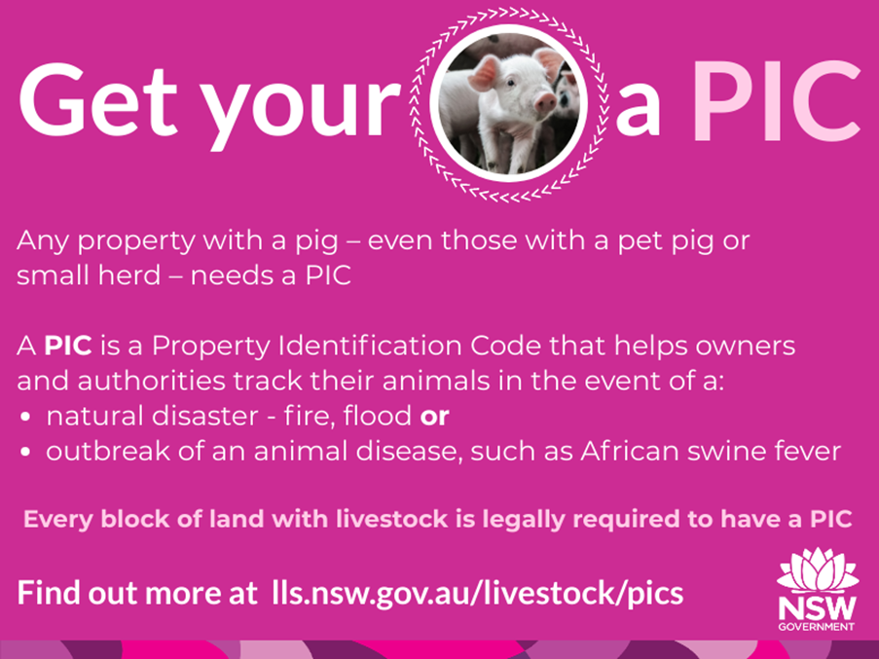

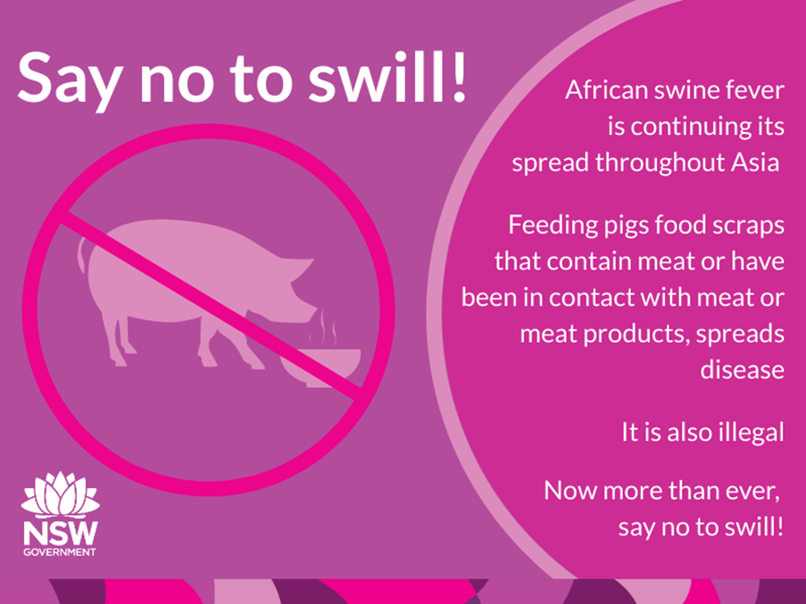

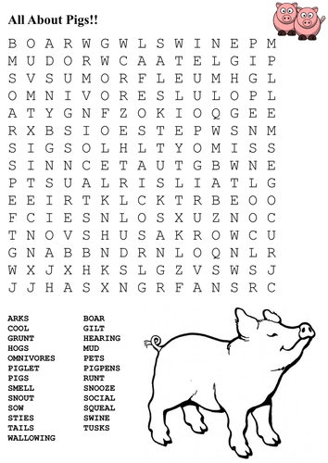

© State of New South Wales through Local Land Services 2019. The information contained in this publication is based on knowledge and understanding at the time of writing April 2020. However, because of advances in knowledge, users are reminded of the need to ensure that the information upon which they rely is up to date and to check the currency of the information with the appropriate officer of Local Land Services or the user’s independent adviser. For updates go to www.lls.nsw.gov.au