What is a False Pregnancy?
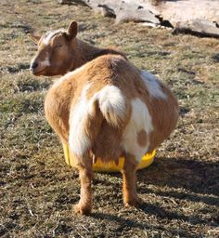
A false pregnancy is the accumulation of aseptic fluid in the uterus without the presence of a pregnancy that is maintained by the presence of the corpus luteum on the ovary. The Corpus luteum continues to produce progesterone and the uterine fluid builds making the goat look like she is pregnant (as you can see in this photo).

A false pregnancy occurs when:
- There is a persistent corpus luteum following an oestrus cycle in which a pregnancy did not occur. This appears more common in some dairy breeds and certain family lines.
- The presence of a corpus luteum following embryonic death and resorption of the embryo.
- Increased incidence with progesterone treatment with artificial insemination.
Clinical signs seen with a False Pregnancy
The doe’s abdomen gradually becomes enlarged and there will be a degree of udder development. If the false pregnancy is a result of an embryonic death then the false pregnancy can last the length of a normal pregnancy (150 days) building up litres of fluid (1-7 litres). Once the progesterone secretions ceases the fluid is released in what is called a cloudburst.
When the false pregnancy has occurred due to the doe not being mated, then the false pregnancy is normally less than the normal gestation length, she will cycle again after the cloudburst and if she is not mated can have another false pregnancy.
The fluid released in the cloudburst is generally clear with mucus (sometimes with a bit of blood) and the hair around the tail and perineum is wet and sticky. Some does will squirt the fluid out in small amount over several days and can be confused with cystitis (bladder infection).
How to diagnose a False Pregnancy?
Diagnosis of a false pregnancy can be established with an ultrasound or blood laboratory tests which look for pregnancy specific proteins.
A False pregnancy can be treated with a hormone from your private veterinarian that will stop the corpus luteum producing progesterone, release the uterine fluids and assist with contraction of the uterine muscles. The prognosis for future fertility is generally good especially if they are mated during their next oestrus cycle.
Any further questions with regards to False Pregnancies in goats please don’t hesitate to call me on Ph: 49328866 or email kylie.greentree@lls.nsw.gov.au

