Blue Green Algae
There has been a number of enquiries with regards to low dam levels and the potential of blue green algae poisoning in livestock. Blue green algae will normally be obvious to the naked eye causing a green discolouration to the surface of the dam (see photo below), it may have an unpleasant odour and sometimes the wind blows and it aggregates as scum on the edge of the dam. If you do notice a green discolouration on the surface of your dam then we are able to test the water to see if it is blue green algae.
Blue Green algae is toxic to livestock and can kill animals within 24-72 hours after ingestion but it usually occurs when the blue green algae have accumulated as scum on the side of the dam and the livestock are drinking from this point. Cases of blue green algae poisoning are very rare but can occur when a number of triggers align; these include increase in water temperature, fertilisers used around the dam, increased contamination of manure from livestock, increase in soil erosion, a decrease in the level of zooplankton that eat the algae and livestock drinking from a highly contaminated area at the edge of the dam.
Clinical signs you may see in your livestock with blue green algae poisoning include breathing difficulties, muscle twitching, salivation, appear weak, rapid pulse, depressed, photosensitisation and death. Other stock may simply not drink the water and become dehydrated. If you are concerned that your dam has blue green algae then please call and we can send water samples away for testing.
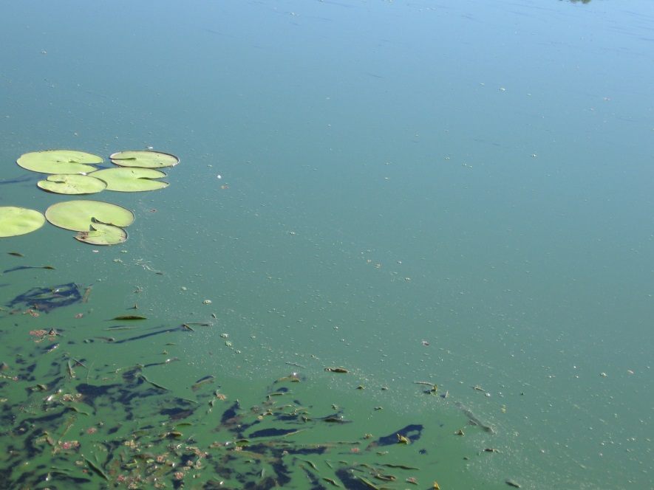
If you are concerned about the quality of the drinking water as the water levels get lower then we have water sample kits in any LLS office that you are able to collect and send a water sample away to be tested to make sure the quality of the water is adequate for livestock.
Tocal are running the Faecal Egg Course on the 14th March. Please let me know if you are interested in participating.

Urolithiasis: Have you ever had a male goat straining and you think they are constipated? Usually they are not constipated (constipation is rare), they may have a stone blocking their urethra preventing a good flow of urine from the bladder. Stones in the bladder or urethra are called uroliths and they can be deadly! Uroliths are more of an issue in male goats and especially in castrated males. Male goats have a much narrower urethra than females and therefore calculi forming in the urinary tract have difficulty passing. Stones in the bladder are usually associated with high concentrate diets, decreased water intake, low fibre diets and sometimes a genetic predisposition. Always ensure there is adequate fibre in your goat’s diet and clean accessible water at all times to help prevent the formation of uroliths.

