Obstructive Urolithiasis in Goats
Over the last month, I have had several questions about bladder stones in goats. These stones are also called uroliths and small calculi break off the uroliths and become lodged in the urethra which prevents urine outflow and severe pain. The most common scenario is in pet goats that are being fed on a high grain/concentrate diet and a diet that is low in fibre. There are a number of predisposing factors that can lead to the precipitation of minerals from the urine and the formation of calculi. The uroliths can be made of different minerals and they will depend on the diet composition. High calcium diets, such as pastures and hay containing lupins, clover and lucerne are high in calcium and often will predispose the goat to Calcium Carbonate crystals, whereas high grain rations or concentrate diets are often high in phosphorus and low in calcium predispose goats to struvite crystals (magnesium ammonium phosphate) in the bladder. Obstructive uroliths are rarely seen in female goats due to their wider and shorter urethra allowing the calculi to pass easily.
Predisposing Factors:
- Decrease in water intake; this can be because the water is dirty, difficult to reach, too hot during hot weather or too cold during cold weather, not enough space at the trough, bullying behaviour keeping some goats away from the trough. Goats are particularly finicky about the water quality!
- Decreased urine output
- High concentrate / grain diet (usually leads to Calcium: Phosphorus imbalance) providing excess energy way beyond their metabolic needs
- Low fibre in the diet also causes decreases saliva production and therefore decrease in water consumption and decrease phosphorus excretion
- Wethers, usually those that have been castrated at an early age limiting the width of the urethra. Uroliths can certainly occur in entire males too, but early castrated wethers are more commonly represented with urolithiasis
- High Calcium diet (Lucerne, Clover, Lupins)
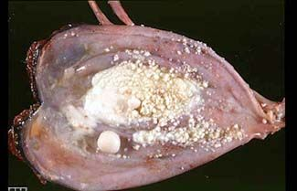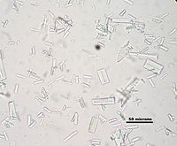
Figure 1& 2: Bladder Stones (photo 1) and struvite crystals in urine under the microscope (photo 2)
Clinical signs seen with urethral obstruction: Restlessness, straining to urinate, tail twitching, vocalising in pain, stretching out posture that can easily be mistaken for constipation (uncommon to get constipation in goats), crystals and blood may be seen on the hairs at the end of the penis, blood in the urine, prolonged urination, dribbling urine, loss of appetite, lethargic, abdominal swelling.
Urethral obstruction requires immediate veterinary attention as rupture of the bladder and/or urethra can occur within 24-48 hours resulting in death.
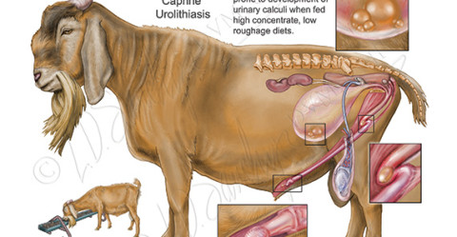

Figure 2: Medical illustration of male urinary tract and uroliths in the bladder and urethra
Preventing formation of Uroliths
- Increase urine output: this can be done by providing good quality, easily accessible, clean water, increase fibre intake which increases saliva production, addition of salt to the goats ration at a rate of 3% of the total dry matter intake can increase water intake. Dry matter intake estimation = 2% of Body weight e.g. a 40kg wether would eat approximately 0.8Kg dry matter and therefore you could add 24g of salt to this ration.
- Acidify Urine: Acidifying urine will increase the solubility of most uroliths and inhibit further uroliths formation. Discuss this with your veterinarian about the addition of anionic salts such as ammonium chloride at 1-2% of total daily dry matter. Ammonium chloride is not palatable to goats so needs to be mixed with something sweet such as honey or sugar solution.
- Dietary Management: Goats require fibre in their diet as this will increase saliva production and assist with the excretion of phosphorus that builds up in the uroliths. Discuss with your veterinarian or nutritionist about obtaining ideal Calcium: Phosphorus ratio (2:1 to 2.5:1) in your goats diet. The animals most commonly seen with uroliths are wethers, males and pet goats. These goats require less energy and calcium than breeding does and growing stock, therefore high quality grass hay is adequate.
- Delayed Castration: If possible delay castration until 3 months of age to ensure the urethra reaches its maximum width.
Any further questions with regards to Uroliths in goats please do not hesitate to call me on Ph. 49328866 or email kylie.greentree@lls.nsw.gov.au or contact your local Veterinarian.
Reference:
Smith MC, Sherman DM. Goat Medicine Second Edition. 2009
Photos 1) & 2) http://www.angoras.co.za/article/bladder-stones
Photo 3: http://www.sawchynmi.com/sawchynportfolio/ruminant/

