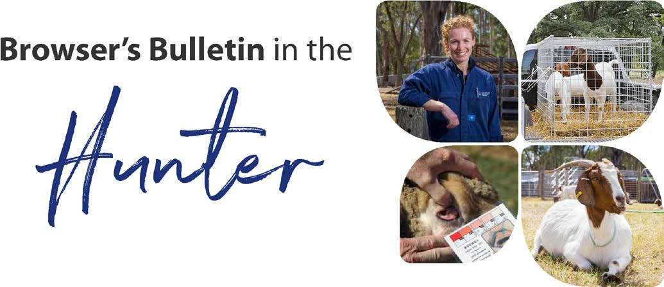
July 2020

Browser’s Bulletin 46:

A Case of Listeriosis in Sheep and Goats in the Hunter

Over the last few months a producer in the Hunter has had several health issues in their sheep and goats. They have lost 4 sheep,1 goat, have had 1 abortion in a doe, scours, ill thrift and encephalitis. It has been a really difficult time!

The producers had recently brought new sheep onto the property which were kept in a separate pen from the other sheep and goats, but they were in close proximity to the regular herd. Not long after they arrived on the property, the introduced sheep became unwell with a nasal discharge and respiratory noise.

Not long after arrival of the new sheep, the resident sheep also became unwell, with respiratory signs and scours. All sheep and goats had recently been drenched and the faecal egg count was 0 eggs per gram of faeces. Their Clostridial vaccinations were up to date and there had been no changes in diet.

Listeria is a bacterial organism that can survive for years in the soil and water. An animal becomes infected by ingesting the organism. Listeria can be distributed by carrier animals, wildlife including birds (chickens, wild birds etc.), commonly linked to mouldy hay, rotting vegetation, feeding off the ground, poor sanitation, increase in stress, overcrowding, concurrent disease and an increase in incident during the cooler months. Listeria prefer little to no oxygen and can become a more virulent form when conditions are ideal.

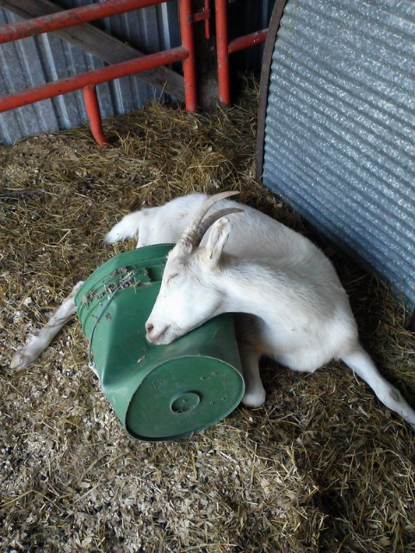
Clinical signs seen with Listeria infections include encephalitis, sudden death, septicaemia with bloody scours, abortion, keratoconjunctivitis and a metritis (infection in the uterus). On this property the producers encountered most of these clinical signs. This photo is not a goat from the property, but it illustrates clinical signs seen in the goat with encephalitis, with a twisted neck, circling in one direction and the inability to eat.

Antibiotic treatment and supportive therapy are essential in the early stages of the disease otherwise treatment is generally not successful.

Control of Listeria once it is on your property is very difficult! Listeria can quickly become resistant to disinfectants, so daily cleaning of feed and water troughs is important (elbow grease), removal of any wet feed, rotting vegetation, mouldy hay or silage, don’t feed off the ground, prevent access to chickens and remove manure contamination where possible, especially in the feeding area and burning of infected carcasses.

This is not only an incredibly interesting case, but there are several important take home messages that I thought all producers could benefit from:

- The importance of Quarantining new introductions, also to keep at a distance from your stock. Respiratory conditions can travel quite a distance on the wind.
- Do not feed off the ground
- Do not feed mouldy hay or silage
- Remove wet food
- Prevent access to birds where possible. This is possible with chickens but not with wild birds and wildlife.
- Regular cleaning of troughs

Once an animal becomes infected with Listeria it is then spread via the faeces and bodily secretions, contaminating the soil very quickly. We cannot be 100% sure where the Listeria came from in this case, but the new introductions are certainly high on my suspect list. Listeria could pop up on anyone's property at any time and it is important to be aware of preventative and control measures.

Listeria organisms can also affect humans leading to fever, vomiting, diarrhoea, encephalitis and miscarriage and stillbirths in pregnant women. People that are immune compromised (newborn, heart or liver disease, diabetes, cancer) are more susceptible to infection and must keep their distance from any confirmed Listeria case. Always remember to use personal protection and wash hands thoroughly as there are many zoonotic diseases out there and we need to ensure the protection of yourself, family, friends and staff. I have included the NSW Health Factsheet with regards to Listeriosis. https://www.health.nsw.gov.au/Infectious/factsheets/Pages/listeriosis.aspx

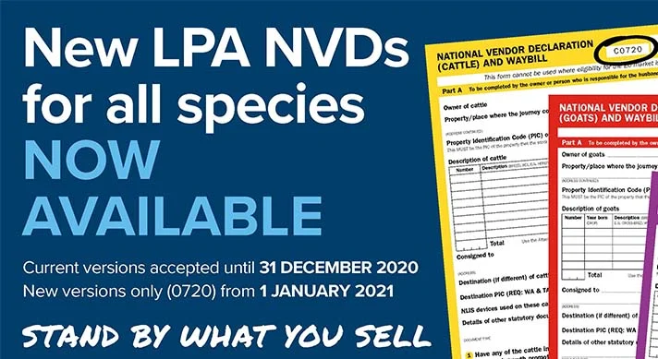
New versions of Livestock Production Assurance National Vendor Declarations (LPA NVDs) for all species are now available, identified by version number 0720.
Current versions of NVDs for all species - cattle, EU-cattle, sheep and lambs, goats, and bobby calves - will continue to be accepted until 31 December 2020.
From 1 January 2021, only the updated versions of all NVDs (0720) will be accepted for all species.
The development of updated versions of LPA NVDs for all species followed a review of all NVD versions by SAFEMEAT in 2019, which recommended a number of changes be made.
LPA accredited producers, feedlots and value chain stakeholders can use the electronic National Vendor Declaration (eNVD) platform to automatically access the updated versions.
New NVD books can be ordered through the LPA service centre, using LPA log in details.
As part of the MLA Accelerated Adoption Initiative announced in November 2019, there is no cost for LPA NVD books until 30 June 2021.
For instructions on how to complete the new version (0720) NVDs, visit the ISC website.
For simple step-by-step instructions on how to use the eNVD platform, watch the video on https://www.integritysystems.com.au/nvd

References:
Matthews, J. 2009. Diseases of the Goat (3rd edition)
Smith, M.& Sherman, D.A. 2009 Goat Medicine Second edition:

© State of New South Wales through Local Land Services 2019. The information contained in this publication is based on knowledge and understanding at the time of writing November 2019. However, because of advances in knowledge, users are reminded of the need to ensure that the information upon which they rely is up to date and to check the currency of the information with the appropriate officer of Local Land Services or the user’s independent adviser. For updates go to www.lls.nsw.gov.au

