Goat Lice…. How do I get rid of them?
There are two types of lice that affect goats; these include a biting louse (Bovicola caprae, Bovicola limbata and Bovicola crassiceps (exotic to Australia)) and a sucking louse (Linognathus stenopsis and Linognathus africanus) which lead to itchy skin and hair loss around the head, neck and back. Biting lice feed mainly on the skin scurf, superficial skin cells and bacteria which will cause an intense irritation. Goats with biting lice will be seen rubbing against trees and fences causing damage to the fibre and decreasing the value of the fibre cut as well as the skin quality. The sucking lice will cause reduced weight gains and anaemia. Most lice infestations on goats are a mixture of both biting and sucking lice. Lice on goats are generally species specific except for Bovicola ovis (sheep) and Bovicola caprae (goats) can cross over from sheep to goats but they do not survive very long on the other species and are an unlikely source of infestation. Infestations of lice often come from new introductions, contact with feral goats, goats that were missed at the last treatment or contact with other goats at shows/field days/fence line.
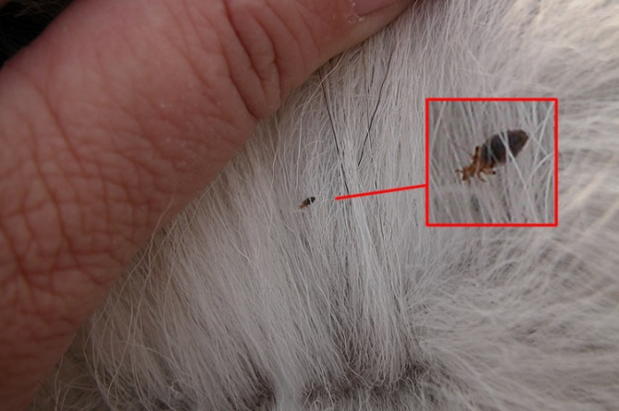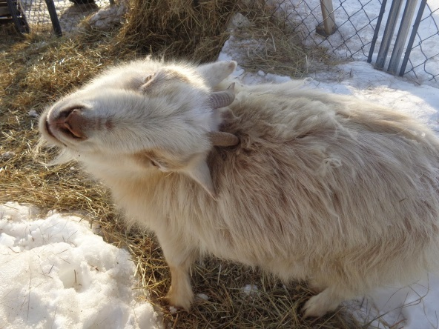
The entire lifecycle of the louse is spent on the goat. The eggs are attached to the hairs and hatch after 10-14 days. This is important to remember when you are treating the animal. Most lousicides are not effective against the nits (eggs) and new lice will emerge after 10-14 days.
Lice dislike warmer weather so they are at their lowest number in late summer and peak in winter. Lice also tend to multiply on debilitated animals complicating their illness by producing anaemia. It is recommended to treat lice in late summer/early autumn when the lice numbers are at their lowest and the entire herd should be treated at the same time. If you have sheep that are in contact it is important to treat them at the same time too.
Diazinon (organophosphate) is a chemical registered for use in goats to treat for lice infestations. Diazinon products include Nucidol 200EC, Dijet, WSD Diazinon or Coopers Diazinon to name a few. Diazinon comes in a spray and it is important to make sure the hair of the goat is thoroughly wet to the skin. Follow the label instructions and take records of the withholding period of any chemicals used on your stock. There used to be a backline called Clout S (Deltamethrin) registered for use in goats that was a lot easier but unfortunately it is no longer registered for use. Some producers with small numbers of goats can use a dusting powder called “Inca Pestene Insect Powder” (Rotenone and Sulfur); with these powders you need to work the dust into the skin with your fingers. With any chemical it is important to check if it can be used on animals producing milk for human consumption and also wear the appropriate protective clothing written in the safety instruction on the chemical label.
If you are having difficulty controlling lice in your goats please call me or your Veterinarian for some additional advice. Any further questions please contact call me on Ph: 49328866 or email kylie.greentree@lls.nsw.gov.au

