Ruminal Acidosis
It is important to change a goat’s diet slowly over 5-10 days in order to give the rumen bacteria a chance to adapt to the new diet. If goats are given an excessive amount of a high energy feed, it will rapidly ferment leading to excessive production of lactic acid. This excess acid causes a loss of all the good bacteria which is replaced by bad bacteria and toxins which are absorbed into the blood stream causing a ruminal acidosis.
Clinical signs that may be seen include lethargy, anorexia, abdominal pain, grinding teeth, diarrhoea, laminitis and death. In severe cases veterinary attention will be required but in mild cases they can be treated with an Epsom salts drench. The Epsom salts (MgSO4) can act as a laxative to move excessive grain through more rapidly and will help buffer the acid in the rumen. The dose rate for Epsom salts is 200g in 300ml of water on day 1, 100g of Epsom salts on day 2, 75g on day 3 and 50g on day 4. Another alternative drench would be 100g of sodium bicarbonate (baking soda, bicarbonate of soda) which will decrease the acidosis in the rumen but do not overdose with sodium bicarbonate as it can lead to an alkalosis. Other treatments to assist recovery include correcting any dehydration, and yoghurt/probiotics can reintroduce those good bacteria that had been killed off.
Subacute ruminal acidosis often goes unnoticed especially in dairy goats and pet goats (pygmy goats). The pet goats often get sub-clinical acidosis because they are on an inappropriate diet that is too high in grain. Fibre is an essential part of the goat’s diet and fibre in the rumen stimulates fermentation. Long fibre stimulates eructation, cud chewing and salivation. The length and structure of the fibre in the feed is important. Finely chopped straw is far less effective than unprocessed straw or hay. The rule of thumb to follow is that the fibre should be wider and longer than the animal’s muzzle. Saliva contains bicarbonate and phosphate ions which buffer the rumen and maintain the pH.
Prevention of subclinical acidosis:
- feed long fibre to stimulate chewing and saliva flow
- feed whole uncrushed grains so starch is released at a lower rate and the ruminal pH is not depressed
- Feed starchy concentrates in small amounts and often
- Feed a complete diet
Interesting Recent Case
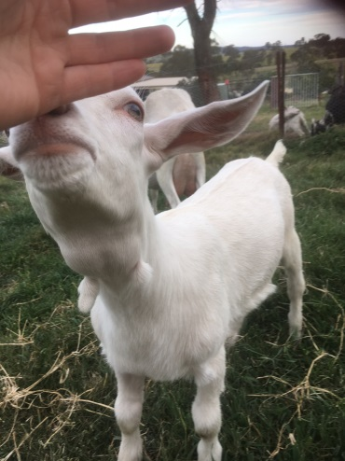
Thymic hyperplasia is a common condition seen in kids, resulting in a soft swelling in the neck region (also called “Milk Goitre”). The thymus enlargement is probably a normal occurrence that can be noticeable from 2 weeks of age and will spontaneously regress around 6 months of age. Often a “Milk Goitre” is mistaken for “Goitre” or a Thyroid gland enlargement which is caused by an iodine deficiency. Thyroid enlargement is usually part of a syndrome where you will see abortions/ stillbirths, illthrift and weak kids with poor weight gain and rough coats. Goats with “Milk Goitre” are usually in good condition with a good growth rate and shiny coat.
Reminder: Clostridial Vaccinations are important to remember as Goats are highly susceptible to Enterotoxaemia (Pulpy Kidney) which often occurs due to dietary changes. The vaccination that is used should cover Enterotoxaemia and Tetanus at the minimum as the other Clostridial diseases are not as common in goats. If you are in a liver fluke area then Black Disease can develop and in fighting bucks Malignant Oedema or “Big Head” caused by Clostridial bacteria can occur.
Primary course: 2 doses 4-6 weeks apart
Boosters are required every 6 months with one dose 4-6 weeks before kidding ensuring maximum transfer of immunity to kids.
Kids start their primary course of vaccinations at 3-4 weeks of age if the dam is not vaccinated; otherwise start their primary course of vaccinations at 8 weeks of age if the dam is vaccinated.

