Murray-Darling Healthy Rivers Screening our Streams 2022-23
  - Guidelines and conditions for Screening our Streams 2022-23 - Fish-friendly screen installation to protect native fish and improve water efficiency in the Western region.

  - This project is supported by Western Local Land Services, through funding from the Australian Government through the Department of Agriculture, Water and the Environment.

Contents

Contents ii
About the program 1
Successful trial site 1
What can I apply for? 2
Australian suppliers 2
Applicant eligibilty 3
Conflict of interest 3
Conditions of funding 3
How to apply 4
Assessment and notification process 4
Application feedback 5
How your information is used 6

About the program
Fish-friendly screens do not slow water delivery rates. Along with native fish, larvae and eggs, the screen will also stop any floating weed or debris entering the pump. Installation of the screen at the intake point protects the pump from clogging and allows the pump to work at optimum performance. This minimises wear and tear on the pump and reduces the amount of time for pump shutdown to clean secondary filters.

In Australia, millions of native fish, larvae and eggs are lost from natural water ways every year by being sucked into pumps. Since early European settlement, native fish populations are estimated to have decreased by 90 per cent across the Murray-Darling Basin. Implementing diversion screening technology is one way a water diverter can ensure native fish populations are sustained while improving water quality delivered to their property.
The Murray-Darling Healthy Rivers Program aligns with the Western Local Strategic Plan 2021-2026 strategy to support the efficient use of water resources, consistent with current best practices, technology and innovation.
The Screening our Streams - Fish-friendly screen installation to protect native fish and improve water efficiency in the Western region project addresses these strategies by providing support to landholders to install fish-friendly diversion screens on pump intakes. The program aims to seek expressions of interest across river systems of the Western region.

Successful trial site
In 2020, Western Local Land Services engaged with Porker Citrus at Ellerslie in the Lower Darling River to install a fish-friendly screen on an irrigation pump as a trial site. Since installation, Porker Citrus have experienced improved efficiencies on their farm as they no longer need to shut down the pump to clean filters with a pressure washer every two hours during peak irrigation season. Interest in the technology continues to gather momentum, with Western Local Land Services supporting landholders with assistance towards the cost of installation of screens through incentive funding programs over consecutive years. This funding program will continue to provide opportunity to landholders to get involved in the innovative technology.
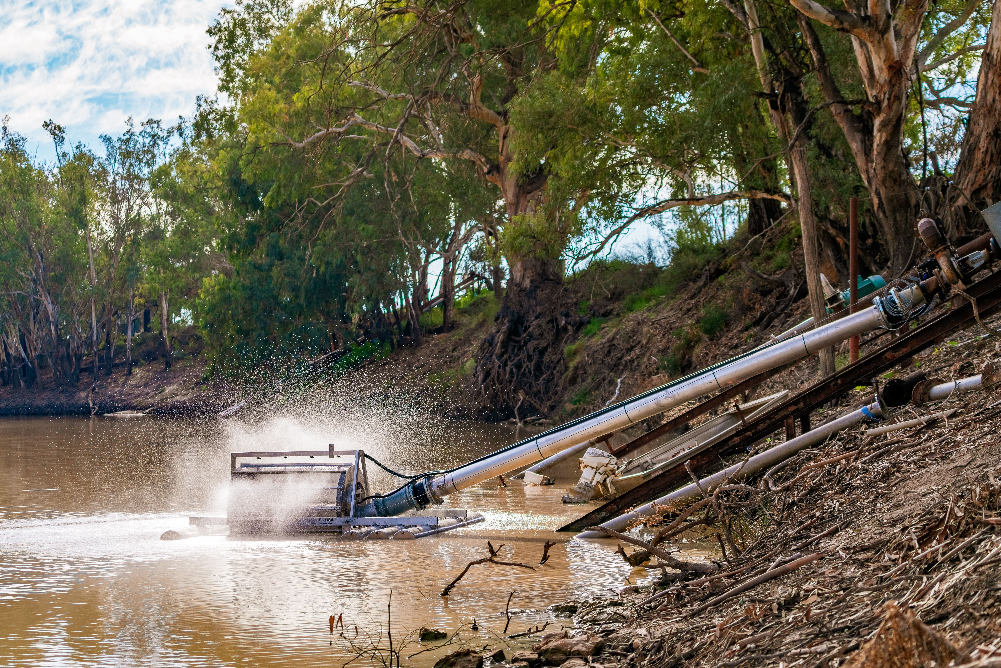
Figure 1: The 8 inch Riverscreen floating diversion screen operating at Porker Citrus
on the Darling River at Ellerslie. (Image: David Sickerdick Photography)
A virtual field day has been produced to showcase the trial project and can be found on the Western Local Land Services Youtube channel, or click the link here: https://youtu.be/Ny-1Rh50NRA.
There are a range of screens available in Australia that can be adapted to suit the needs of different water users and fish communities. The style and cost will differ due to the requirements of each site, such as intake size, pumping volume and flow rate. It is important to contact suppliers to research which screen will suit the river conditions, diversion capacity and operation and determine the total installation cost.

What can I apply for?
Western Local Land Services will provide $5,000 plus GST, towards the supply and installation of a fish-friendly diversion screen. The first payment of 75% will be paid upon contract sign-off and confirmation of the order, with the remaining payment of 25% paid upon installation.
The total cost of installation will vary as each pump system requirements are different. You will need to research and determine the most suitable screen to fit your pump and system. This will include contacting the suppliers to provide pumping information to ascertain suitability. As interest continues to increase and industry experts are coming on board, the suppliers may refer you to a local irrigation business for installation.
The screen must comply with the following NSW Department of Primary Industries Fisheries minimum standards to help sustain native fish populations:
- maximum 1-2 mm aperture mesh
- approach velocity does not exceed 0.1 m/sec (8cm in front of the screen face) when pump is operated at maximum flow rate
- able to spread velocity evenly across the screen face to avoid velocity hotspots
- maximum 1-2 mm tolerance on gaps between moving parts
- incorporates some form of cleaning mechanism, i.e. not reliant on river flow alone to clean the screen.

If your application is approved, you will need to provide a detailed quote outlining the total cost of the project, including installation. All the figures included in the quote must indicate GST and provide evidence that the screen meets the minimum standards detailed above.
Note: It is recommended that you arrange a site visit with the screen manufacturer or supplier to confirm suitability prior to securing a quote and submitting your Expression of Interest.
Visit the Fish Screens Australia website for more information on screens. Better Farming, Better Fishing. (fishscreens.org.au)

Australian suppliers
There are numerous screens available in Australia to suit various irrigation systems, and smaller stock and domestic pumps. Below is a list of screens and the nearest distributor, or contact your usual irrigation expert:

AWMA Fish Exclusion Screens  Contact: Peter Ebenwaldner  peter@awmawatercontrol.com.au  Mobile 0408 862 645  Cohuna, Vic | Clemons Clearwater Self-cleaning Suction Screen  Contact: Glen Carolan  glen@irrigationdirect.com.au  Mobile 0419 636 768  Dubbo, NSW
Johnson Offshore Intake  Systems Screens  info.johnsonscreens.au@aqseptence.com  07 3867 5555  Geebung, QLD | DAMA Manufacturing Ltd  Tel. +64 27 493 3183  New Zealand | Riverscreen – Eagle I Machinery  Contact: Greg Berryman  greg@eaglei.com.au  Mobile 0429 989 714  Finley, NSW

Applicant eligibilty
The program is available to:

- individual landholders or organisations. Note that the applicant must be the water access licence holder, or have written permission from the water access licence holder to apply
- individual landholders or organisations that are willing to pay for the remainder of the cost of the screen or screens for their pump system
- properties located within Western Local Land Services region.

The program is not available to:

- individual landholders or organisations with an outstanding monitoring activity or contract with Western Local Land Services or the former Catchment Management Authority
- individual landholders or organisations with outstanding debt, including rates, owing to Local Land Services.

Conflict of interest
Local Land Services staff and board members are required to identify and declare conflicts of interest so that they can be managed in an open and transparent way. This policy extends to external parties or individuals who may be associated with Local Land Services staff or Local Land Services board members through immediate family relationships, close friendships or business relationships. All applicants will be required to identify any such conflicts. Should a conflict be identified, a conflict of interest declaration form will be provided to the applicant to complete.

Conditions of funding
If your application is successful, the following conditions of funding will apply:
- you must undertake all investigations to seek advice on the most suitable screen for your needs, including obtaining a written quote if notified of approval
- you must formally commit to undertaking your project by entering into a funding agreement with Western Local Land Services
- you must assume responsibility to order and purchase the screen. Western Local Land Services require proof of order prior to the first payment
- you must assume full ownership of the screen and maintain the screen in operational order, including bearing all associated costs of managing and maintaining the screen
- you must submit a photo of the pump prior to installation, during installation and post installation
- you must submit annual monitoring for a period of five years (a template will be provided)
- the maximum amount of funding available is $5,000, plus GST per screen.
- 75% of the payment will be made up front on acceptance of the funding agreement and evidence of screen order. The remaining 25% t will be paid once the screen is installed
- you must supply a correctly rendered tax invoice for each payment when it becomes due. Invoices are to be submitted to the project mangager and made out to:
Local Land Services
Locked Bag 21
Orange NSW 2800
- screen must be installed and operational by 30 April 2023. Note that an inspection will be carried out by a Western Local Land Services officer to verify the successful completion of the project
- if screen is unable to be installed by 30 April 2023, applicants must contact Western Local Land Services to request a variation
- variations to the funding agreement must be requested via email or in writing to the project manager and will be assessed on a case by case basis
- you must agree to allow Western Local Land Services to publish information about you and your project on our website, Facebook page and other communication channels and products as required
- you must complete and submit a survey following the successful installation of the screen
- funds will be returned to Western Local Land Services if any of these conditions are not met
- you must complete and submit a follow-up survey annually for five years following the installation of the screen.
It is recommended that you do not apply for funding if you are not able to meet these conditions.

How to apply
Interested landholders are required to complete the following application process:

- To apply, you must complete the Screening our Streams 2022-23 Expression of Interest form, available from www.lls.nsw.gov.au/western or contact Western Local Land Services to request a form. Expressions of Interest close by 5 pm Friday 2 December 2022, or when funding is fully allocated.

- Following the closure of expressions of interest, a Western Local Land Services officer will liaise with you to ensure suitability for your pump is confirmed prior to entering into a contract with Western Local Land Services.
For further information on the program or for assistance with your application, please contact Kaye Gottschutzke on 0429 981 331.

Assessment and notification process
- Applications are now open and will be assessed as they are received with applications closing 5 pm, Friday 2 December, 2022 or when funding has been fully allocated.
- Applications will be assessed against the criteria set in these guidelines: ie evidence of compliance with NSW DPI Fisheries minimum standards; applicant eligibility; and agreement with the Conditions of Funding.
- Please note: Applications will be assessed in order of receipt,therefore mailed applications may be disadvantaged as they will be lodged by the date received by Western Local Land Services.
You will receive notification from Western Local Land Services when your application has been assessed and to inform you of the outcome of your application.

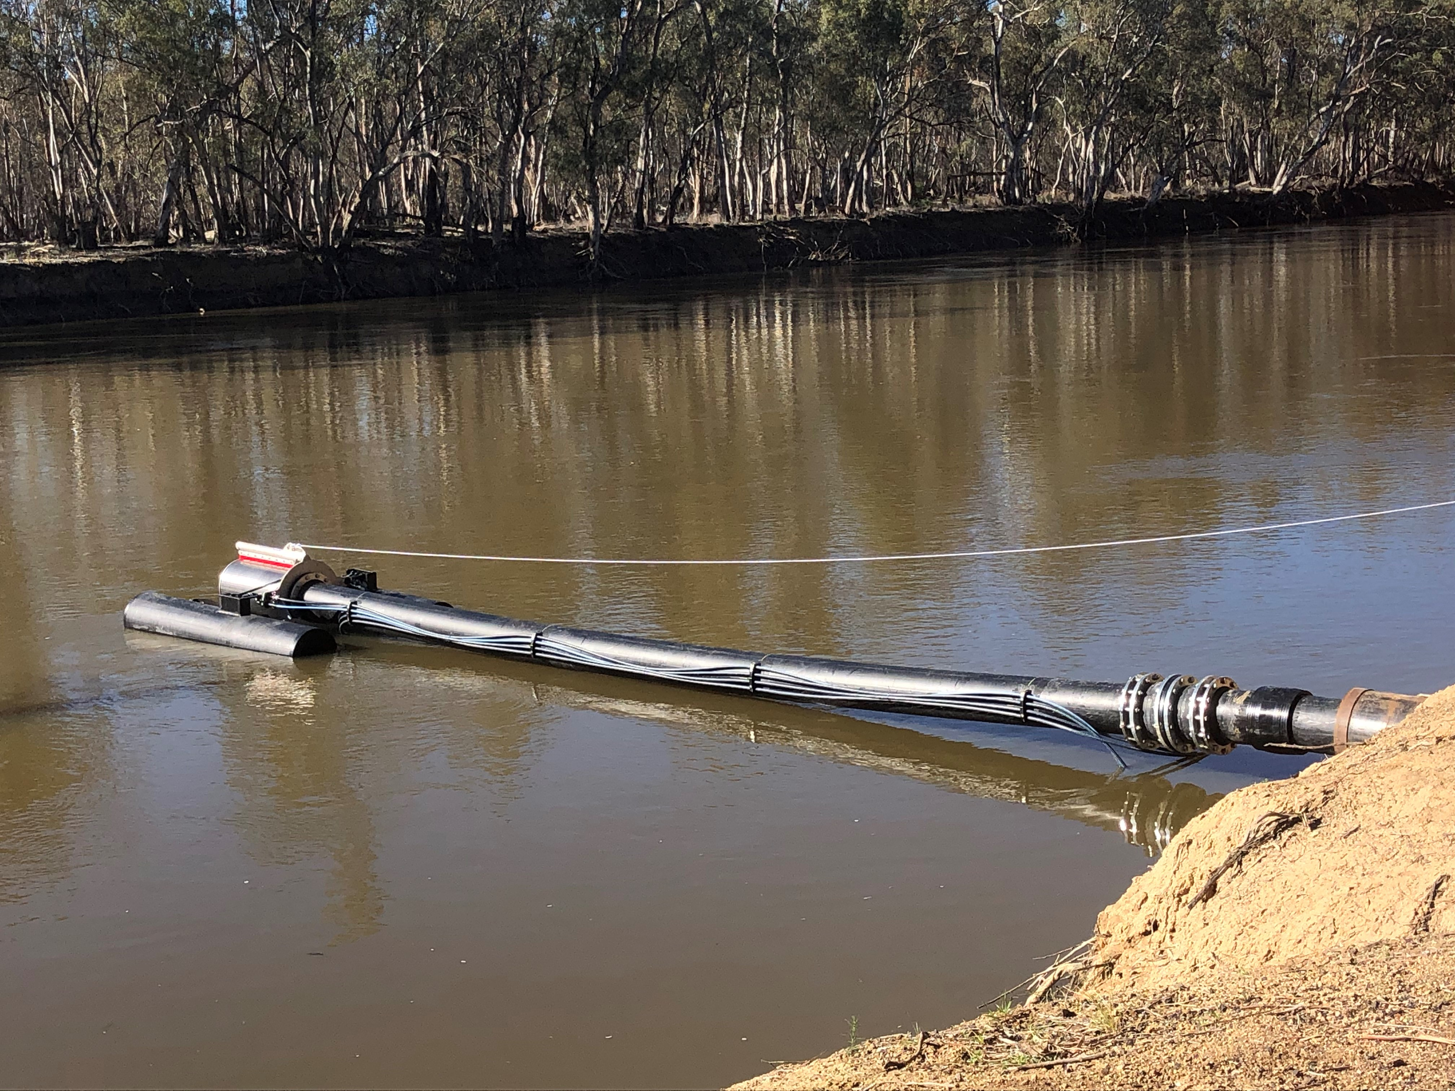
Figure 2: AWMA’s self-powered, self-cleaning intake screen on submersible
pontoon in raised position to be lowered to river bed.

Email your expression of interest to: kaye.gottschutzke@lls.nsw.gov.au.

Alternatively, you can post your expression of interest to:
Western Local Land Services
Screening our Streams Project
PO Box 363,
Buronga, NSW, 2739.

Expressions of interest must be submitted by 5 pm Friday 2 December, 2022.

Application feedback
If your application was not successful, you may ask for feedback on why it was not supported. Please contact Kaye Gottschutzke on 0429 981 331.

How your information is used
The information you provide to Western Local Land Services in your application will be stored and used in accordance with the Privacy Act 1988. If you have concerns about the amount or type of information we require in the application form, please contact Kaye Gottschutzke on 0429 981 331.
Western Local Land Services will also use this information to communicate to the public about the program. This may include publishing communication articles on our website, Facebook page and other communication channels and products, as required.

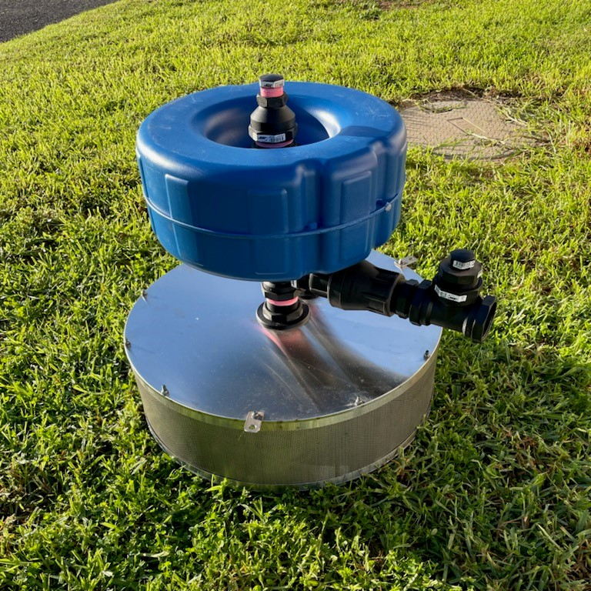
Figure 3: The self-cleaning 2 inch diversion screen ready for installation, designed and manufactured
by Mildura Irrigation Repairs for a stock and domestic pump on the Darling River.

