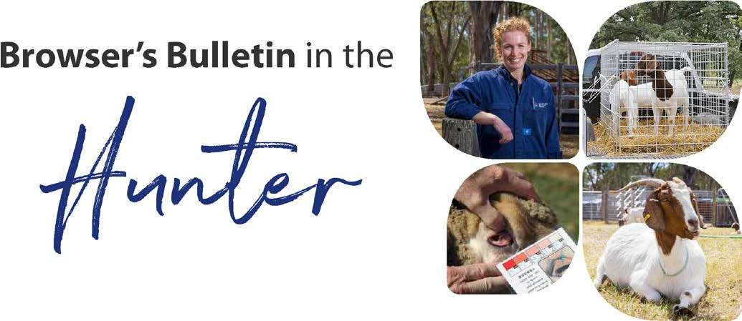
May 2021

Browser’s Bulletin 56:
NLIS Summary for Sheep and Goat Producers

Over the last month we have had a lot of new members to the goat group, so, I thought it was a fantastic opportunity to discuss the National Livestock Identification Scheme (NLIS) and sheep and goat producer movement obligations.

NLIS is Australia’s scheme for identification and tracing of livestock and is crucial in protecting and enhancing Australia’s reputation as a producer of quality meat products. NLIS allows Australia ongoing access to valuable export markets. NLIS also enables Australia to act quickly in food safety and disease incidents. NLIS (Sheep and goats) was introduced in 2006 and in NSW (New South Wales) it is a mob-based system.

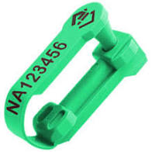
If you have livestock, your property should have a Property Identification Code (PIC). If you are unsure if your property has a PIC, you can contact your Local Land Service Office and they will assist you. All sheep and goats (exemptions: rangeland /feral, dairy goats, and earless goats) must be tagged with a NLIS ear tag before they are moved from the property to a saleyard, abattoir, and other property. The tag must be an approved NLIS tag with the Property Identification Code (PIC) of the property the sheep/goats are moving from, unless the sheep were bought in, and they have already been tagged. NLIS ear tags can be purchased through your local rural merchant. Orders can take up to 14 days.

If you are moving sheep/goats off your property, you will need to fill out travel documents (National Vendor Declaration (NVD) or Travelling Stock Statement (TSS)). To obtain NVDs or electronic versions (eNVD) then you need to be accredited with Livestock Production Assurance (LPA). To do this, go onto https://www.integritysystems.com.au/on-farm-assurance/livestock-product-assurance/

LPA NVDs provide evidence of livestock history and on farm practices when transferring animals through the chain. LPA ensures that livestock owners understand responsible animal treatments, stock feeds and pasture treatments, dispatch and movement requirements of livestock, biosecurity, and animal welfare. Once you are LPA accredited you can order NVDs via the LPA website.

The next step is to set up a NLIS Database account if you have not done this already. All movements on and off the property must be recorded on the NLIS Database as a mob-based movement. For movements to and from a saleyard the saleyard will notify the NLIS database of the movement , movements to the abattoir will be done by the abattoir, goats to and from an accredited depot will be done by the depot operator but all other sheep and goat movements between PICs must be recorded on the NLIS Database by the receiver of the stock. Sometimes, the previous owner/friend/family will offer to do the NLIS Database movement for the receiver of the stock. There is no problem with a third party doing the NLIS movement for the receiver, but the receiver needs to ensure that the transfer has been done as it is their responsibility. This NLIS Database movement needs to be done within 48 hours of arrival at a new PIC.

Before stock leave your property, it is important to ensure each sheep or goat has an approved NLIS ear tag (Except feral goats and dairy goats).
Breeder NLIS ear tags for sheep and goats are printed with the PIC of the property on which the stock are born and tagged for the first time. Breeder tags are usually produced in their year of birth colour (see the table below). Pink post-breeder tags are used to identify sheep or goats that are no longer on their property of birth and have lost their ear tag, consequently they are tagged with a pink post-breeder tag printed with the PIC of the property on which it is being tagged.
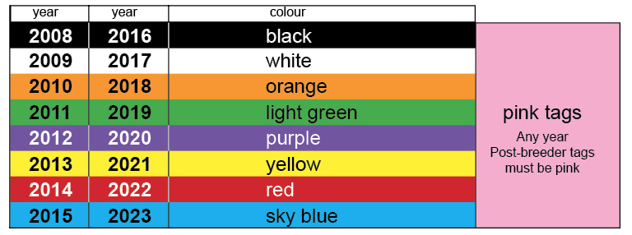
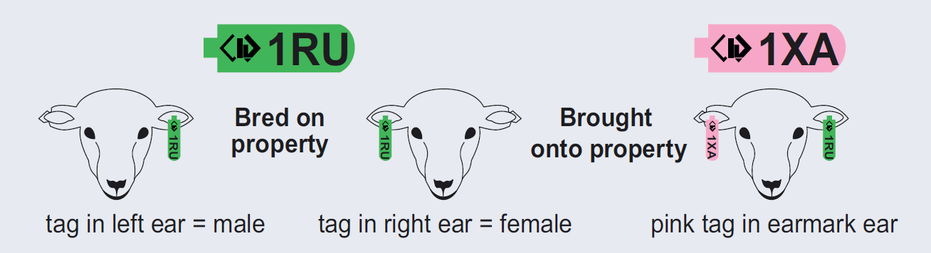
Each consignment of sheep/goats must be accompanied by an accurate, fully completed, and signed travel document (NVD or TSS). The NVD is a legal document that must be completed correctly. If you have sheep or goats in the consignment from multiple PICs, then all PICs must be listed on the NVD. If it is impractical to record all PICs-of-origin on the NVD, an acceptable alternative is to apply a pink post-breeder tag to all non-vendor bred sheep/goats in the consignment (i.e. in addition to their original NLIS tag), as shown in the diagram on the righthand side, above.” More information can be found in the NSW DPI Factsheet at NLIS: Sheep and goats - Basic information (nsw.gov.au)
If you are selling stock off an agistment property, then you need to use a NVD for the agistment property and this travel document must be retained for 7 years. It is illegal to remove any NLIS ear tags and illegal to make any alterations to the pre-printed NVD.

The last step in the movement of sheep/goats, is to do the transfer on the NLIS Database. Once you are logged into the Database, select ‘mob-based movement’ off or onto your PIC. Enter details and follow prompts. If you are having any difficulties, then please contact your LLS (Local Land Services) Office or the NLIS helpdesk https://www.nlis.com.au/contacts/ NSW NLIS Helpline: 1300 720 405 for assistance.

Exemptions from NLIS Tagging
- Feral goats are exempt from tagging if they move directly from property of capture to slaughter, or via one goat depot to an abattoir for slaughter. This exemption does not apply to goats sold at a saleyard, or feral goats moved to another property from a goat depot. All movements to the goat depot and from the depot must be recorded by the depot operator as a mob-based movement on the NLIS Database and must be uploaded within 2 working days of the goats arriving or leaving.
- Dairy goats and earless goats are exempt from tagging for movement between properties but must have a completed travel document (NVD). If dairy goats and earless goats are going to saleyard or abattoir they must be tagged.

The NSW Police can pull over vehicles carrying stock and request to see travel documents and ensure that stock are correctly identified with NLIS ear tags. If you do not have the correct paperwork you may face prosecution and a penalty of up to $2200.

For most of you, this will be second nature, but some new producers may find it all very daunting! Please do not hesitate to contact me via phone or email at kylie.greentree@lls.nsw.gov.au , so we can get you on the right track.

References:
- https://www.dpi.nsw.gov.au/animals-and-livestock/nlis/sheep-goats/guidelines/faqs
- https://www.goatindustrycouncil.com.au/industry-programs/national-livestock-identification-system/
- https://www.dpi.nsw.gov.au/__data/assets/pdf_file/0019/732313/nlis-feral-and-rangeland-goats.pdf
- https://www.dpi.nsw.gov.au/animals-and-livestock/nlis/sheep-goats
- https://www.integritysystems.com.au/identification--traceability/national-livestock-identification-system/
- https://www.dpi.nsw.gov.au/animals-and-livestock/nlis/sheep-goats/guidelines/basic

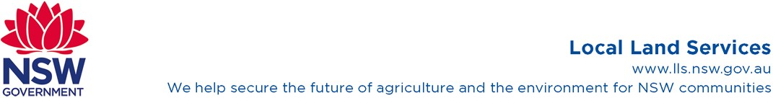
© State of New South Wales through Local Land Services 2019. The information contained in this publication is based on knowledge and understanding at the time of writing November 2019. However, because of advances in knowledge, users are reminded of the need to ensure that the information upon which they rely is up to date and to check the currency of the information with the appropriate officer of Local Land Services or the user’s independent adviser. For updates go to www.lls.nsw.gov.au

