Coccidiosis in Goats
Coccidia is caused by a protozoal parasite, there are 12 species of Coccidia that affect goats and all except 1 (which can be transmitted between sheep and goats) are specific to goats. Therefore the Coccidia species that affect cattle, poultry and domestic pets do not affect goats.
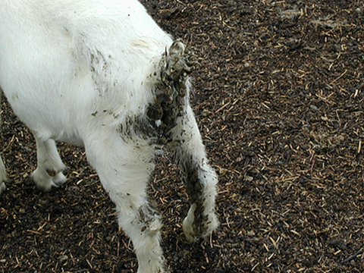
Coccidia eggs (oocytes) are ingested by kids in their first few weeks of life. Once the oocytes are ingested they mature in the intestinal cells of the kid and produce millions of oocytes in 3-4 weeks after ingestion contaminating the environment. Certain environmental situations lead to higher exposure of the Coccidia oocytes, including housing in sheds, overcrowding, short pasture and stress factors such as weaning, transport, change in diet and adverse weather conditions.
The most common time Coccidiosis is detected is from 4-7 weeks of age and after this time kids tend to develop immunity unless they are still under stress factors such as poor hygiene. Under conditions of stress, adults can also become susceptible to Coccidia.
Clinical signs that you may see in kids with Coccidia infections include depression, colic, weight loss, diarrhoea (sometimes with blood and mucus), dehydration, dull coat and death. Some kids may have a sudden onset of colic and death in 24 hours without any signs of diarrhoea which is due to a massive release of Coccidial organisms from the intestinal cells. Any kid that has been unwell due to Coccidia will have a decreased growth rate and poor fibre production.
All kids are infected with Coccidia at a very young age, so it is normal to detect oocytes in a faecal egg count. Clinical signs will depend on the number of Coccidia present, the species of Coccidia, the history and environment.
Prevention is better than cure!
*Good hygiene is the cornerstone to coccidiosis control.
* Avoid overcrowding
* Clean straw pens and regularly cleaned (at least every 3 weeks) or slatted floors to prevent environmental build up.
* Raise the food and water to prevent faecal contamination
* Ensure the water troughs do not overflow
* Don’t mix different age groups.
* Prevent stress
* Maintain good health with good nutrition and worm control
* Keep pastures long
Some intensive operations use prophylactic medications in the feed to control coccidiosis. What these medications do is decrease the oocytes output and therefore the kids are exposed to less oocytes in their environment allowing them to develop their immunity with less chance of ill health. It is important if these prophylactic medications are being used, to monitor food input. Food input= drug input. Note treating scouring kids with a worming drench does not kill coccidian parasites.

If you are having problems with Coccidiosis in your herd it is important to discuss preventative measures with your Veterinarian. Many drugs used in treatment of coccidiosis are off label with goats, so you may require a veterinary prescription. Any further questions please do not hesitate to call me on Ph: 49328866

