Property Planning Program
Guidelines and expression of interest form

Expressions of interest are being called for from individuals, groups and organisations applying to participate in property planning with Ecosystem Management Understanding (EMU)TM within the Western region of NSW.

EOI due 9 am Monday 12 July 2021

Hand delivery:  To any Western Local Land Services office  Email:  georgina.chaplain@  lls.nsw.gov.au | Post:  Western Local Land Services EMU Property Planning  PO Box 307  Cobar NSW 2835

In partnership with

Ecosystem Management Understanding (EMU)TM call for expressions of interest
Western Local Land Services is funding a property planning process called Ecosystem Management Understanding (EMU™).
The EMU™ approach helps land managers to understand landscape processes, conditions and trends. On- ground projects are developed that address ecological sustainability and agricultural productivity.
Involvement in the EMU™ process is totally voluntary and all information stays on property. The land manager’s knowledge provides the foundation for the process with the facilitators helping to build a baseline assessment of the property.
The program will extend to four land managers with a preference for groups within the same district or adjoining properties, however, individual land managers can still apply.
For more details on the EMU™ approach see www.emulandrecovery.org.au.

Outcomes for participants
The program will be delivered by an EMU™ facilitator and Western Local Land Services staff and involves the following stages:
- Baseline assessment of each property
- Identify and map processes which threaten the health of the landscape of each property
- Identify and map priority projects for each property
- Project proposals developed for each property
- Involvement in a field day discussing outcomes

Contact your Local Land Services office:

If you are interested in submitting an expression of interest please contact Paul Theakston, Rangeland Rehabilitation Officer, or you can contact your Local Land Services officer. Aboriginal land managers can also contact local Aboriginal Communities Officers.

Location | Staff contact | Phone | Address
Balranald | Tanisha Shields | 0447 642 131 | 82 Market Street  Balranald NSW 2715
Bourke | Gemma Turnbull | 02 6870 8632 | 21 Mitchell Street  Bourke NSW 2840
 | Guy Gibbs  (Aboriginal Communities) | 02 6870 8629
Broken Hill | Craig Anderson | 0439 181 579 | 32 Sulphide Street  Broken Hill NSW 2880
 | Warren Kelly  (Aboriginal Communities) | 0439 981 483
Buronga | Luke Stacey | 0419 518 307 | 32 Enterprise Way  Buronga NSW 2739
Cobar | Paul Theakston | 0428 259 231 | 62 Marshall Street  Cobar NSW 2835
 | Brian Dohnt | 0455 901 258
Hillston | Andrea Cashmere | 02 6967 2507 | 180 High Street  Hillston NSW 2675
Regional | Paul Theakston  Senior Land Services Officer  (Rangeland Rehabilitation) | 0428 259 231 | 62 Marshall Street  Cobar NSW 2835
 | Craig Anderson  Land Services Officer (Rangeland Rehabilitation) | 0439 181 579 | 32 Sulphide Street  Broken Hill NSW 2880

Where the funding comes from
Western Local Land Services utilises funds from the Australian Government’s National Landcare Program.

National Landcare Program Phase Two – Regional Land Partnerships
The Regional Land Partnerships program is part of the Australian Government’s investment to deliver on- ground natural resource management through projects targeting key national environment and sustainable agriculture priorities at the regional level. One of the outcomes for this program is an increase in the awareness and adoption of land management practices that improve and protect the condition of soil, biodiversity and vegetation.
Western Local Land Services must demonstrate its ability to deliver against the program’s strategic objectives and targets and funding may only apply to specific activities and areas of the Western region.
For more information on the National Landcare Program visit www.nrm.gov.au.

Local Land Services funding guidelines

Eligibility
- if your property falls within the boundary of the Western region, you’re eligible to submit an expression of interest. See map below outlining the Western region
- your project may be used by Local Land Services for demonstration and/or promotional purposes with your consent
- expressions of interest are invited from all land managers including individuals, groups, non- government organisations, not-for-profit organisations, Local Government and State Government agencies (core functions of government agencies will not be funded)
- where an applicant is not the owner/lessee of the land, specific permission will be required from the owner/lessee to implement the project. Written permission from the owner/lessee will be required before approval.

This program is not available to:

- individuals with an outstanding monitoring activity with Western Local Land Services or the former Catchment Management Authority
- individuals with outstanding contracts with Western Local Land Services, including incomplete weed management contracts
- individuals with outstanding debt, including rates, owing to Local Land Services
- applicants applying for works proposed on land located outside the Western region

Participant’s commitment
The role of the participant
The role of the participant is to actively engage in the workshops to ensure they develop the knowledge and skills to assess their property according to the EMU process. Further expectations of the participants are listed below:
- attend at least three workshops. Workshops may be held either on the participant’s property or properties of other participants
- participate in at least one property visit with the EMU™ facilitator and Western Local Land Services staff
- participate in a mix of phone and email communication with the EMU™ facilitator and Local Land Services staff
- maintain regular liaison with Local Land Services staff in relation to program developments and requirements
- complete program evaluation and reporting requirements
- be a program ambassador, promoting the program through case-studies, media stories or host a field day if required
- participants will be required to sign a Participant Commitment Statement agreeing to their role in the program and committing to participation in activities.

Assessment process
Your application will be assessed by a panel that may be made up of a mix of Western Local Land Services staff and an EMU™ facilitator. Based on the information provided the assessment panel will:
- confirm that the participant meets the funding criteria.
- determine if the application is part of a group or an individual. Preference will be given to groups with adjoining property boundaries
- score your application based on the answers provided in the expression of interest form
- rank all eligible participants, with the highest ranked participants given the first offer of participation.

Map of the Western region
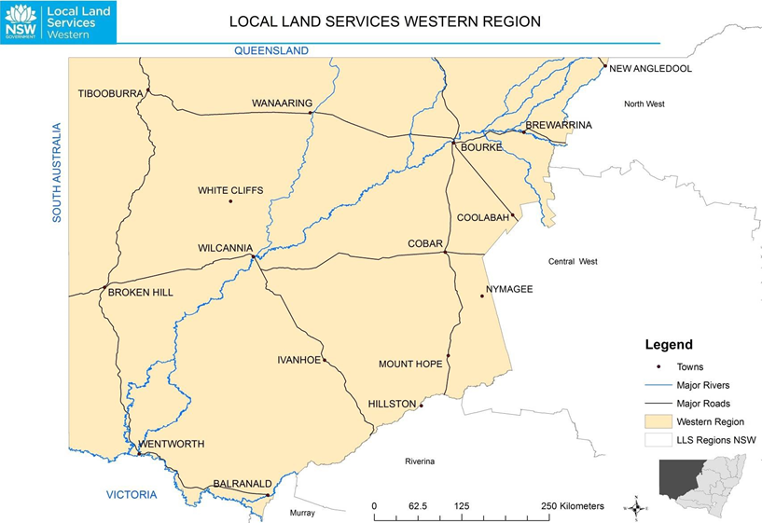

Compliance with existing State and Commonwealth legislation
Local Land Services only provides the funding to run the EMU™ workshops. Any project proposals generated as a result of participant’s involvement with EMU™ does not authorise you to implement the project. You must ensure that your project has all necessary approvals, licenses, permits, consents, etc. and that your project complies with all relevant legislation including, but not restricted to, the following:

Legislation | How is it relevant? | More information
Crown Land Management Act 2016 - NSW | Western Lands Lease conditions | https://legislation.nsw.gov.au/view/html/inforce/current/act-2016-058
National Parks and Wildlife Act 1974 - NSW | Protection of Cultural Heritage sites | https://www.legislation.nsw.gov.au/view/whole/html/inforce/current/act-1974-080
Biodiversity Conservation Act 2016 and Local Land Services Amendment Act 2016 - NSW | Clearing or disturbance of native vegetation | https://www.legislation.nsw.gov.au/view/html/inforce/current/act-2016-064
Biodiversity Conservation Act 2016 - NSW | Protection of threatened species and endangered ecological communities when installing infrastructure | https://www.legislation.nsw.gov.au/view/html/inforce/current/act-2016-063
Environment Protection and Biodiversity Conservation Act 1999 - Federal | Protection of flora, fauna, ecological communities and heritage places | https://www.legislation.gov.au/Details/C2021C00182
Environmental Planning and Assessment Amendment Act 2017 - NSW | Impact of project proposal on threatened species and/or ecological communities | https://www.legislation.nsw.gov.au/view/html/inforce/current/act-2017-060
Local Land Services Act 2013 – NSW | Project proposals must be located within the Local Land Services Western Region | https://www.legislation.nsw.gov.au/view/html/inforce/current/act-2013-051
Water Management Act 2000 – NSW | Impact of project on streams, flow of water and complying with any Floodplain management plans | https://legislation.nsw.gov.au/view/html/inforce/current/act-2000-092
Prevention of Cruelty to Animals Act 1979 - NSW | Infrastructure must be compliant with codes | https://www.legislation.nsw.gov.au/view/html/inforce/current/act-1979-200
Work Health and Safety Act 2011 | Safe work method statements and reporting | https://www.legislation.gov.au/Details/C2018C00293

Project timeframe
Land managers who are successful in their expression of interest will participate in up to three workshops by 31 December 2021. The exact number of workshops and dates will be negotiated with successful participants.
A field day will also be conducted by 31 May 2022, subject to negotiating with the participants.

Lodging an expression of interest

If you believe that your project fits the criteria, you can lodge an expression of interest form, found on our website. Expression of interest forms will be assessed if they are received or post-marked by 9am Monday 12 July 2021. You will receive an acknowledgement to confirm receipt of your application form.
Email your application form to:

georgina.chaplain@lls.nsw.gov.au

Alternatively, you can post your application form to:

Western Local Land Services
EMU™ Property Planning
PO Box 307
Cobar, NSW 2835.

You can also hand deliver to any Western Local Land Services office. For office locations please visit: https://western.lls.nsw.gov.au/our-region/contact-us
Application forms must be submitted by 9 am, Monday 12 July 2021.

The expression of interest form is found below.

Applicant details – lodge by 9 am Monday 12 July 2021

Name  Please include first and last name, not initials |  |  | Mailing address
Property name |  |  | Nearest locality
Email
 | Do you wish to receive all future correspondence on your EOI by email? ☐Yes ☐ No
Contact Number
LLS Holding Number |  | WLL |  | DP/Lot Number

- If successful, are you willing to agree to the Participant Commitment Statement? ☐ Yes ☐ No

- Are you part of a formal or informal group seeking to do property planning? ☐ Yes ☐ No
Note: preference will be given to groups with adjoining property boundaries.
If you are part of a formal or informal group, please list the other members.

- Have you taken part in property planning workshops and if so, what was your experience (positive or negative)?

- How have you dealt with natural resource management issues on your property?

- Why do you want to be involved in the Ecosystem Management Understanding (EMU™) process?

Signature of applicant:

Date: / /2021

