Caseous Lymphadenitis (CLA)
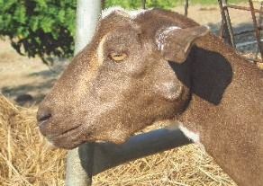
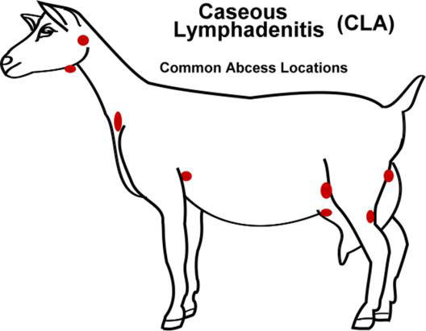
Over the past few weeks, I have had a few enquiries about CLA. CLA is caused by the bacteria Corynbacterium pseudotuberculosis. Generally you will see enlarged lymph nodes, especially around the head. Occasionally they can get internal CLA which is called the visceral form and the only clinical sign you will see is emaciation. The visceral form is rare in goats.
Once on a farm, CLA is very difficult to eradicate. The bacteria are easily spread between goat through environmental contamination, flies, open wounds and inhalation. Often it can be brought onto a property through new goat introductions, so care must be taken when purchasing new animals and ensure you ask the producer if they have had any issues with CLA on their property.
CLA can be diagnosed on clinical examination and culture of the abscess. Care must be taken to ensure that none of the abscess contents contaminate the ground. The suspect animal should be isolated ASAP. The pus in a CLA infected lymph node of a goat is a creamy white colour that is thick and clinging. If the pus is free flowing then it is unlikely to be CLA. In sheep the CLA infected lymph nodes are greener in colour with concentric rings.
It is important to isolate new introductions for as long as physically possible. It can take up to 6 months for CLA to express itself with enlarged lymph nodes. It is recommended if CLA is diagnosed on your property, that culling infected goats is generally the most successful method of control, along with regular palpation of lymph nodes of other goats that have been in contact with the infected animal.
Treatment is not usually attempted as antibiotics generally do not penetrate the abscess. Control of this disease is achieved by vaccination and prevention through management strategies. Vaccination recommendations consist of 2 injections given 4 weeks apart followed by a booster every 6 months in goats and 12 months in sheep. Vaccines available include the 3-in-1 or the 6-in-1 which will cover CLA and Clostridial diseases.
Tips for Goats in Hot Weather: Goats are always thought to be very hardy animals, and they certainly can live in very harsh climates but they don’t deal well with extremes in climatic conditions. Those goats with a fleece such as Angora and Cashmere goats have less thermal insulation than wool on sheep. Goats generally have smaller body mass than sheep at any given age and also they lay their fat down in their abdomen so they have very little subcutaneous fat and consequently provided less tolerance to extreme weather conditions. Always ensure goats have plenty of cool, clean water available to them and on extremely hot days and it can help to add electrolytes to the water. Provide plenty of shade for goats especially when it comes to the storms. Goats don’t like to get wet and they will stress in storms even leading to death and abortions.

