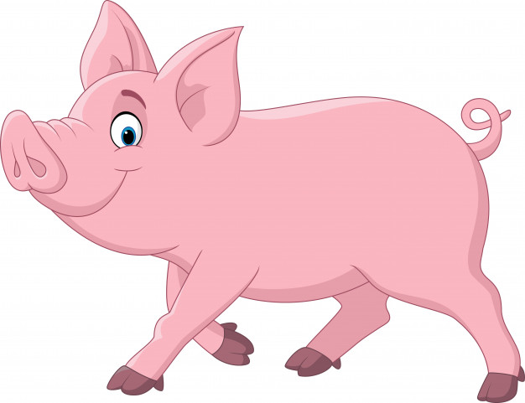
Hunter LLS Pig Newsletter 4: Vaccinations

July 2020

We are often asked what vaccinations do pigs need? This depends on a number of factors, including the age of the pigs and purpose of the pigs. Pigs in a large breeding facility require vaccinations to cover more diseases than those who live free range and are not used for breeding purposes. However vaccination is one of the best and simplest methods we have of managing disease in our free range pig herds, yet it is often overlooked. Vaccinations help prevent some diseases that can affect productivity or even cause death.
The more common vaccination schedule for pigs in Australia include vaccinating for the following diseases:

 | Leptospirosis | Erysipelas | E.coli | Parvovirus
Gilts at Selection | + | + | + | +
4-6 Weeks later | + | + |  | +
3-4 weeks before farrowing | + | + | +

Leptospirosis causes stillbirths, high piglet mortality rates and abortions and is a zoonoses, which means that it can also cause disease in humans. Porcine Parvovirus causes reproductive failure. It is different to the parvovirus in dogs. E.coli (a bacteria) causes scouring in suckling pigs and in pigs after weaning. Vaccinating the sow 3-4 weeks before farrowing, helps prevent scours in newborn piglets (as long as they receive adequate colostrum). To prevent scouring, decreased growth rate and sudden deaths in pigs after weaning, the vaccination is to be given to sucker pigs one week before weaning. Erysipelas may cause fever, diamond skin disease, arthritis, abortion, heart disease and death.
Erysipelas, Leptospirosis and Porcine Parvovirus are all present in the environment, in the soil, manure or urine, so avoiding them is nearly impossible.
There are also vaccines available for: Porcine Circovirus (PCV), Enzootic pneumonia, Porcine pleuropneumonia, Glasser’s disease and Porcine Proliferative Enteropathy.
Whenever a pig is vaccinated for the first time, it will require a booster vaccination, usually 4 weeks later. The second vaccination is extremely important and must not be missed or your pigs will not have protection from the disease or diseases that you are trying to prevent.
If you have never given a pig an injection before, it can be a daunting experience. Try and find someone with experience to give you some guidance and help you out. It is a good idea to have another person hold piglets while you vaccinate them. If you are vaccinating larger animals, it is essential to have a race or crate that will stop the animal moving around and will make the job a lot easier and more pleasant for both you and the pig.
Vaccines are not available in single doses but this should not deter you from using them, because when compared to the cost of not vaccinating, disposing of any unused product is worth it. Using the right equipment is very important. Read the product instructions to find out what size needle to use as this will vary depending on the route of injection. Subcutaneous injections are delivered just under the skin, so the needle will need to be quite short, while a longer needle that can penetrate the fat layer and reach the muscle is needed for an intramuscular injection.
A combined parvovirus, leptospirosis and erysipelas vaccine is available in Australia.
Vaccines are very effective at reducing the incidence and severity of disease, but as they depend on the integrity of the animal’s immune system, no vaccine used on its own is 100% effective. Vaccines must always be used in combination with good hygiene and management together with biosecurity programs.
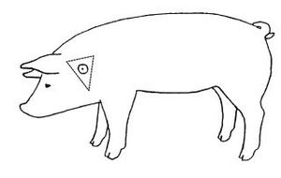
Remember:
- Always follow the manufacturer’s recommendations, read the label and check the expiry date
- Observe the withholding period
- Follow storage instructions as most vaccines require refrigeration
- Use the correct size needle Vaccination Site (high behind the ear)
- Give the correct dose
- Always use clean equipment and clean the vaccination site of any dirt or organic matter before each injection (avoid injection of animals during wet weather or under dirty/dusty conditions)
- Complete the vaccination process as required – give the second injection on time
- Give booster vaccinations every 6 months
- Keep a record of any treatments given to your pigs
- Ask your vet for advice on an appropriate vaccination program
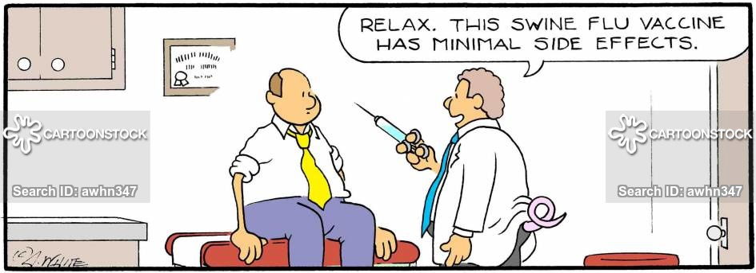

© State of New South Wales through Local Land Services 2019. The information contained in this publication is based on knowledge and understanding at the time of writing July 2020. However, because of advances in knowledge, users are reminded of the need to ensure that the information upon which they rely is up to date and to check the currency of the information with the appropriate officer of Local Land Services or the user’s independent adviser. For updates go to www.lls.nsw.gov.au
