On-Farm Sustainable Water Use in the Western Region.
  - Guidelines and conditions for Fish-friendly Screens for Efficient Use of Water 2021-22 Project.

  - This project is supported by Western Local Land Services, through funding from the NSW Government.

Contents

Contents ii
About the program 1
Successful trial site 1
What can I apply for? 2
Applicant eligibilty 2
Conflict of interest 3
Conditions of funding 3
Applicants please note 4
How to apply 4
Assessment and notification process 4
Application feedback 5
How your information is used 5

About the program
In Australia, millions of native fish, larvae and eggs are lost from natural water ways every year by being sucked into pumps. Since early European settlement, native fish populations are estimated to have decreased by 90% across the Murray-Darling Basin. Implementing diversion screening technology is one way a water diverter can ensure native fish populations are sustained while improving water quality delivered to their property.
Fish-friendly screens do not slow water delivery rates. Along with native fish, larvae and eggs, the screen will also stop any floating weed or debris entering the pump. Installation of the screen at the intake point protects the pump from clogging and allows the pump to work at optimum performance. This minimises wear and tear on the pump and reduces the amount of time for pump shutdown to clean secondary filters.

The On-Farm Sustainable Water Use in the Western Region Program aligns with the Western Local Strategic Plan 2021-2026 strategy to support the efficient use of water resources, consistent with current best practices, technology and innovation.
The Fish-friendly Screens for the Efficient Use of Water 2021-22 Project addresses these strategies by providing support to landholders to install fish-friendly diversion screens on pump intakes. The program aims to seek Expressions of Interest across river systems of the Western Region of NSW with the aim of targeting specific reaches as funds become available.
The 2021-22 project targets the Lower Darling River from the junction at Wentworth to Menindee reach.
Expressions of Interest received for pumps that are outside the target reach for 2021-22 will be recorded and filed, providing direction for future internal and external funding opportunities throughout the duration of the Western Local Strategic Plan 2021-2026.

Successful trial site
In 2020, Western Local Land Services engaged with Porker Citrus to install a fish friendly screen on an irrigation pump as a trial site. A virtual field day has been produced to showcase the project and can be found on the Western Local Land Services Youtube channel, or click the link here: https://youtu.be/Ny-1Rh50NRA. Applicants are encouraged to watch the footage and engage with Porker Citrus to gain an understanding of the benefits of fish friendly screens for the environment and production. Please contact Jim on 0427 279 257 or email porkers@activ8.net.au. Alternatively, contact Western Local Land Services Senior Land Services Officer, Kaye Gottschutzke on 0429 981 331.
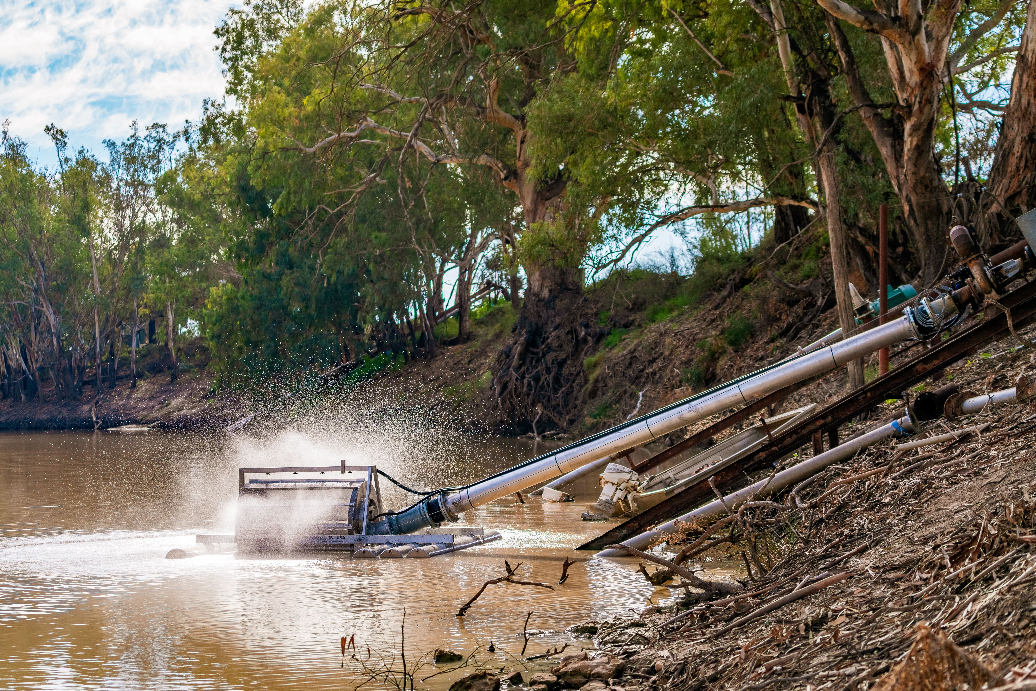
Figure 1: The 8 inch Riverscreen floating diversion screen operating at Porker Citrus
on the Darling River at Ellerslie. (Image: David Sickerdick Photography)

What can I apply for?
Western Local Land Services will provide $5,000.00 plus GST, per entity towards the supply and installation of a fish-friendly diversion screen. The first payment of 75 per cent will be paid upon contract sign-off and confirmation of the order, with the remaining payment of 25 per cent paid upon installation.
As each pump system varies, you will determine the most suitable screen to fit your pump and system. This will include contacting the suppliers to provide pumping information to ascertain suitability.
The screen must comply with the following NSW Department of Primary Industries Fisheries minimum standards to help sustain native fish populations:
- maximum 1-2 mm aperture mesh
- approach velocity does not exceed 0.1 m/sec (8cm in front of the screen face) when pump is operated at maximum flow rate
- able to spread velocity evenly across the screen face to avoid velocity hotspots
- maximum 1-2 mm tolerance on gaps between moving parts
- incorporates some form of cleaning mechanism, i.e. not reliant on river flow alone to clean the screen.

If your application is approved, you will need to provide a detailed quote outlining the total cost of the project, including installation. All the figures included in the quote must indicate GST and provide evidence that the screen meets the minimum standards detailed above.
Note: It is recommended that you arrange a site visit with the screen manufacturer or supplier to confirm suitability prior to securing a quote and submitting your Expression of Interest.
Visit the Fish Screens Australia website for more information on screens for better farming, better fishing, including links to suppliers in Australia. Better Farming, Better Fishing. (fishscreens.org.au)

Applicant eligibilty
The program is available to:

- individual landholders or organisations. Note that the applicant must be the water access licence holder, or have written permission from the water access licence holder to apply
- individual landholders or organisations that are willing to pay for the remainder of the cost of the screen or screens for their pump system
- properties located within Western Local Land Services region. Properties located in the designated reach of the Darling River will be eligible for funding in 2021-22. Nb: Applications outside the target reach will be retained to determine reaches for future funding programs.

The program is not available to:

- individual landholders or organisations with an outstanding monitoring activity or contract with Western Local Land Services or the former Catchment Management Authority
- individual landholders or organisations with outstanding debt, including rates, owing to Local Land Services.

Conflict of interest
Local Land Services staff and board members are required to identify and declare conflicts of interest so that they can be managed in an open and transparent way. This policy extends to external parties or individuals who may be associated with Local Land Services staff or Local Land Services board members through immediate family relationships, close friendships or business relationships. All applicants will be required to identify any such conflicts. Should a conflict be identified, a conflict of interest declaration form will be provided to the applicant to complete.

Conditions of funding
If your application is successful, the following conditions of funding will apply:
- you must undertake all investigations to seek advice on the most suitable screen for your needs, including obtaining a written quote if notified of approval
- you must formally commit to undertaking your project by entering into a funding agreement with Western Local Land Services
- you must assume responsibility to order and purchase the screen. Western Local Land Services require proof of order prior to the first payment
- you must assume full ownership of the screen and maintain the screen in operational order, including bearing all associated costs of managing and maintaining the screen
- you must submit annual monitoring for a period of five years
- the maximum amount of funding available per entity is $5,000.00, plus GST per financial year.
- 75 per cent of the payment will be made up front on acceptance of the funding agreement and evidence of screen order. The remaining 25 per cent will be paid once the screen is installed
- you must supply a correctly rendered tax invoice for each payment when it becomes due. Invoices are to be submitted to the project mangager and made out to:
Local Land Services
Locked Bag 21
Orange NSW
- screen must be installed and operational by 31 March 2022. Note that an inspection will be carried out by a Western Local Land Services officer to verify the successful completion of the project
- if screen is unable to be installed by 31 March 2022, funds must be returned to Western Local Land Services by 15 April 2022, unless a variation to the contract has been sought and approved
- variations to the funding agreement must be requested via email or in writing to the project manager and will be assessed on a case by case basis
- you must agree to allow Western Local Land Services to publish information about you and your project on our website, Facebook page and other communication channels and products as required
- you must complete and submit a survey following the successful installation of the screen
- funds will be returned to Western Local Land Services if any of these conditions are not met
- you must complete and submit a follow-up survey five years following the installation of the screen.
It is recommended that you do not apply for funding if you are not able to meet these conditions.

Applicants please note
Funding for this program is limited, therefore applications for the target reach of the Lower Darling River from the junction at Wentworth to Menindee only will be assessed for the 2021-22 project. As funding becomes available, Western Local Land Services will continue with the On-Farm Sustainable Water Use in the Western Region Program, targeting other reaches according to Expressions of Interest. Applications received in 2021-22 for pump systems outside of this reach will be recorded and kept on file for assessment in future funding programs.

How to apply
Interested landholders are required to complete the following application process:

- To apply, you must complete the Fish-friendly Screens for Efficient Use of Water 2021-22 Expression of Interest form, available from www.lls.nsw.gov.au/western or contact Western Local Land Services to request a form. Expressions of Interest must be submitted by 5 pm Thursday 30 September, 2021.

- Following the closure of expressions of interest, a Western Local Land Services officer will liaise with you to ensure suitability for your pump is confirmed prior to entering into a contract with Western Local Land Services.
For further information on the program or for assistance with your application, please contact Kaye Gottschutzke on 0429 981 331.

Assessment and notification process

Following submission of Expression of Interest forms, all applications will be assessed by the On-Farm Sustainable Water Use Team. Each application will be assessed against the following criteria:
- What is the volume of water extracted annually through the pump system?
- To what extent has the applicant researched suitability for their system for the most appropriate screen?
- To what extent has the applicant shown that the screen will comply with the NSW DPI Fisheries minimum standards?
- To what extent is the applicant ready to go to contract (ie seek a written quote, supplied baseline monitoring data)?
- What percentage is the cost sharing borne by the applicant?

Applications will be scored and ranked accordingly. Funds will be allocated as per the ranking order of eligible projects until funds are exhausted. You will receive notification from Western Local Land Services when your application has been assessed and to inform you of the outcome of your application.

Email your Expression of Interest to: kaye.gottschutzke@lls.nsw.gov.au.
Alternatively, you can post your Expression of Interest to:
Western Local Land Services
Fish-friendly Screens Project
PO Box 363,
Buronga, NSW, 2739.
Expressions of Interest must be submitted by 5 pm Thursday 30 September, 2021.

Application feedback
If your application was not successful, you may ask for feedback on why it was not supported. Please contact Kaye Gottschutzke on 0429 981 331.

How your information is used
The information you provide to Western Local Land Services in your application will be stored and used in accordance with the Privacy Act 1988. If you have concerns about the amount or type of information we require in the application form, please contact Kaye Gottschutzke on 0429 981 331.
Western Local Land Services will also use this information to communicate to the public about the program. This may include publishing communication articles on our website, Facebook page and other communication channels and products, as required.

