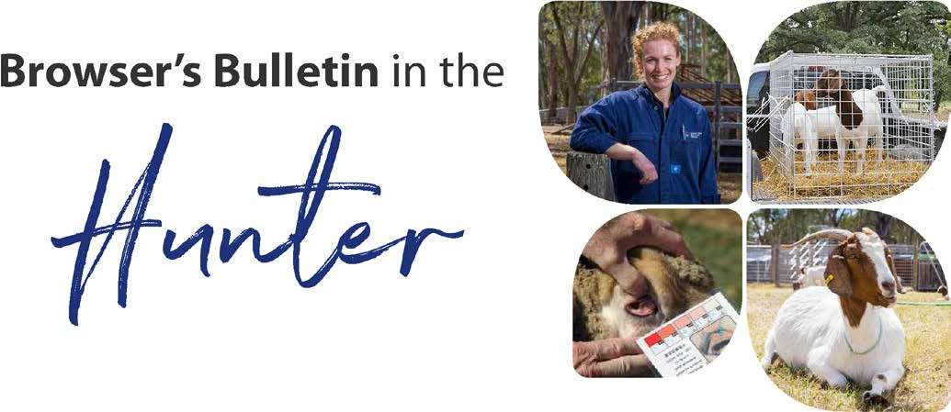
April 2021

Browser’s Bulletin 55:

Skin Disease Investigation

April 2021, I was contacted by a Lower Hunter producer who was concerned that his lambs had photosensitisation as they had a rash and hair loss over their face (See photos below). The lambs were 1-5 weeks of age, but the ewes did not appear to be affected. The Hunter producer had bought 10 Australian White ewes from the Molong region in December 2020. The skin lesions had been noticed over the last month, with crusty scabs around the lips, nostrils and hair loss over the nose, ears, and some lambs had hair loss between the shoulders and down the back. The sheep were on improved pasture, with a kikuyu, rye, clover mix and being fed small amounts of sheep pellets.
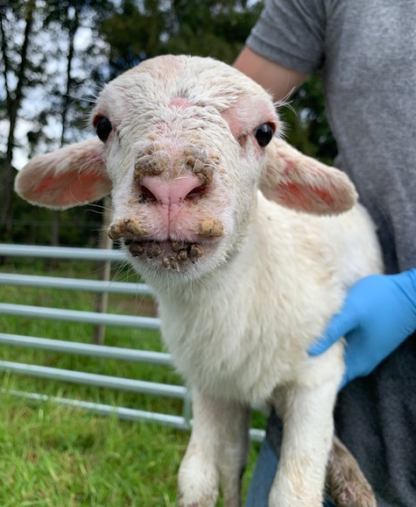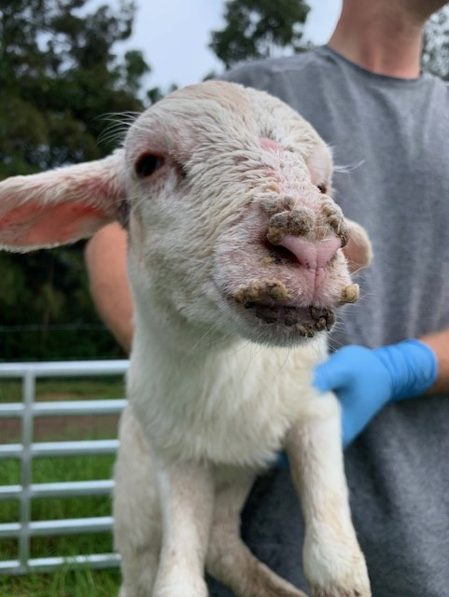
Considering the age of the animals affected, the weather conditions we have had in the Hunter during previous months (Jan-April 468 mm rain) and feed available in the paddocks, my primary differential was ‘Rain Scald’ (Dermatophilosis). Other differentials I was considering from the description of the clinical signs include; Orf (Scabby Mouth), Blue Tongue virus (spread by mosquitos), fly bites and photosensitisation but unlikely as it was the lambs affected and not the ewes.
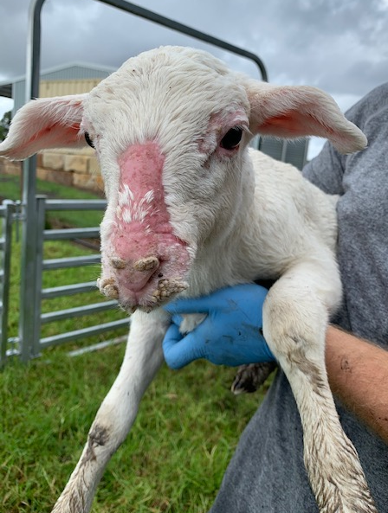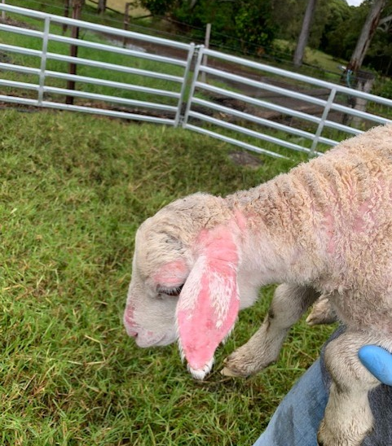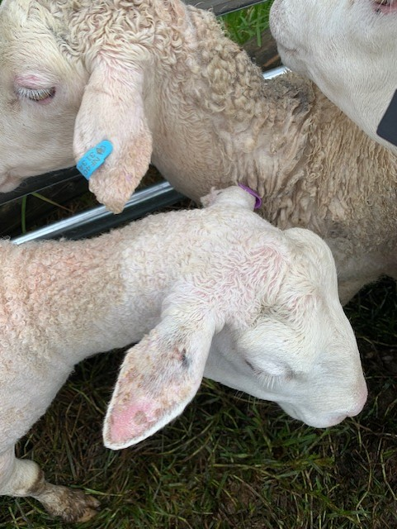
Scabby Mouth is also called- Sore Mouth, Orf, Contagious Ecthyma and Contagious Pustular Dermatitis. It is a viral skin disease caused by a parapoxvirus and is primarily seen in sheep and goats. Once Scabby Mouth is on your property it is on your property for ever. Outbreaks tend to occur at lambing or kidding time, when newly susceptible offspring are exposed to the virus through a break in the skin and normally initiated by lambs/kids chewing on thistles or spikey hay. The incubation period is 3-14 days after exposure to the virus. Clinical signs seen with Scabby mouth include scab-like lesions around the oral cavity and extend to nasal mucosa and in more severe cases the lesions have been reported on the ears, face, around the eyes, poll, scrotum, perianal region, and distal extremities. Lesions may also develop on the udder and teats of the nursing ewe/doe which can lead to pain and refusal to nurse their offspring and consequently neonatal starvation.

Once this virus is on your property, vaccines are available to help in its control. The vaccine is a live vaccine and should only be used when the disease is known to be present on the property. When purchasing these ewes from Molong, the new producer was told to vaccinate the sheep/lambs for Scabby Mouth. Advise to vaccinate, made me overly concerned that the ewes had come from a property that was positive for Scabby Mouth and that the lesions I was seeing was Scabby Mouth.

This is not only an interesting skin disease case but also emphasises the importance of good biosecurity practices when purchasing livestock. I encourage everyone to ask many questions about their health and disease history in order to prevent the introduction of disease onto your property. If you are unsure about a disease or a recommended vaccine, please do not hesitate to call your local District Veterinarian and find out more.

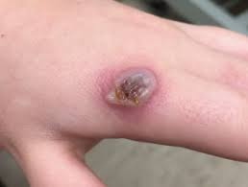
Scabby Mouth is also a zoonotic disease, so anyone handling infected sheep or goats should wear gloves. See the hand lesion in the photo,

Diagnostic samples were taken, and fortunately the results have come back negative for Scabby Mouth and Blue Tongue Virus and positive to Dermatophilosis. Dermatophilosis is caused by the bacterium Dermatophilus congolensis which is an obligate parasite of ruminant skin. When the host’s immunity wanes, the bacteria germinate and penetrate the skin and invade the hair/wool follicles. The body attempts to fight the infection by sending white cells to the hair follicles which produces a serous fluid that becomes a thick scab on the surface of the skin.

Predisposing conditions to Dermatophilosis include skin damage from biting insects or physical abrasion, stress, concurrent diseases that compromise the hosts immunity and excessive rain. We certainly have had excessive rain in the Hunter and across a large part of NSW. Excessive rain without appropriate shelter can lead to dilution of the sebaceous layer of the skin therefore increasing the chance of clinical disease. Young stock are much more susceptible to clinical disease. In this case, on examination of the ewes they were showing crusty lesions on the ears, poll and around the udder but not to the same severity as the lambs. They also had a considerable internal parasite burden that would have lowered their immune system. Antibiotic treatment (Oxytetracycline LA), drenching and providing shelter in rainy conditions was recommended but just an improvement in the weather has led to noticeable recovery in the lambs and new hair growth.

Below, I have included several images demonstrating how similar skin diseases can appear. The photos are in order: Photosensitisation in a lamb from Cowpea aphid, Blue Tongue Virus, Scabby Mouth, Scabby Mouth and Dermatophilosis.
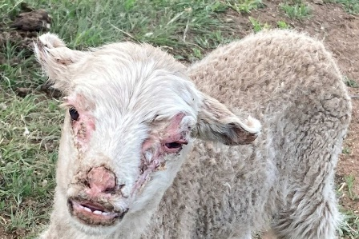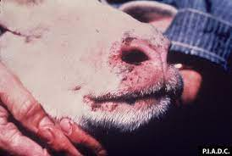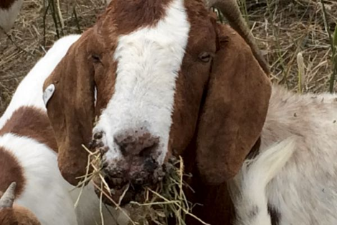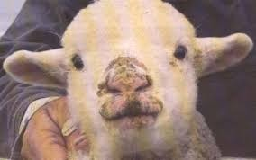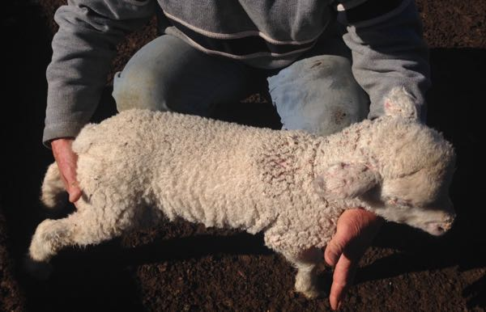
If you have other questions and concerns about skin diseases, please send me an email on kylie.greentree@lls.nsw.gov.au

References:
- https://www.dpi.nsw.gov.au/__data/assets/pdf_file/0006/179835/sheep-health-scabby-mouth.pdf
- http://www.flockandherd.net.au/sheep/ireader/dermatophilosis.html
- Matthews, J; 2016. Diseases of the Goat 4th Edition
- Pugh D.G, Baird A.N; 2012. Sheep and Goat Medicine 2nd Edition.
- Smith,M.C. Sherman, D.M.2009. Goat Medicine 2nd Edition.

© State of New South Wales through Local Land Services 2019. The information contained in this publication is based on knowledge and understanding at the time of writing November 2019. However, because of advances in knowledge, users are reminded of the need to ensure that the information upon which they rely is up to date and to check the currency of the information with the appropriate officer of Local Land Services or the user’s independent adviser. For updates go to www.lls.nsw.gov.au

