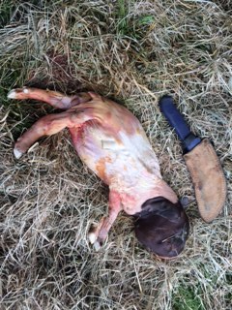
What to do when your does are aborting?
Many of you would be going through kidding at the moment and every now and then you are faced with the devastation of multiple abortions. It is often difficult to work out the actual cause but if we can gather all the necessary information it may assist us with a diagnosis and put preventative measure in place to prevent further issues.
Important information required when dealing with abortions in goats
- What stage of gestation did the abortion occur?
- What is the general breeding history of the herd? i.e. have many does returned to service during the joining period?
- What is the incidence of abortions, stillbirths and weak kids in the herd? What clinical signs are you seeing with the weak kids?
- Is it an individual or herd problem? Number of animals affected?
- Have there been any newly introduced animals? Are the abortions occurring in the homebred or introduced does?
- Vaccination history?
- Have abortions occurred in previous years?
- What feed are they on? Are they being fed any supplements?
- How is the food stored?
- What is the does body condition score?
- Any know concurrent diseases in the herd? Internal parasites?
- Age of the doe that is aborting?
- Any drugs used in the herd?
- Could the goats have had any access to poisons?
- Have the does been exposed to any stress? i.e. transport or handling
- Any mummified foetuses present?
- Is the doe showing any clinical signs other than abortion?
It is important to save all the products of abortion to assist with a diagnosis but always be careful and wear your personal protective equipment (gloves, mask and protective clothes) as some causes of abortion can be zoonotic and cause severe illness in people, especially pregnant ladies and children. Any aborting doe should be isolated from the rest of the herd until there is a diagnosis or the uterine fluid discharge has stopped.
A placenta and the aborted foetus can be very useful in the diagnosis of abortion. It is a good idea to take a photo and write down a description of what you see at the time of abortion. Ideally, if you can get the placenta and foetus to a veterinarian as soon as possible, we may be able send samples away for testing. Bag the foetus and placenta and put the samples into an esky with an ice-brick. Samples go off very quickly, so if you cannot get your samples to a veterinarian it is best to destroy them via incineration or burial ASAP.
If you have any further questions please contact me on Ph: 0428498687.

