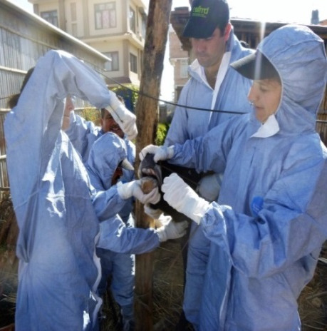
Real-Time Foot & Mouth Disease Training in Nepal
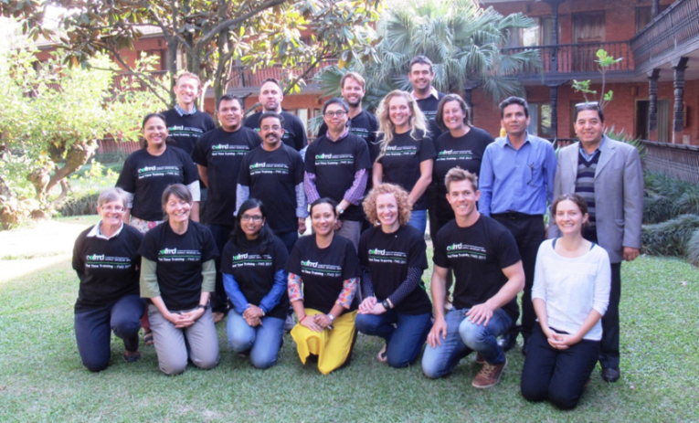
The 25th Kathmandu Real-Time Foot-and-Mouth disease (FMD) Training Course (KTC25) was conducted from 6 to 10 November, 2017. There were 15 participants; 5 from Nepal and 10 from Australia. The course was the result of an ongoing collaboration between the European Commission for the Control of FMD (EuFMD), a division of the Food and Agriculture Organisation of the United Nations (FAO), and the Australian Government Department of Agriculture and Water Resources.
I was fortunate enough to be one of the Australians selected to undergo this training!
The EuFMD provided the majority of the training with presentations from a team at the Pirbright Institute who undertake environmental detection of FMD virus, senior staff of the Nepalese Department of Livestock Services, The Australian Government Department of Agriculture and local knowledge from the Nepalese course participants. Nepal was selected for the real-time training as Foot and Mouth Disease is endemic in the country.
We conducted a transect study on a local village that had experienced FMD 1-2 years ago, we visited and surveyed a total of 42 farms looking into the risk factors and impacts of FMD. The study indicated the loss of income was very significant along with the social and emotional costs of the disease. Risk factors in these villages include close animal contact, sharing of equipment, co-grazing, small ruminants and spread of the virus on farmers.
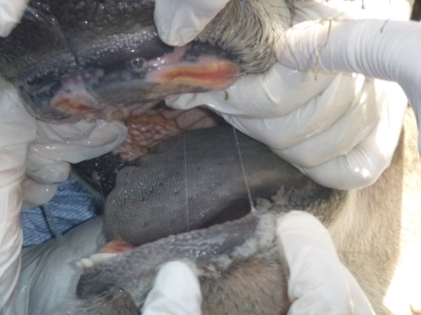
The following day we visited 5 farms were FMD lesions were visible. We conducted a clinical and epidemiological FMD investigation. Several of the animals examined also had secondary bacterial infections which required treatment. The clinical investigation highlighted a classical local spread pathway: sale of a clinically infected cow, shared animal housing, co-grazing and the close proximity to other farms’, infected farm being a milk collection point (which also promotes wider spread outside the local area) and the initial case was in very close proximity to a goat collection point.
Our samples came back as positive for Foot and Mouth Disease, and the scientists from Pirbright also got positives to FMD in the environment.

Interestingly we also visitied a goat market on the Thursday which was just out of this world! There were thousands of different breeds of goats from all across Nepal and India. Goats generally don’t show as severe clinical signs to FMD and often go unnoticed. Pirbright Institute went inside the goat pens and took environmental samples which also came back as positive to FMD with no animal showing clinical signs of FMD.
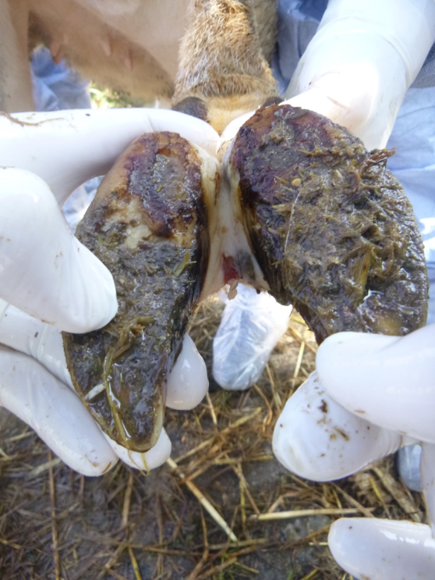

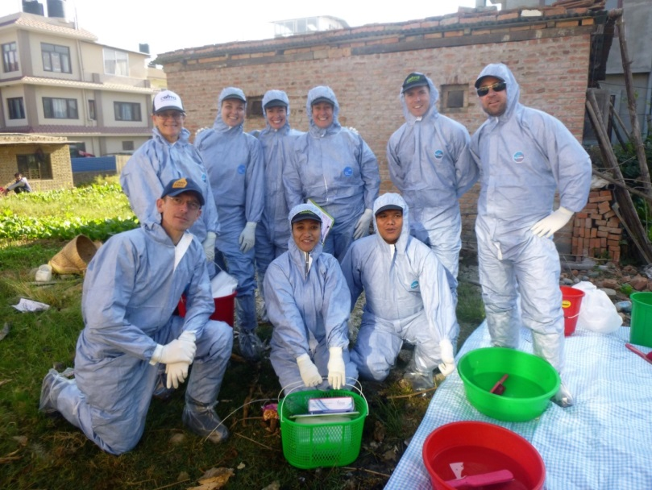
An outbreak of FMD in Australia would be absolutely devastating! In the case of an outbreak we need to ensure early detection of the disease occurs in order to stop the spread and return Australia to a FMD Free status ASAP. It has been estimated that direct costs over the 10 years following a FMD outbreak could be $6 billion (for a small outbreak) rising to over $51 billion for a large, multi-state outbreak.
It is believed the biggest risk to Australia is illegal importation of products eg meat products, contaminated soil, poorly treated skins, illegal boats with food products on board or international travellers with contaminated clothes, shoes or amazingly the virus can even remain viable in the respiratory tract of people that have had contact with FMD positive animals.
To undergo this real-time training in Nepal was such an invaluable experience, and I am so thankful to have been given this opportunity and in the unfortunate event of an FMD outbreak in Australia all the vets and agricultural staff that have undergone this training will be a wonderful resource.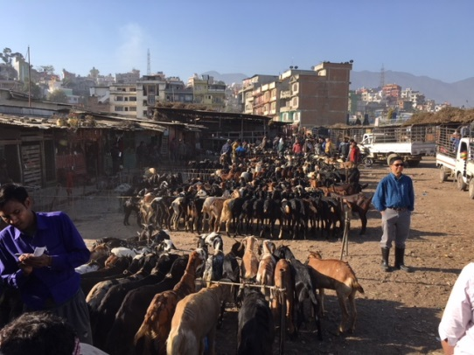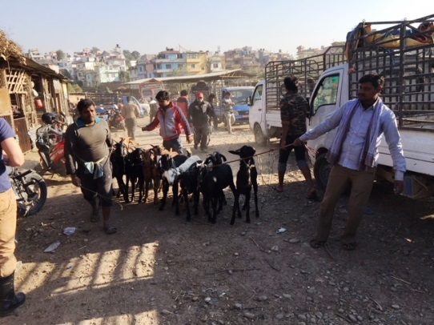

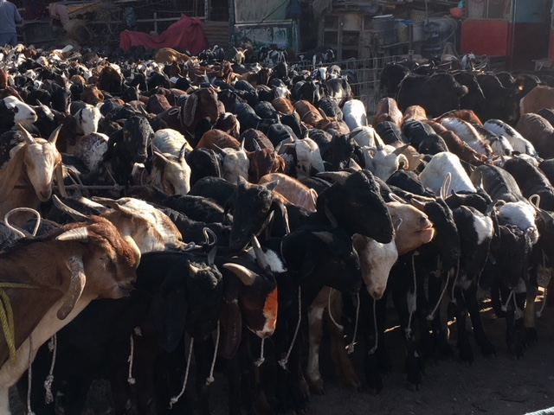
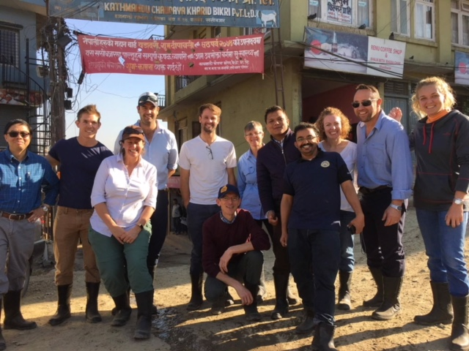
I have included some of my photos that I thought you may like to have a look at from the Kathmandu Goat Market and goats I came across in the villages with a spectacular view! There were thousands of goats at the goat market with none showing ill-health but FMD was detected in the pens on this day. It just shows how difficult it is to detect FMD in small ruminants.

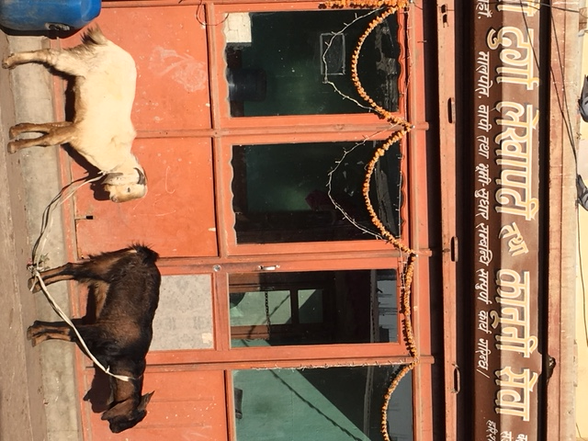
Native Goats of Nepal: Khari (Hill Region), Terai (Terai Region), Sinhal (in mountain region) and Chyangra (in Himalayan Region)
Goats came in from all across Nepal and India. Most farms had many goats as the cattle are sacred animals and not used as a source of meat in Nepal.

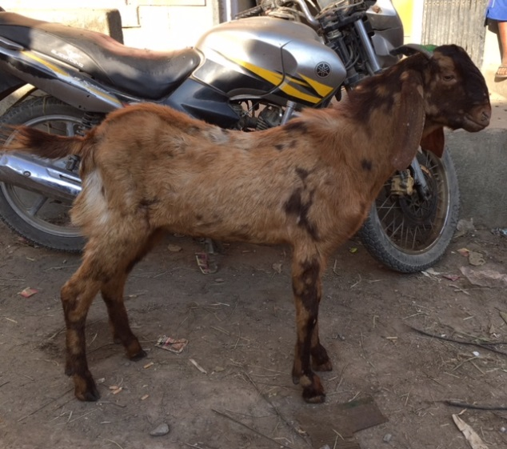
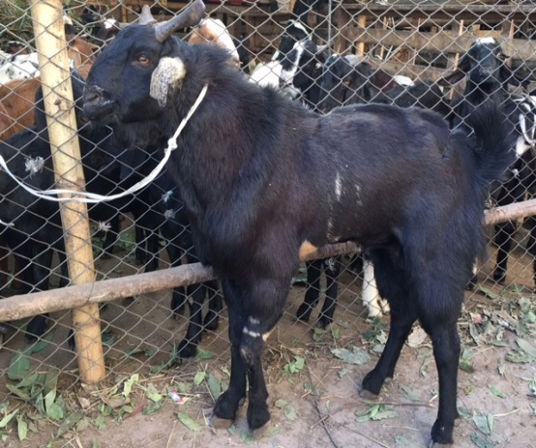
Beetal Goat
Sirohi Goat Breed

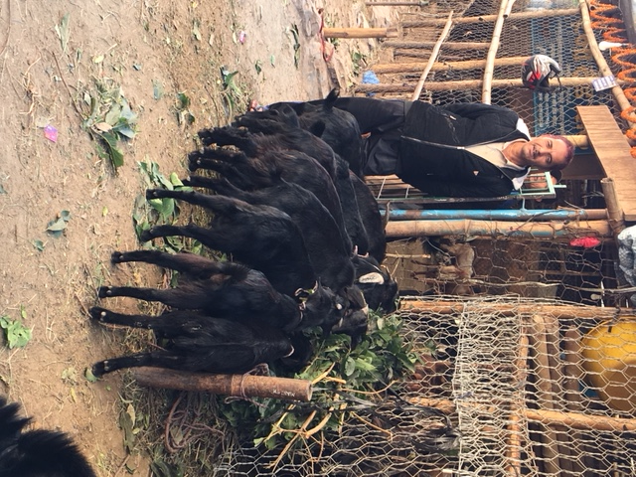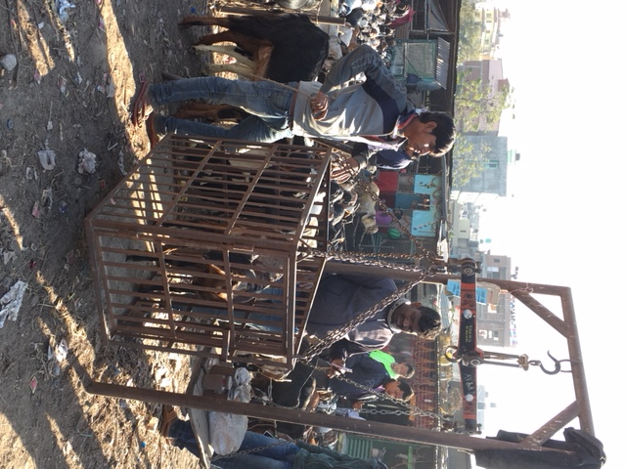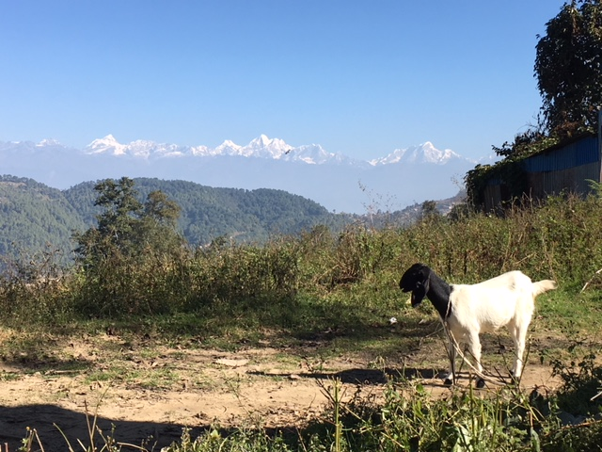
Bengal Goats
Scales used to weigh the goats at market.
Goat with a view!

