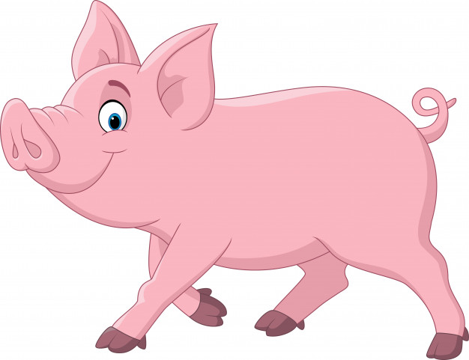
Hunter LLS Pig Newsletter 3: Swill Feeding

June 2020

Swill is the traditional name given to food waste fed to pigs. Swill feeding is illegal as it has been the cause of Foot and Mouth Disease and African Swine Fever outbreaks overseas. Prohibiting swill feeding assists in keeping Australia free of many exotic diseases. Swill may contain serious exotic diseases that could devastate our livestock industries and stop our meat products being exported. The recent outbreak of African Swine Fever in China illustrates the risks involved and potential economic impact if a disease such as this was to be introduced in Australia. Restricting the types of materials fed to pigs are mandatory measures, as outlined in section 24 of the Biosecurity Act 2015. These animal species must not have access to or be fed, any food waste from restaurants, cafes, kitchens, festivals or other food producing outlets that contain meat or meat products from mammals or has been in contact with meat from mammals as outlined in clause 37 and clause 38 of the Biosecurity Regulation 2017. Penalties for swill feeding are up to $220,000 for an individual and $440,000 for a corporation.

These foods are NOT to be fed to all pigs, including pet pigs. It is ILLEGAL to feed these products to animals:
- Any food containing mammal products, such as: pies, sausage rolls, bacon and cheese rolls, pizza, salami, deli meats, table scraps etc
- Any carcase or part of a carcase of a mammal, including raw or cooked meat, bone, offal, blood or hide.
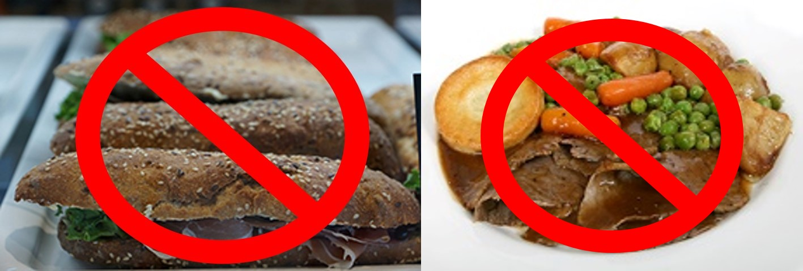
- Household, commercial or industrial waste, including restaurant food and discarded cooking oils
- Anything that has been in contact with prohibited pig feed via collection, storage or transport in contaminated containers (such as meat trays and take-away food containers)

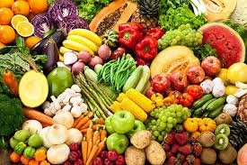
The following CAN be fed to pigs, as long as they have not been in contact with meat products or stored in contaminated containers:
- Commercial Pig Feed
- Fruit, vegetables and cereals
- Milk, milk products and milk by-products
- Eggs

African Swine Fever – China
African Swine Fever (ASF) is a highly infectious viral disease of pigs that is exotic to Australia. It is transmitted primarily by direct contact between pigs or ingestion of contaminated meat (swill feeding). Ticks can also spread the disease between pigs. No vaccine is available. There was an outbreak of ASF in China, detected on 1st August 2018. This is the first report of ASF in Asia, outside of Russia. It has been suggested that swill feeding may have been the mechanism of introduction, as the sick and dead pigs were fed catering and kitchen waste. Infected pigs had clinical signs of fever, vomiting and constipation and died within 2-5 days of showing clinical signs.

ASF remains exotic to Australia. There are ongoing cases of ASF in China, Indonesia, Korea, Laos, Papua New Guinea, Philippines, Timor-Leste and Vietnam. There are also cases in Europe (including Greece, Hungary and Russia) and Africa (including Namibia and South Africa). We all need to do our part to keep ASF out of Australia. Do not feed swill to pigs!

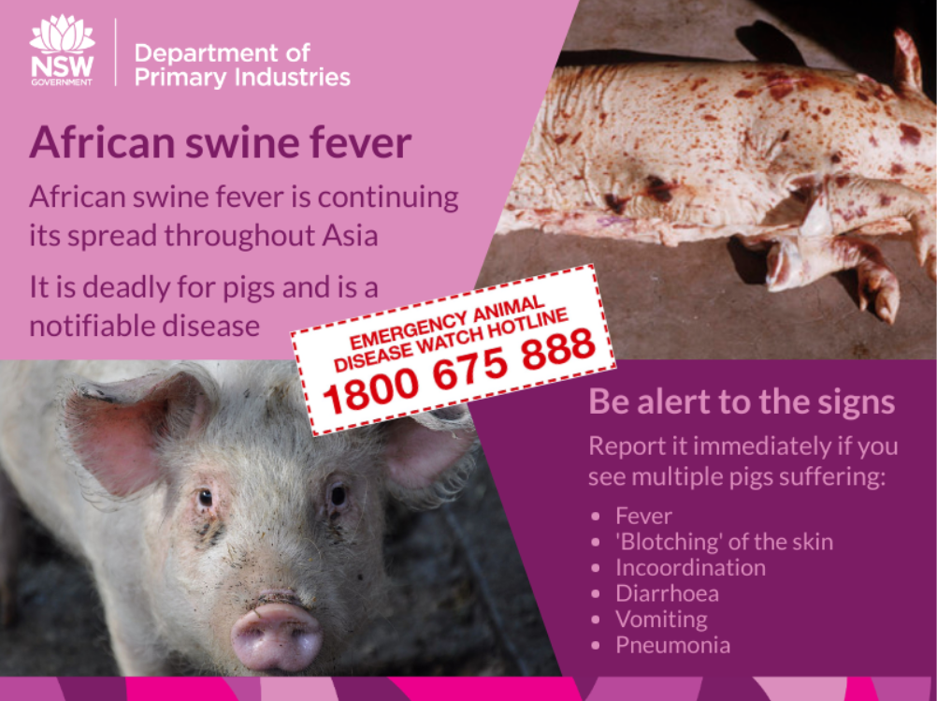

© State of New South Wales through Local Land Services 2019. The information contained in this publication is based on knowledge and understanding at the time of writing June 2020. However, because of advances in knowledge, users are reminded of the need to ensure that the information upon which they rely is up to date and to check the currency of the information with the appropriate officer of Local Land Services or the user’s independent adviser. For updates go to www.lls.nsw.gov.au

