Schools Property Planning Competition 2020

Brookfield

Name of School:

Name/s of Contributing Student/s:

Year level of Student/s:

Date Submitted:

Elements to consider when completing your Property Plan for Brookfield:
Consideration of Land Capability in Land Use and Management strategy recommendations | You have been given the Schools Property Planning Competition Manual in which the land capabilities have been outlined in there and the maps given have the approximate areas of the land capabilities.
Issues and hazards addressed | For your ‘Brookfield Property Plan’ please think of and address any issues or hazards associated with the changes or in general. Note these and any relevant solutions or risks involved.
Enterprise selection and suitability and Marketing options | When deciding on your plan consider if your enterprise selection is suitable for what the landholders’ aims, values and goals are. If you decide that your plan will be intensive, cell grazing, free range moose meat production, consider;  - The level of labour needed, and if your enterprise will generate enough income to employ the labour required?  - Consider if there is a market for moose meat in the local area or if you will need to find export options and transport etc.  - Consider other technologies that will help with your enterprise and the aims, goals and values.
Consideration of land manager’s conditions | Consider yourself contracted to deliver a working, feasible property management plan for the Savage family and Brookfield. Consider their goals, aims and values and also consider that they are absentee landholders living in another state and visiting sporadically throughout the year. Don’t limit yourself with traditional thinking, think outside the box.
Legal consideration accounted for | All properties in NSW need to understand and account for any legal considerations. For example, if you are looking to sow down a new pasture in your plan to rejuvenate a paddock for your moose, then please consider your legal constraints.
Biosecurity and Emergency Planning | Everyone in the region has seen the devastation of the prolonged drought and the bushfires. Properties such as Brookfield need to be prepared for these events and with the Savages being absentee landholders, they need to be highly organised and equipped with forward planning, for such events. They also need to be up to date with their biosecurity. Are there any technologies that can help them? What are the legal requirements to consider? Allow for these in your plan.
Other funding options considered | You have a budget to work from, however this is not limiting. Consider;  - if your enterprise will generate extra income  - other options for funding i.e. grant funding (not just from LLS)  - you can go over budget if you have reason for it and you can stay well under budget also (this is just a guide).
Monitoring and evaluation | All good property plans include a strategy to monitor and evaluate the improvements that have been implemented to ensure they are in fact improvements. When thinking of what to monitor, it could be in relation to but not limited to; finances or cost: benefit ratios, natural resources, animal health and husbandry, water quality etc. Monitoring usually has timelines associated.

Your plan for Brookfield should include the following:

Brookfield Property Plan
This is where you outline your changes, and implementation of improvement/changes. Don’t forget that the plan will be for the next 5 years and can be put into stages if necessary.

Risk Analysis
All good plans include a risk analysis to ensure that the changes and the impact of them on the business are understood and accounted for. A risk analysis will determine which risk factors would potentially have a greater impact on your enterprise and therefore must be managed by the landholders with these factors in mind. There are many different types of risk analysis. Choose one that works for you and your changes. Below is a guide for a SWOT analysis.
Internal | Strengths | Weaknesses | Internal
External | Opportunities | Threats | External

Overall budget and timeline
Your budget for ‘Brookfield’ is $200,000 over 5 years. Please outline how much of the budget will be spent on what changes and indicate these on the timeline. Don’t forget to include the costs of contractors if they are big jobs that can’t be completed while the family is on the property. Below is a sample table. Please feel free use another format if you wish.
Year | ACTION | FINANCIALS  (Start Up Budget $200,000)
 |  | INCOME | EXPENDITURE | PROFIT/LOSS
Year 1
2020
Year 2
2021
Year 3
2022
Year 4
2023
Year 5
2024
Year 6-10

Maps
The plan needs to be put onto a map. There are mapping guides in the manual to help you. You need to have at least one map to represent your plan, however, don’t forget you can zoom in to show exactly what your technical ideas are. These can be added here or attached.
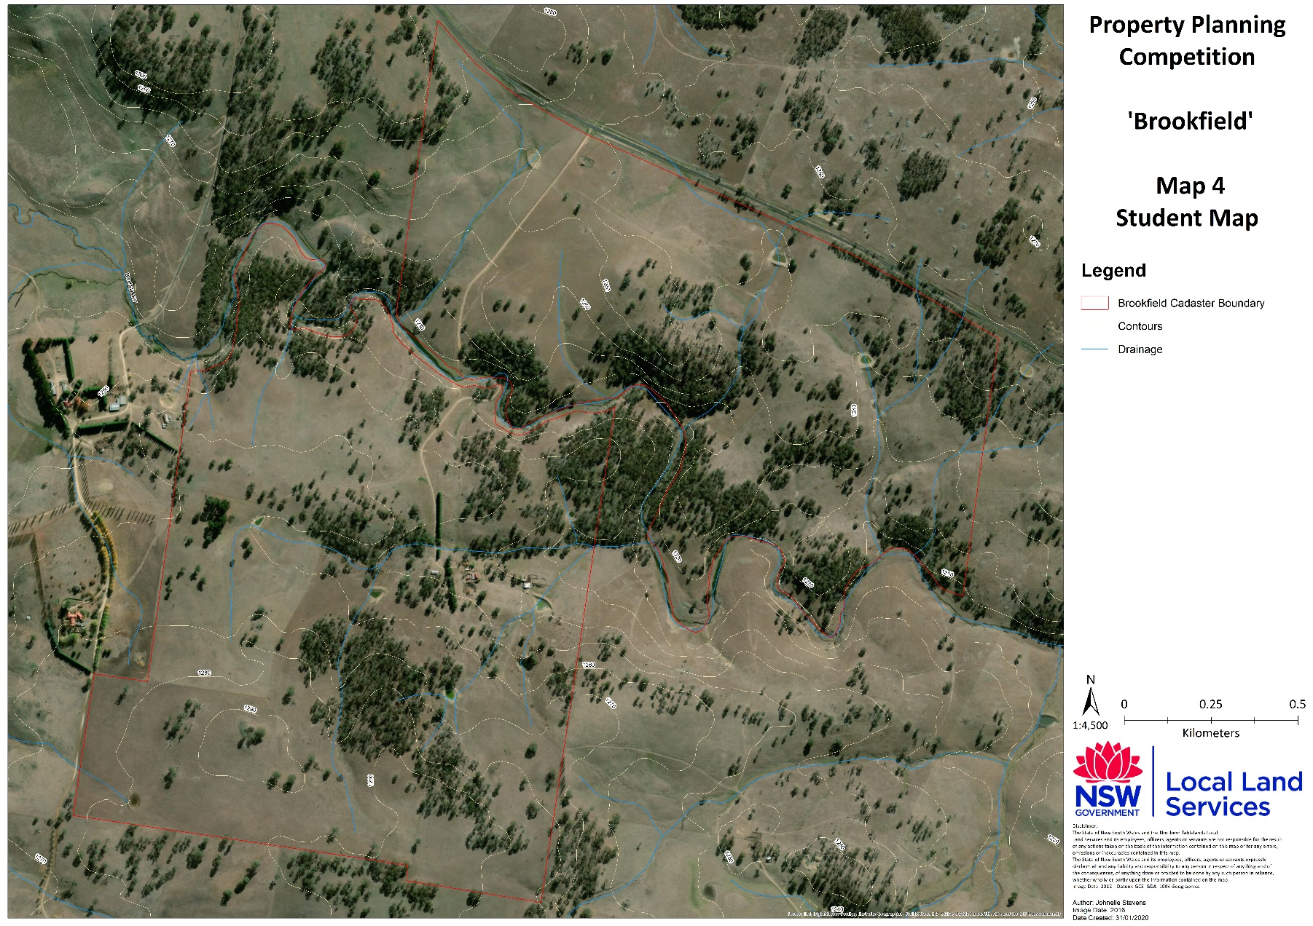

References
In the Property Planning Competition Manual there is a great deal of information, but it isn’t the only source; consider other options for information, including people and please reference all information used.

Criterion | Not Done: 0 | Consideration Given:1-2 | Adequate Standard: 3-5 | High Standard: 6-8 | Score
Enterprise selection and suitability, marketing options, with consideration to the landholder’s considerations. | No information presented to show enterprise selection or marketing. No consideration given to landholders aims. | Irrelevant or inappropriate enterprise selection or marketing, no reasoning. Some consideration given to some aims. | Appropriate enterprise and marketing selection. Relevant and adequate explanation. Some consideration given to all aims. | Appropriate enterprise and marketing selection. Innovative ideas demonstrated that meet the requirements of the landholder and high level of consideration shown for all aims.
Consideration given to ‘elements’ table, where changes were made. | No consideration given to elements. | Some consideration given to some elements. | Some consideration given to all elements. | High level of consideration shown for all elements.
Risk analysis and understanding of risks associated. | No risk analysis or discussion addressing risks. | Inappropriate risks analysed. | Appropriate risks analysed addressing some issues. | Through risk analysis addressing all risks associated.
Budget and timeline. | No consideration of budget or timelines. | Some consideration of budget or timelines. | Some consideration of budget and timelines of some improvements. | High level of consideration given to outlining the budget, and any income generated. Timelines of all improvements.
Report presentation of the plan. | No effort shown, poor presentation. | Some effort shown to present report. | Report presented clearly with some effort made with presentation. | Report presented very clearly and to a high standard with effort made with presentation.
Map presentation reflecting the plan. | Not included, poor presentation. | Some effort shown to present map. | Map presented clearly with some effort made with presentation. | Map/s presented very clearly and to a high standard with effort made with presentation.
References. | No references provided. | Some references provided but irrelevant resources used. | References given to use of resources. Relevant resources used but not referenced. | List of all relevant resources mentioned, and references given.
Comments: Total:……../56

