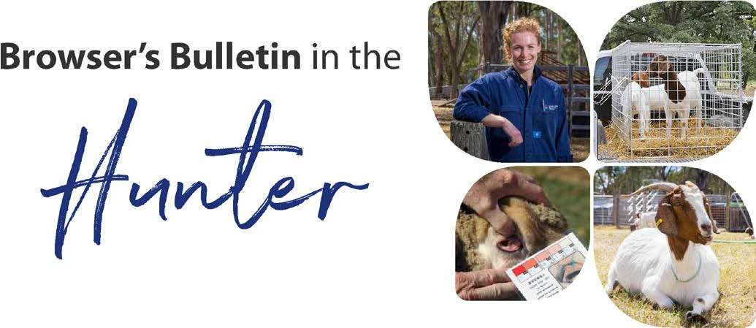
March 2021

Browser’s Bulletin 54:

Tick paralysis in small ruminants
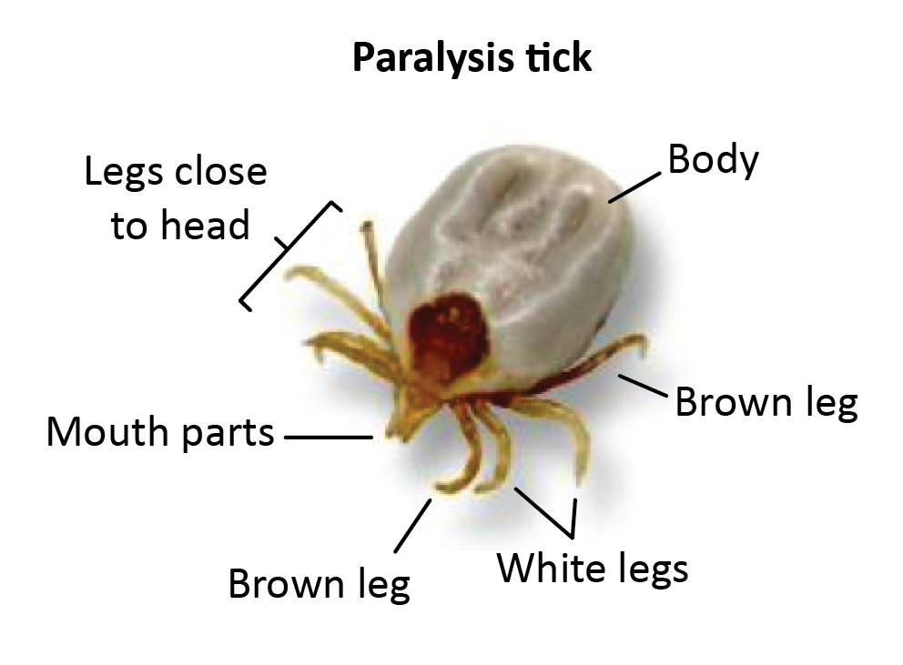

A few months ago, one of our local producers sadly lost a kid goat to tick paralysis. Tick paralysis is something we can see in livestock and consequently we thought it would be beneficial to discuss in this month's Browser’s Bulletin.
The three main ticks of concern in NSW include the paralysis tick, the bush tick and the cattle tick. Cattle tick are usually found in the tick infested zone in Queensland, so any detection of cattle tick out of this region is notifiable. In the Hunter, the main ticks are the bush tick and the paralysis tick.
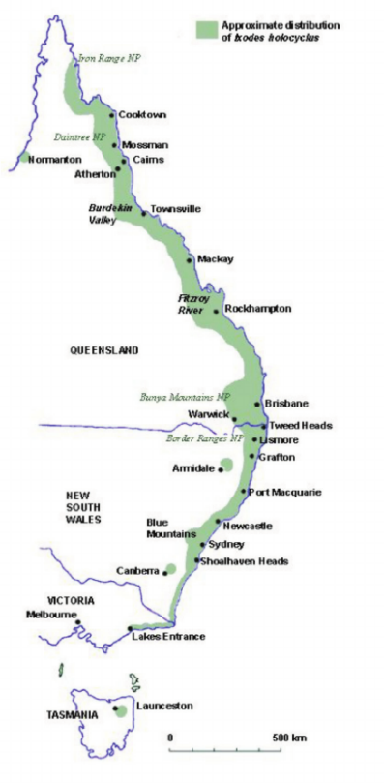
Paralysis ticks (Ixodes holocyclus) are native to Australia and their primary hosts are marsupials (bandicoots, wallabies, echidnas, and possums). The native animals are usually immune to the toxin injected by the paralysis tick’s saliva due to constant exposure to ticks. Unfortunately, they also attach to livestock and our domestic pets causing an ascending paralysis, recumbency, breathing difficulty and death if not treated.

Several tick species are found on goats around Australia with most not causing issues. Unfortunately, here on the North Coast we have the paralysis tick (see map showing the distribution of the paralysis tick along the East Coast of Australia). Ticks are clever at hiding in hard-to-find locations (between hooves, nostrils, anus, vagina, inside ear canals or under fleece) and potentially may have dropped off by the time you are noticing clinical signs in your stock. If you have sheep/goats showing symptoms of tick paralysis, then treatment with tick anti-toxin is available and reasonably successful if treatment is sought early and registered for use in sheep and goats, through your private veterinarian.

The paralysis tick is called a three-host tick. This means throughout its life, the tick must attach to a host, feed, drop off and moult three times with each feed lasting approximately 1 week. The three stages in order are: Larvae (pin head size), Nymph (match head size) and Adult (pea-size). The paralysis tick spends more time on the ground than on the host animal and can survive off the animal for 6-8 months if it is not too hot or too cold (>32C and dry and <7C).

Paralysis ticks are an issue all year around. We tend to see higher numbers of ticks when we have had high rainfall during the previous year, thick ground cover for protection of the free-living stage of the tick and where you will find a lot of wildlife. Given the rainfall this Summer, I am concerned that Spring 2021-2022 could be a bad season for paralysis ticks.

All stages of the tick can inject a neurotoxin into the host animal, but the adult tick injects a larger amount, which affects the nervous system of the animal. Initially you will notice that the animal loses coordination in the hindquarters and the paralysis slowly moves forward, affecting the front legs, breathing and swallowing. Young animals are more susceptible to ticks because of their low body weight and lack of previous exposure to ticks. Experiments have shown that it takes 2 adult tick on a 2–3-week-old calf to cause paralysis. Often the ticks have dropped off before clinical signs can be noticed, making it difficult to diagnose the cause. There is no clinical pathological or necropsy findings that support the diagnosis of tick paralysis. A definitive diagnosis is by finding the offending tick on the animal and the clinical signs of ascending paralysis. Other diseases that cause ascending paralysis include, sway back from copper deficiency, Caprine Arthritis Encephalitis (CAE), botulism, vertebral abscess, congenital spinal abnormality, injection reaction affecting nerves, nutritional deficiency, or trauma.
As the animal becomes bigger, it takes more ticks to cause paralysis, and once the animal is exposed to ticks, it slowly gains a degree of immunity to the toxin.

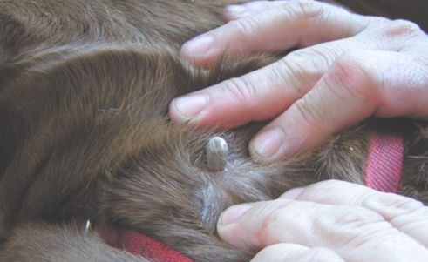
Controlling ticks can be very difficult. Kids, lambs and calves hit the ground when the adult tick is emerging to breed. Try and establish which paddocks on your property have the lowest risk of ticks and graze the younger smaller stock in these paddocks. High risk paddocks have a heavy mulch ground cover and are a thoroughfare for native animals. If you have stock with ticks attached, it is recommended that your treat them before you move them into a clean, cleared paddock.

Products registered in goats for controlling ticks include mixtures of Cypermethrin and Chlorfenvinphos and formulations of Amitraz, but it is important to check the label claims on the products. Amitraz’s label claims to be effective in the control of cattle tick (NSW only) in sheep and goats. With dip and spray products, it is important to ensure the goat is thoroughly wet over the entire body, otherwise ticks will attach to non-treated areas and not be killed by the chemical. Unfortunately spray chemicals are short acting and difficult to apply. Ensure you maintain detailed chemical records and take note of the WHP (with holding period) of the product. Some products cannot be used on animals producing milk for human consumption now or into the future.

An article that you may all find as a handy reference is called “Dosages, withholding periods and export slaughter intervals of parasiticides registered for use in goats in Australia.” The article was published in 2013 so some chemical details could have changed and it is advisable to check registration on the APVMA web page https://apvma.gov.au/ or call your local District Vet for more information.

This article can be could at the following link.
https://www.mla.com.au/research-and-development/search-rd-reports/final-report-details/Productivity-On-Farm/Dosages-withholding-periods-and-export-slaughter-intervals-of-parasiticides-registered-for-use-in-goats-in-Australia/299
file:///C:/Users/greentky/Downloads/B.GOA.0089_Final_Report.pdf
Another handy article is ‘Ticks of Concern to NSW stock owners’ by the NSW DPI. It also has detailed images and descriptions (page 6) of the different ticks for producers to work out which ticks are on their stock. These images show the ticks actual size, demonstrating how easy it is to miss them on your stock.

If you have other questions and concerns about tick paralysis in goats, please send me an email on kylie.greentree@lls.nsw.gov.au

References:
- Matthews, J; 2009. Diseases of the Goat
- Smith, M.C, Sherman, D.M; 2009. Goat Medicine
- NSW DPI Primefact 1372 “Paralysis Ticks and Cattle” https://www.dpi.nsw.gov.au/animals-and-livestock/beef-cattle/health-and-disease/parasitic-and-protozoal-diseases/ticks/paralysis-ticks
- https://www.mla.com.au/globalassets/mla-corporate/extensions-training-and-tools/documents/module-9_gig-guide-oct2017.pdf

© State of New South Wales through Local Land Services 2019. The information contained in this publication is based on knowledge and understanding at the time of writing November 2019. However, because of advances in knowledge, users are reminded of the need to ensure that the information upon which they rely is up to date and to check the currency of the information with the appropriate officer of Local Land Services or the user’s independent adviser. For updates go to www.lls.nsw.gov.au

