Rangeland Rehabilitation Program Application

Coolibah-Black Box Endangered Ecological Community

Application forms must be emailed or post marked by
9 am on Monday 12 July 2021

Email: georgina.chaplain@lls.nsw.gov.au
Post: Western Local Land Services, Rangeland Rehabilitation Program, PO Box 307 Cobar, NSW 2835

Contact / business details
Every field must be completed
Contact name
Please include first and last name – not initials
Location of project (property)
Mailing address
WLL or
Lot, DP number
Telephone
Mobile
Email
ABN
Trading Name
GST registered | Yes / No
Bank details | BSB:  Account no:  Name:

Project title? (less than ten words)

Q1. Why is this project a priority?
Please answer the following questions:
What issue are you addressing?
Is the proposed area the most important in need of rehabilitation — why?
Why is mechanical intervention necessary for the proposed area?

Q2. Description of the proposed works
Please provide relevant details, i.e. hectares, technique, number of plants, machinery, etc.

Q3. Budget
Description of items | Number of items | Cost per item | Applicant contribution | Western LLS contribution | Total cost
Total cost divided by 3 (1:2 cost sharing)
Is applicant contribution equal or greater than “total cost divided by 3” (Yes/No)?
Is Western Local Land Services contribution equal or less than $10,000 (Yes/No)?

Q4. What could go wrong?

These are only the risks associated with the construction of the infrastructure, not the ongoing management. Please be realistic in your assessment. High risk projects will not be penalised.
Risk identified | Actions required to manage risk

Unable to complete project in timeframe due to competing priorities

Wet weather delays construction

Unable to complete project in timeframe due to machinery breakdowns or unable to source contractors

Q5. Project plan/map:

Please use legend supplied.
Name of property: _________________________

Area of property: __________________________

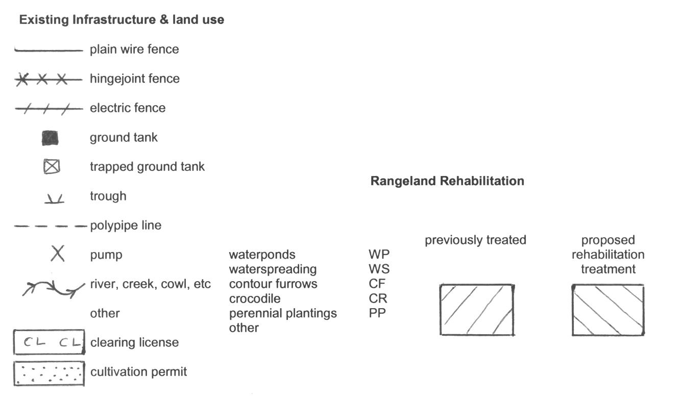

Q6. Are you willing to allow Western Local Land Services to use your project for media promotion, case studies, further research, field days, etc. if asked?
Please note: specific permission from you will be sought before any action is taken
Yes No Will think about it

Q7. Requirement to de-stock the country
I understand the banks require time to settle after being formed and any planted seed needs time to establish. I agree, therefore, to rest the project area from grazing pressure until a minimum of 50 mm of rain has fallen on the project area. Any change to this condition must be agreed to in writing with the Local Land Services
Yes No

Q8. Requirement to obtain an Aboriginal Cultural Heritage assessment
It is a requirement for any successfully funded project to undertake an Aboriginal cultural heritage assessment before any earthworks are started. It is the responsibility of the LLS and the landholder to ensure due diligence takes place with respect to Aboriginal cultural heritage values. If the application is successful, a cultural heritage assessment will be arranged by Local Land Services at no cost to the landholder. Are you willing to have a cultural heritage assessment conducted on the project area?
Yes No

Application Declaration

I ______________________________________ of _______________________________________declare:
(PRINT NAME) (GROUP/ORGANISATION)
That the information provided in this application is complete and correct. I have read and understand the guidelines concerning this application.

(No signature required on application form) Date: ______/______/__________

Application forms must be hand delivered, post marked or emailed by
9 am Monday 12 July 2021

Email: georgina.chaplain@lls.nsw.gov.au
Post: Western Local Land Services, Rangeland Rehabilitation Program, PO Box 307 Cobar, NSW 2835

