How often are you trimming your goat’s feet?
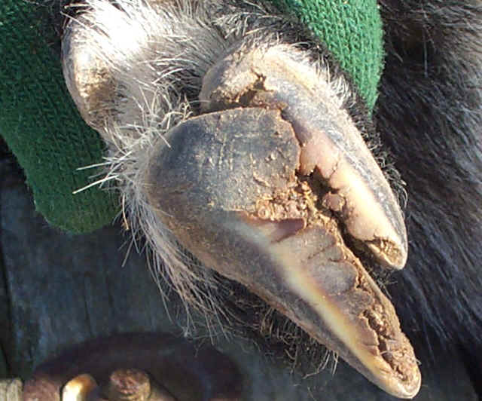
Overgrown feet can cause an abnormal gait and loss of production; they can put stress on joints, tendons and ligaments and are often painful. Goats with overgrown feet will not be willing to move and consequently will eat and drink less or they may get around on their knees. The frequency of hoof trimming will depend on the hardness of the ground that the goats exercise. The harder the surface and the more extensively managed the less likely that the goats will have overgrown feet. The more intensively managed goats will require more frequent hoof trimming. Some producers in the area are trimming their goat’s feet every 2-3 months in order to keep their feet in good condition and consequently assists with high production levels.
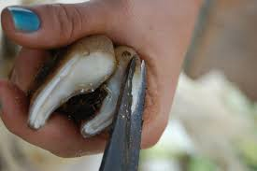
Overgrown feet lead to a number of other serious conditions that will decrease production levels even further. These conditions include; White line disease, foot abscess, interdigital dermatitis and footrot.
If you introduce goats and subsequently they develop lameness with the onset of wet weather, you should isolate them and inspect their feet for footrot. Footrot is a notifiable disease and you should contact us if you think you have footrot on your property. For more information on footrot see the DPI Footrot Primefact. http://www.dpi.nsw.gov.au/animals-and-livestock/sheep/health/footrot/footrot-sheep-goats
I often come across white line disease, where there is a separation between the outer hoof wall and the inner sole. Once this separation occurs dirt and debris are pushed up into the gap often leading to infections of the foot.
To trim your goat’s feet you will need to invest in a good pair of hoof trimmers. You are aiming to have a flat smooth surface from the heel to the toe. If their feet are badly overgrown it may take several trimmings to get the feet back into better condition. It is also important to keep your goats feet dry. When the conditions are wet, goats are much more prone to feet problems. If you need any advice about trimming your goat’s feet please do not hesitate to call.
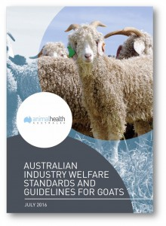
The Goat Agskills book has a great reference for hoof trimming. http://www.tocal.nsw.edu.au/publications/list/animals/goat-agskill
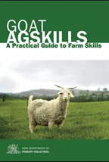
Guidelines for Best Practice Goat Production
Animal Health Australia (AHA) and the Goat Industry Council of Australia (GICA) have developed standards and guidelines that apply to all goat farming enterprise in Australia. These guidelines are recommendation to achieve best practice and welfare for goat production. Download a copy on the AHA website.

