Copper Deficiency
Copper deficiency in goats is usually seen in grazing animals, not those on a concentrate diet. In sheep with copper deficiency the entire herd will normally be affected where in goats the clinical signs will be more sporadic. There are a number of factors that can lead to a copper deficiency;
- Pasture that has been top-dressed with molybdenum and sulphur or have had heavy lime applications which will decrease the copper availability and consequently lead to a copper deficiency.
- Excess Iron or sulphur in the diet will result in copper deficiency even when the copper intake appears adequate
- Heavy worm population can affect the copper uptake by altering the pH of the alimentary tract which consequently makes copper less soluble.
- Fibre goats appear more susceptible to copper deficiency than other breeds.
Clinical signs you may see with Copper deficiency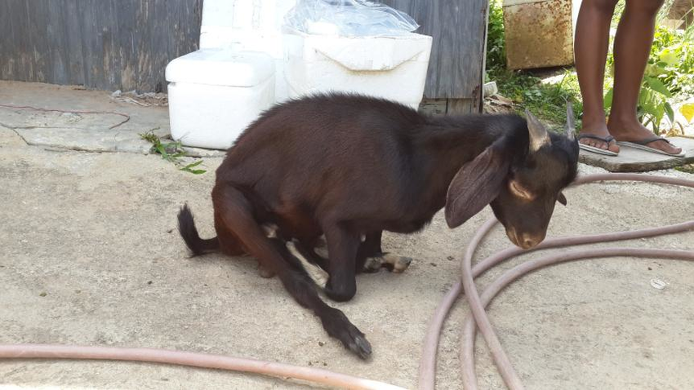
Over the next 2 weeks, I have a fabulous opportunity to travel to Nepal where I will undergo some Foot and Mouth Disease training in order to detect the disease as quickly as possible if it was to come into Australia. I will endeavour to share my experience with you in the next Browser’s Bulletin.
- Anaemia
- Illthrift and increase susceptibility to infection
- Scouring
- Increased susceptibility to bone fractures
- Born with paralysis, low viability, swayback
- Delayed progressive hind limb ataxia which can progress to paralysis (as seen in the photo above) Usually noticed at 3-4 months of age
- Decreased milk yield
- Discolouration of the hair
- Poor fleece quality/ harsh handling to the mohair and a less uniform staple
- Failure to thrive and growth retardation
- conjunctivitis
In the Hunter we certainly see copper deficiency and prevention is better than cure. If you are noticing any of these clinical signs and believe copper deficiency could be a potential problem in your herd then feel free to contact me on Ph: 49328866. Soil and plant analysis and corrective fertilisation may assist the problem along with a herd worm management plan in place. Copper supplementation may be required on your property, but you must be careful not to give excessive amounts as copper toxicity can also occur which can be fatal.

