November 2019

Browser’s Bulletin 38:

Barber’s Pole Worm Explosion after Drought Breaking Rains

Many producers are shocked to hear that even during drought conditions that their sheep and goats are carrying worms. To give you an idea, this week I have had multiple properties with very high faecal egg counts and predominantly barber’s pole worm.

It is important to understand the lifecycle of the worm to appreciate how these drought breaking rains can bring about a barber’s pole worm population explosion and devastation to your small ruminants!

The adult worm survives in the animal for many months producing up to 10 000 eggs per day. These eggs hatch in ideal conditions, then within the moist faecal pellet they develop from larval stage 1 to larval stage 2 to larval stage 3. Larval stage 3 is also called the infective larval stage and it leaves the faecal pellet and moves onto the blade of grass where they are eaten by the sheep and goats. Within the ruminant the worm develops from larval stage 3 to larval stage 4 and finally into an adult worm where the female worms start to produce eggs.

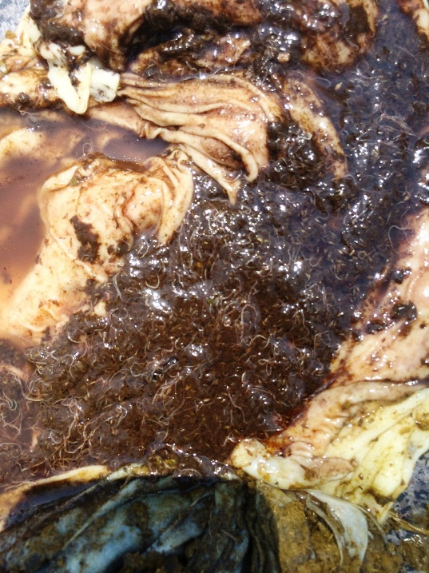
When the weather conditions are not ideal outside (drought conditions, hot and dry or cold and dry) the worm has cleverly adapted its development to remain dormant within the lining of the abomasum (4th stomach) until conditions become more ideal for survival of the worm. This is called hypobiosis.
Figure 1: Barber's pole in 4th stomach

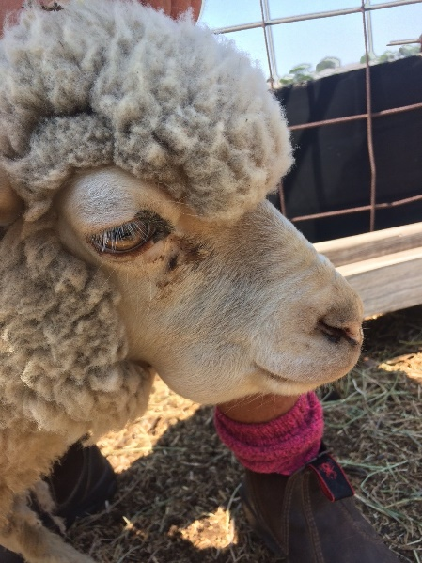
As you could imagine during these drought conditions, the faecal pellet becomes very hard and the larvae cannot penetrate through the outer wall of the pellet but they can survive for many months within the moist dung pellet. So, if suddenly we get drought breaking rains or even multiple summer storms over the Christmas period then the dung pellets will soften, allowing a massive population of infective larvae to escape onto the pasture. During these drought times normally the pasture height is low and the animal is eating closer to the ground where the larvae are more concentrated.
Figure 2: Clinical sign of bottle jaw

Any sign of green pick developing after rain is a sure sign that worm eggs are hatching and infective larvae are being eaten by stock. The dormant larval stage in the animal will be triggered to restart development within the animal.

It is important to keep a very close eye on your stock during these risky periods, looking for clinical signs of barber’s pole worm (anaemia, swelling under the jaw, poor condition, lethargic and death when moved), doing regular monitoring of worm egg counts in faeces (every 2-4 weeks) and using other tools such as FAMACHA every 2 weeks is a very effective means of detecting anaemia and high barber’s pole burdens in small ruminants.
If you have any further questions about internal parasites please email Kylie Greentree on kylie.greentree@lls.nsw.gov.au

© State of New South Wales through Local Land Services 2019. The information contained in this publication is based on knowledge and understanding at the time of writing November 2019. However, because of advances in knowledge, users are reminded of the need to ensure that the information upon which they rely is up to date and to check the currency of the information with the appropriate officer of Local Land Services or the user’s independent adviser. For updates go to www.lls.nsw.gov.au

