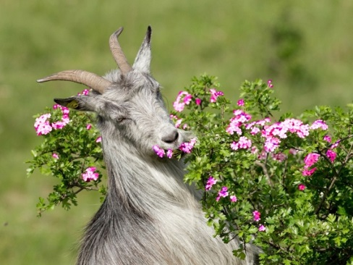
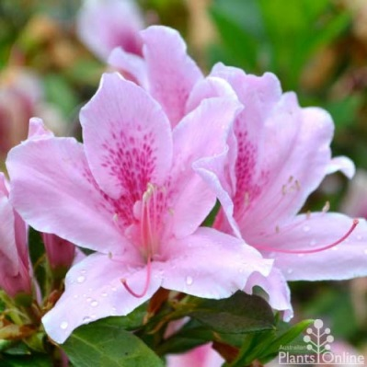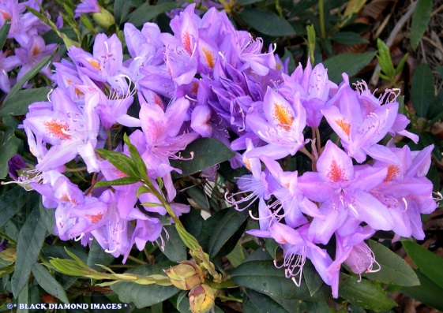
Rhododendrons and Azaleas
The pictures above show just a few of the many colours you will find with Rhododendrons and Azaleas. All Azaleas are in fact true Rhododendrons and Rhododendrons are evergreen plants which can come in a variety of forms such as a potted plant, garden shrubs and trees. Rhododendrons generally grow better in cooler climates but certain varieties will cope well in a coastal environment. There are between 800 and 900 wild kinds of rhododendrons and thousands of hybrids.
Why am I telling you this you may ask? The fact is that these plants are highly toxic to goats and they only have to ingest a small amount (0.1% of the goats body weight) to make a goat very sick.
Many people have these plants growing in their gardens and they will prune them and give all the cuttings to their goats. This can be devastating! Within 6 hours of ingesting these plants they will have severe abdominal pain, bloating, increase in salivation, projectile vomiting, recumbancy and death.
Goats have a very bad habit of ignoring fences and making their way to the rhododendron plant in your house yard, especially in winter when many other plants have dried off and the lovely green Rhododendron looks very appealing, or the well-meaning neighbours throwing the goats their clippings from the garden which can lead to spectacular projectile vomiting and death. Kids are more prone to toxicity as they will eat anything while adults are a little more selective.
I would recommend that all rhododendron plants are securely fenced off or removed if you have goats on your property and if you live in a peri urban area that “Do Not Feed the Goats” sign is placed on the front fence.
If your goat has ingested rhododendrons then a vet should be called as soon as possible. While waiting for the vet to arrive, remove the goat from the plant, empty its mouth and try to keep it moving which will prevent cudding and digestion of the toxin. Strong tea (cooled) can be used as a gastric stimulant and helps precipitates out the toxin, large doses of paraffin oil (500ml) can assist in moving the plant through the gut quickly and activated charcoal can be given at 2-9g/kg to bind the toxin and prevent absorption. Veterinary medications are required to reduce pain, increase the heart rate, treat the shock and fluid loss, provide antibiotics to prevent pneumonia from inhaling vomit and assist with rapid emptying of the gastrointestinal tract.
Prevention is better than cure!

