Keep a close eye on how your kids are growing
Most of you probably have kids on the ground at this time of year and it is important to keep track of growth rates. It helps to keep records of birth weights and weigh the kids regularly so you can make sure they are growing at an ideal rate. If your start regularly weighing growing kids you can detect problems early. The aim is to economically produce a healthy well grown kid with good rumen development at weaning. In general the larger the kid at birth the faster their growth rate. Low birth weights may arise because of undernutrition of the dam in the last trimester, multiple births such as twins and triplets, infectious agents or mineral deficiencies.
Why are your kids not growing as well as they have in the past? Are they getting enough milk supply? Is the kid able to suckle? Could there be a congenital or disease issue preventing suckling? Are the kids being fed on their dam, whole milk or a milk replacer? If you are feeding a milk replacer it is important to feed a good quality milk replacer, feed the correct amount, properly mixed at the correct strength, correct temperature and always use strict hygiene. Kids that are fed more frequently will grow faster than those kids fed twice daily.
From 4 weeks to weaning age the major cause of growth set backs include nutrition, parasites, coccidiosis, chronic diseases such as pneumonia and joint infections and copper deficiency. Prolonged milk feeding beyond 12 weeks of age may restrict rumen development and future productivity of the goat.
It is important to start introducing solid feeds soon after birth. Initially solid feed is rejected but gradually they will increase the amount they swallow. Some of these feeds stay in the rumen and help establish a microbial population and assist with developing the rumen. Fibrous feeds in particular assist with rumen development.
Lameness after Intramuscular Injection
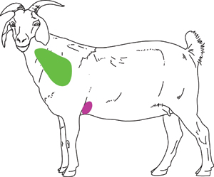
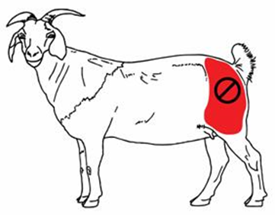
Goats have a relatively small muscle mass in their hind leg particulalry in the gluteal region so it is not uncommon to causea temporary or permanent lameness in the hind limb when you are injecting medications in to the gluteal region. Lameness occurs due to irritating substances or damage to the nerves in the hind leg. Because of these dangers involved in injecting into the hind leg it is recommended that you inject into the mid neck region. This picture demonstrates the recommended site of intramuscular injections in the green section.
Reminder:
Worms are a constant problem with goats. Do regular Faecal Egg Counts (every 4-6 weeks) to keep an eye on your goats to see if they have a worm problem.

