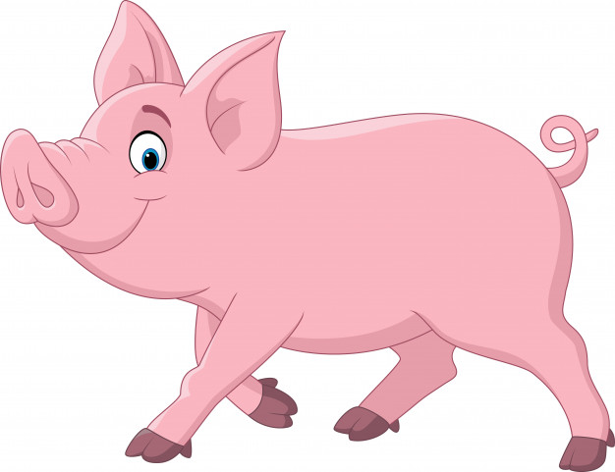

**Hunter LLS Pig Newsletter 2: NLIS & PigPass**

May 2020

**NLIS Pigs: Selling or Giving Away Pigs**

Traceability is crucial to prevent the uncontrolled spread of exotic diseases and to maintain market access.

With African Swine Fever a very real threat to Australia and our pork industry and with positive cases recently confirmed in Bali and Papua New Guinea, it is of utmost importance that all pigs are able to be traced back to where they have come from.

The National Livestock Identification System (NLIS) is a mob-based tracing system for ALL pigs, even pet pigs. It has 4 parts:

1. A **Property Identification Code (PIC)**
2. **Identification** of pigs using either registered **swine brands** or NLIS accredited **eartags** linked to a PIC
3. Movement documents (**PigPass NVD**)
4. Reporting the movements on the **PigPass database**

To **Sell (or give away) Pigs** either to an abattoir, through a saleyard, direct to another producer or even to a friend or family member down the road, you must:

1. Have a PIC
2. Have a registered swine brand or eartags linked to your PIC (pigs less than 25kg must only be identified with an eartag and must not be branded in NSW)
3. Ensure all pigs have an NLIS eartag or swine brand
4. Be registered for PigPass (www.pigpass.com.au/register)
5. Complete a PigPass National Vendor Declaration (NVD) which accompanies the pigs
6. 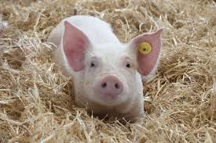Keep a record of the PigPass NVD for 3 years

To **Purchase (or receive) Pigs** you must:

1. Have a PIC
2. Provide your PIC to the seller
3. Be registered with PigPass so you can record movements onto your property within 2 days
4. Keep a record of the PigPass NVD for 3 years

If you need a PIC, apply to your Local Land Services (LLS) to obtain a PIC for your property 1300 795 299

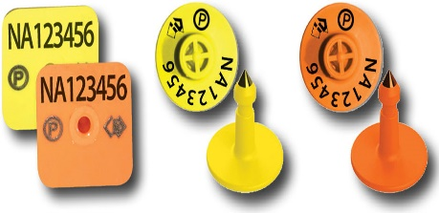NLIS accredited ear tags are either yellow or orange in colour and are printed with the property’s unique PIC, the NLIS logo and a ‘P’ inside a circle**. Breeder tags** are **yellow** and must only be attached to pigs bred on the same property as the PIC on the ear tag. **Post-breeder tags** are **orange** and are used on pigs that were born on a different property. The PIC on the tag must belong to the property on which the pigs are being tagged. More than one post-breeder tag may be attached to a pig, as a different tag is attached each time the pig moves from a different property (PIC). NLIS accredited Ear tags can be ordered through your local produce stores or online.

If you are a pig owner and want to be added to our mailing list to receive updated information regularly, please contact your Local Land Services Office on 1300 795 299 and ask to be added to the list.

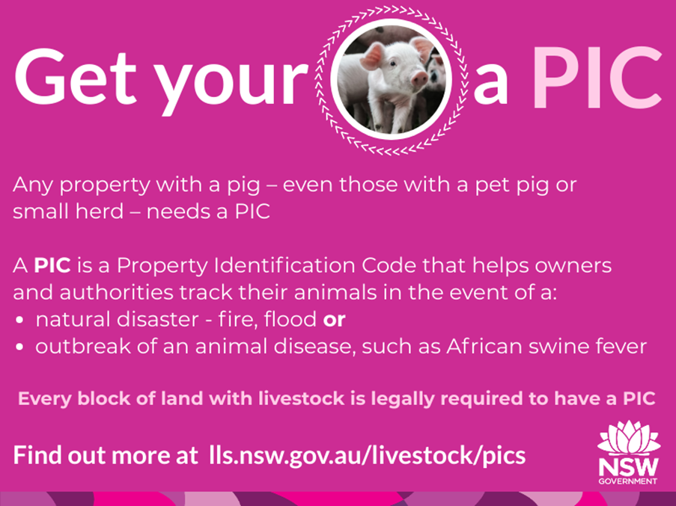

© State of New South Wales through Local Land Services 2019. The information contained in this publication is based on knowledge and understanding at the time of writing April 2020. However, because of advances in knowledge, users are reminded of the need to ensure that the information upon which they rely is up to date and to check the currency of the information with the appropriate officer of Local Land Services or the user’s independent adviser. For updates go to www.lls.nsw.gov.au